735 Before You I Kneel CW 735

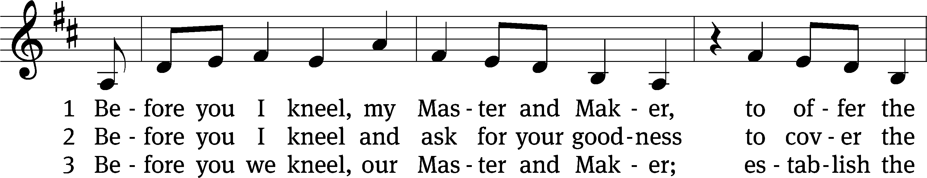

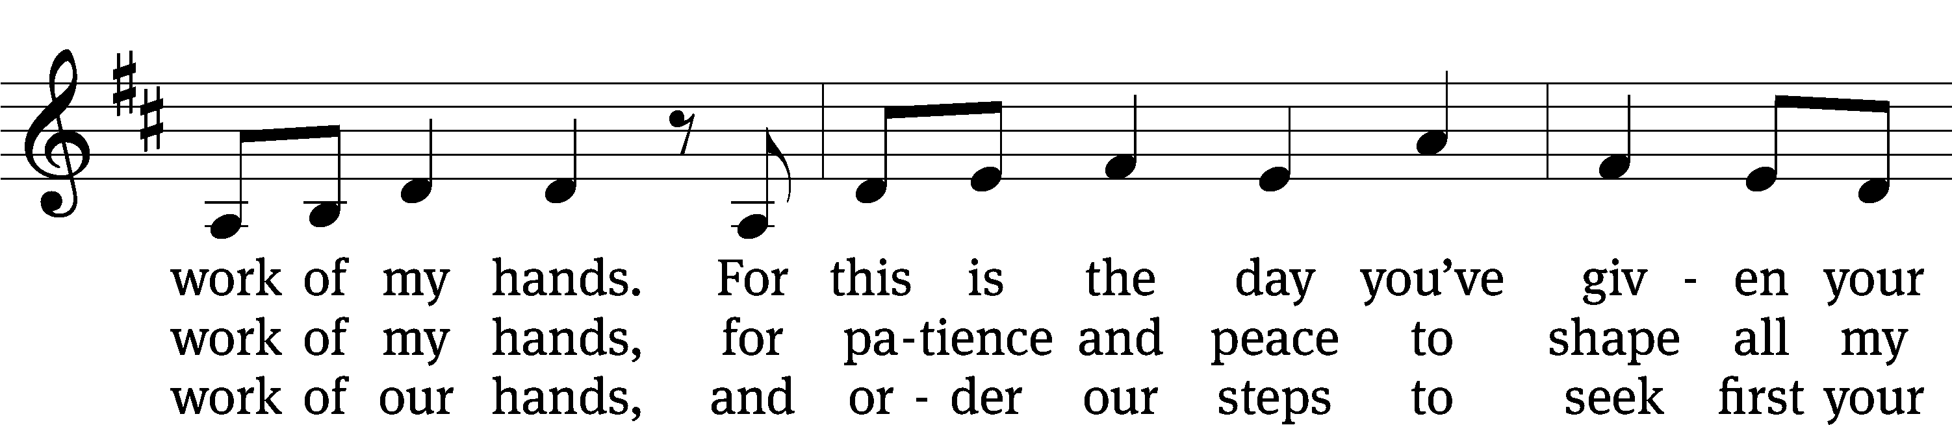

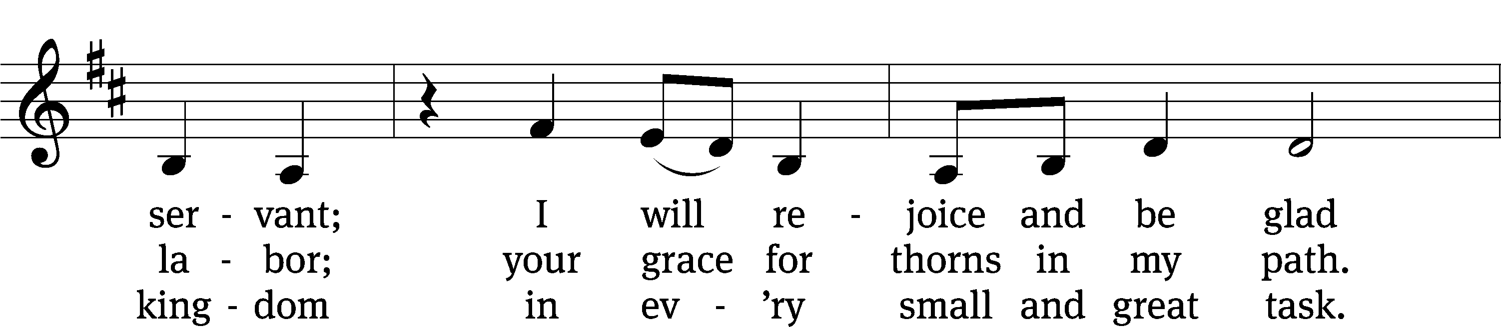

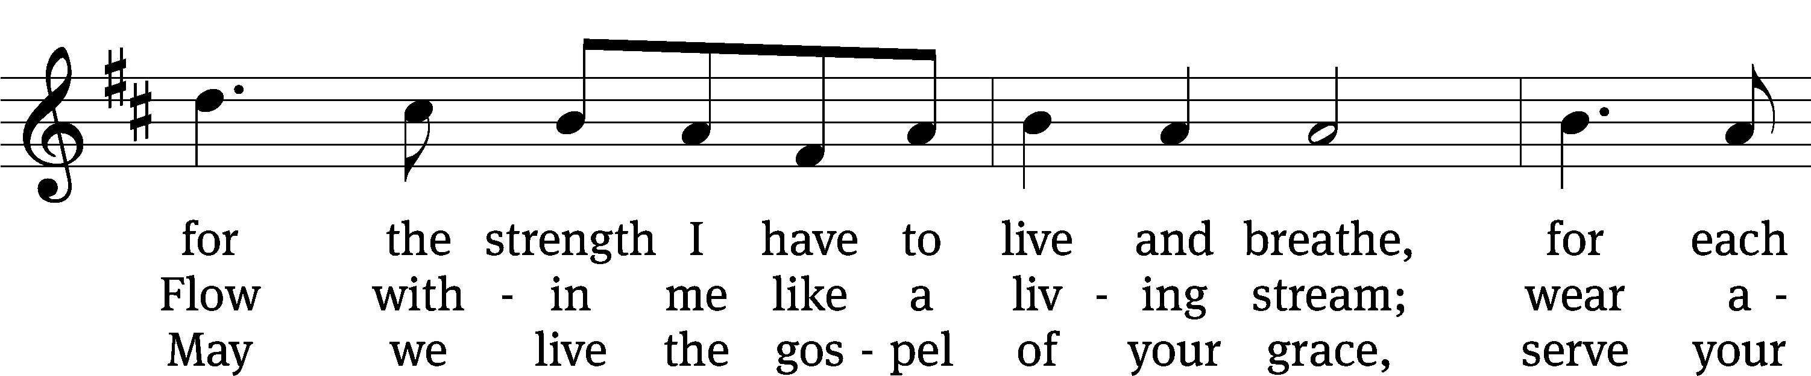

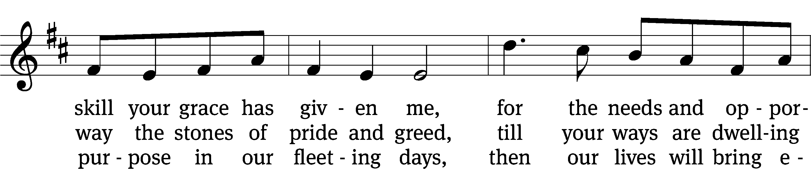

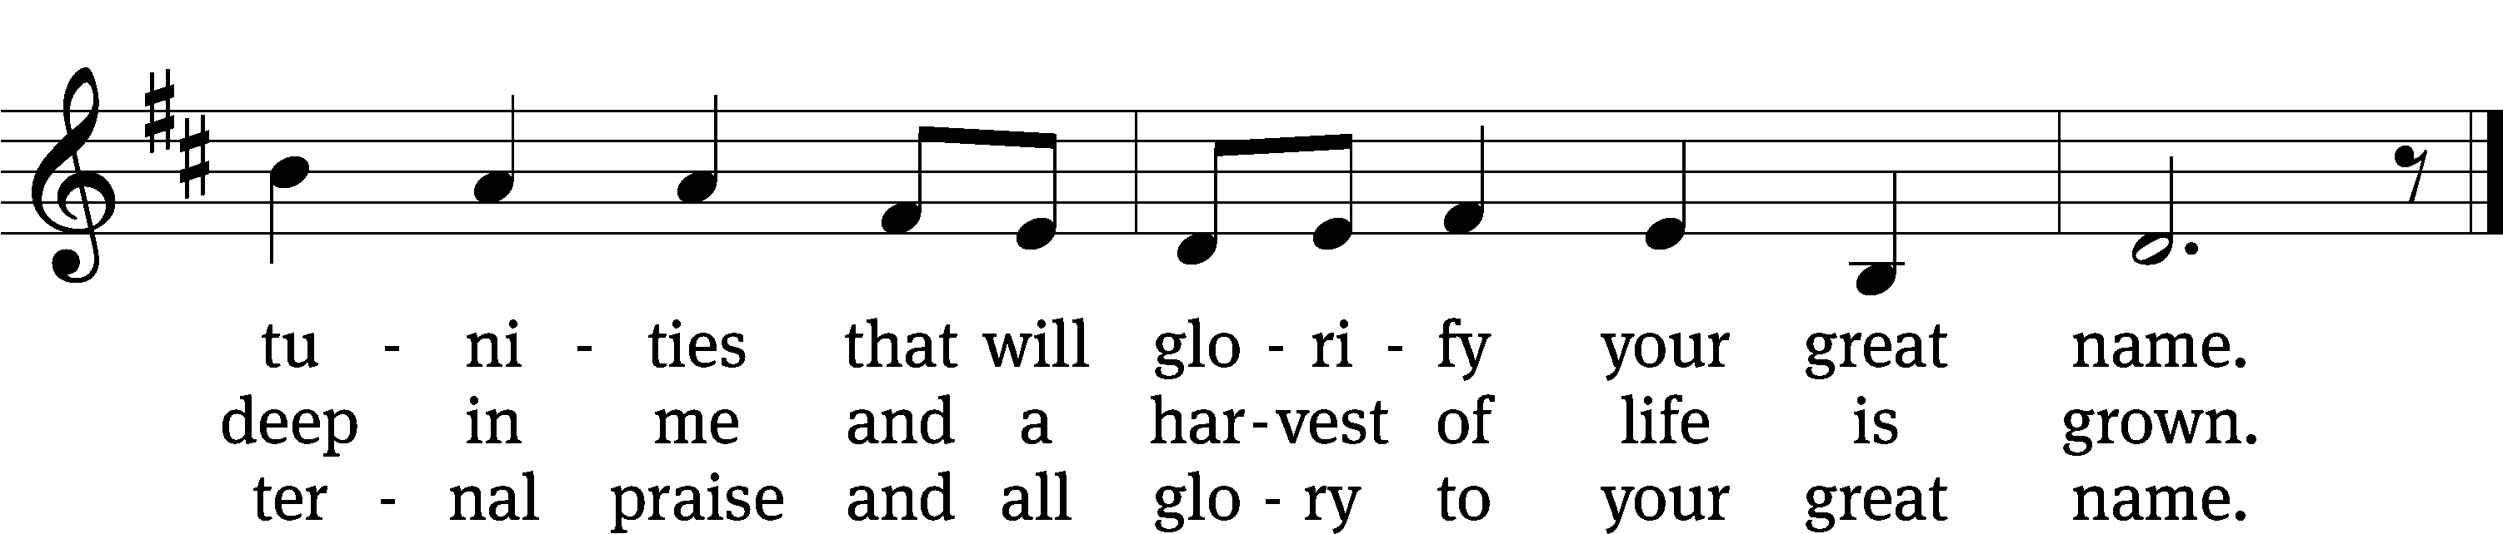

Text: Stuart Townend, b. 1963; Jeff Taylor, b. 1957; Kristyn Getty, b. 1980; Keith Getty, b. 1974  
Tune: Stuart Townend, b. 1963; Jeff Taylor, b. XXXX; Kristyn Getty, b. 1980; Keith Getty, b. 1974  
Text and tune: © 2012 Getty Music and Seek 1st Publishing, admin. MusicServices.org and Townend Music. Used by permission: OneLicense no. 722228

Stand

In the name of the Father and of the T Son and of the Holy Spirit.

**Amen.**

Confession

If we claim to be without sin, we deceive ourselves and the truth is not in us.

**If we confess our sins, God is faithful and just**   
 **and will forgive us our sins**   
 **and purify us from all unrighteousness.**

Let us confess our sins to the Lord.

**Holy God, gracious Father,**   
 **I am sinful by nature**   
 **and have sinned against you in my thoughts, words, and actions.**   
 **I have not loved you with my whole heart;**   
 **I have not loved others as I should.**   
 **I deserve your punishment both now and forever.**   
 **But Jesus, my Savior, paid for my sins**   
 **with his innocent suffering and death.**   
 **Trusting in him, I pray: God, have mercy on me, a sinner.**

Silence for meditation and reflection

Our gracious Father in heaven has been merciful to us. He sent his only Son, Jesus Christ, who gave his life as the atoning sacrifice for the sins of the whole world. Therefore, as a called servant of Christ and by his authority, I forgive you all your sins in the name of the Father and of the T Son and of the Holy Spirit.

**Amen.**

Lord, Have Mercy CW 190

In peace let us pray to the Lord.

**Lord, have mercy.**

For the peace from above and for our salvation, let us pray to the Lord.

**Lord, have mercy.**

For the peace of the whole world, for the well-being of the Church of God, and for the unity of all, let us pray to the Lord.

**Lord, have mercy.**

For this holy house and for all who offer here their worship and praise, let us pray to the Lord.

**Lord, have mercy.**

Help, save, comfort, and defend us, gracious Lord.

**Amen.**

Glory to God in the Highest CW 191

*Refrain:* Glory to God in the highest, glory to God, and peace to his people on earth, and peace to his people on earth.

Lord God, heavenly King, almighty God and Father, we worship you, we give you thanks, we praise you for your glory.

Lord Jesus Christ, only Son of the Father, Lord God, Lamb of God, you take away the sin of the world; have mercy on us. You are seated at the right hand of the Father; receive our prayer.

For you alone are the Holy One, you alone are the Lord, you alone are the Most High, Jesus Christ, with the Holy Spirit in the glory of God the Father. Amen. *Refrain*

# The Word

The Lord be with you.

**And also with you.**

Prayer of the Day

Let us pray.

Lord God, in mercy receive the prayers of your people. Grant them the wisdom to know the things that please you and the grace and power always to accomplish them; through your Son, Jesus Christ our Lord, who lives and reigns with you and the Holy Spirit, one God, now and forever.

**Amen.**

Be seated

First Reading 2 Samuel 11:1–17,26-27

1In the spring, at the time when kings go off to war, David sent Joab out with the king’s men and the whole Israelite army. They destroyed the Ammonites and besieged Rabbah. But David remained in Jerusalem.

2One evening David got up from his bed and walked around on the roof of the palace. From the roof he saw a woman bathing. The woman was very beautiful, 3and David sent someone to find out about her. The man said, “She is Bathsheba, the daughter of Eliam and the wife of Uriah the Hittite.” 4Then David sent messengers to get her. She came to him, and he slept with her. (Now she was purifying herself from her monthly uncleanness.) Then she went back home. 5The woman conceived and sent word to David, saying, “I am pregnant.”

6So David sent this word to Joab: “Send me Uriah the Hittite.” And Joab sent him to David. 7When Uriah came to him, David asked him how Joab was, how the soldiers were and how the war was going. 8Then David said to Uriah, “Go down to your house and wash your feet.” So Uriah left the palace, and a gift from the king was sent after him. 9But Uriah slept at the entrance to the palace with all his master’s servants and did not go down to his house.

10David was told, “Uriah did not go home.” So he asked Uriah, “Haven’t you just come from a military campaign? Why didn’t you go home?”

11Uriah said to David, “The ark and Israel and Judah are staying in tents, and my commander Joab and my lord’s men are camped in the open country. How could I go to my house to eat and drink and make love to my wife? As surely as you live, I will not do such a thing!”

12Then David said to him, “Stay here one more day, and tomorrow I will send you back.” So Uriah remained in Jerusalem that day and the next. 13At David’s invitation, he ate and drank with him, and David made him drunk. But in the evening Uriah went out to sleep on his mat among his master’s servants; he did not go home.

14In the morning David wrote a letter to Joab and sent it with Uriah. 15In it he wrote, “Put Uriah out in front where the fighting is fiercest. Then withdraw from him so he will be struck down and die.”

16So while Joab had the city under siege, he put Uriah at a place where he knew the strongest defenders were. 17When the men of the city came out and fought against Joab, some of the men in David’s army fell; moreover, Uriah the Hittite died.

26When Uriah’s wife heard that her husband was dead, she mourned for him. 27After the time of mourning was over, David had her brought to his house, and she became his wife and bore him a son. But the thing David had done displeased the Lord.

The Word of the Lord.

**Thanks be to God.**

119A Teach Me, O LORD Psalm 119A

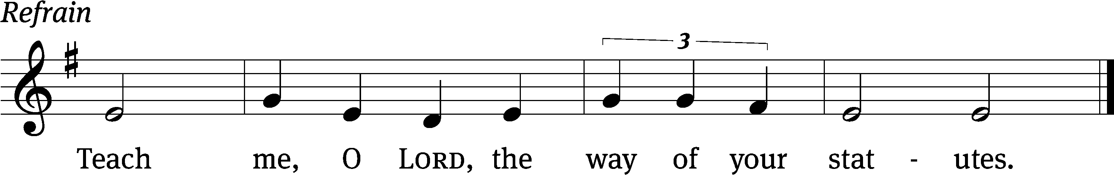

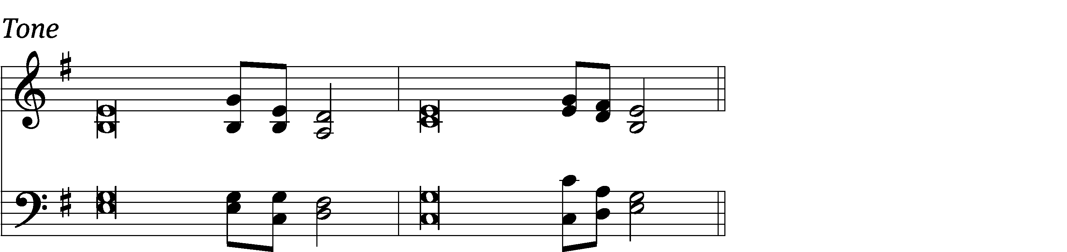

Blessed are those whose ways are / blameless,  
 who walk according to the law / of the Lord.  
Blessed are those who keep his / statutes  
 and seek him with / all their heart.  
You have laid down / precepts  
 that are to be ful- / ly obeyed. *Refrain*

Oh, that my ways were / steadfast  
 in obeying / your decrees!  
Then I would not be / put to shame  
 when I consider all / your commands.  
I will praise you with an / upright heart  
 as I learn your / righteous laws.  
**Glory be to the Father and** / **to the Son**  
 **and to the Holy** / **Spirit,**  
**as it was in the be-** / **ginning,**  
 **is now, and will be forever.** / **Amen.** *Refrain*

Tune: Thomas Pavlechko  
Setting: Thomas Pavlechko  
Music: © 2004, 2012 Augsburg Fortress. Used by permission: OneLicense no. 722228

Second Reading 1 Thessalonians 4:1–12

1As for other matters, brothers and sisters, we instructed you how to live in order to please God, as in fact you are living. Now we ask you and urge you in the Lord Jesus to do this more and more. 2For you know what instructions we gave you by the authority of the Lord Jesus.

3It is God’s will that you should be sanctified: that you should avoid sexual immorality; 4that each of you should learn to control your own body in a way that is holy and honorable, 5not in passionate lust like the pagans, who do not know God; 6and that in this matter no one should wrong or take advantage of a brother or sister. The Lord will punish all those who commit such sins, as we told you and warned you before. 7For God did not call us to be impure, but to live a holy life. 8Therefore, anyone who rejects this instruction does not reject a human being but God, the very God who gives you his Holy Spirit.

9Now about your love for one another we do not need to write to you, for you yourselves have been taught by God to love each other. 10And in fact, you do love all of God’s family throughout Macedonia. Yet we urge you, brothers and sisters, to do so more and more, 11and to make it your ambition to lead a quiet life: You should mind your own business and work with your hands, just as we told you, 12so that your daily life may win the respect of outsiders and so that you will not be dependent on anybody.

The Word of the Lord.

**Thanks be to God.**

Stand

Gospel Acclamation Ephesians 5:2

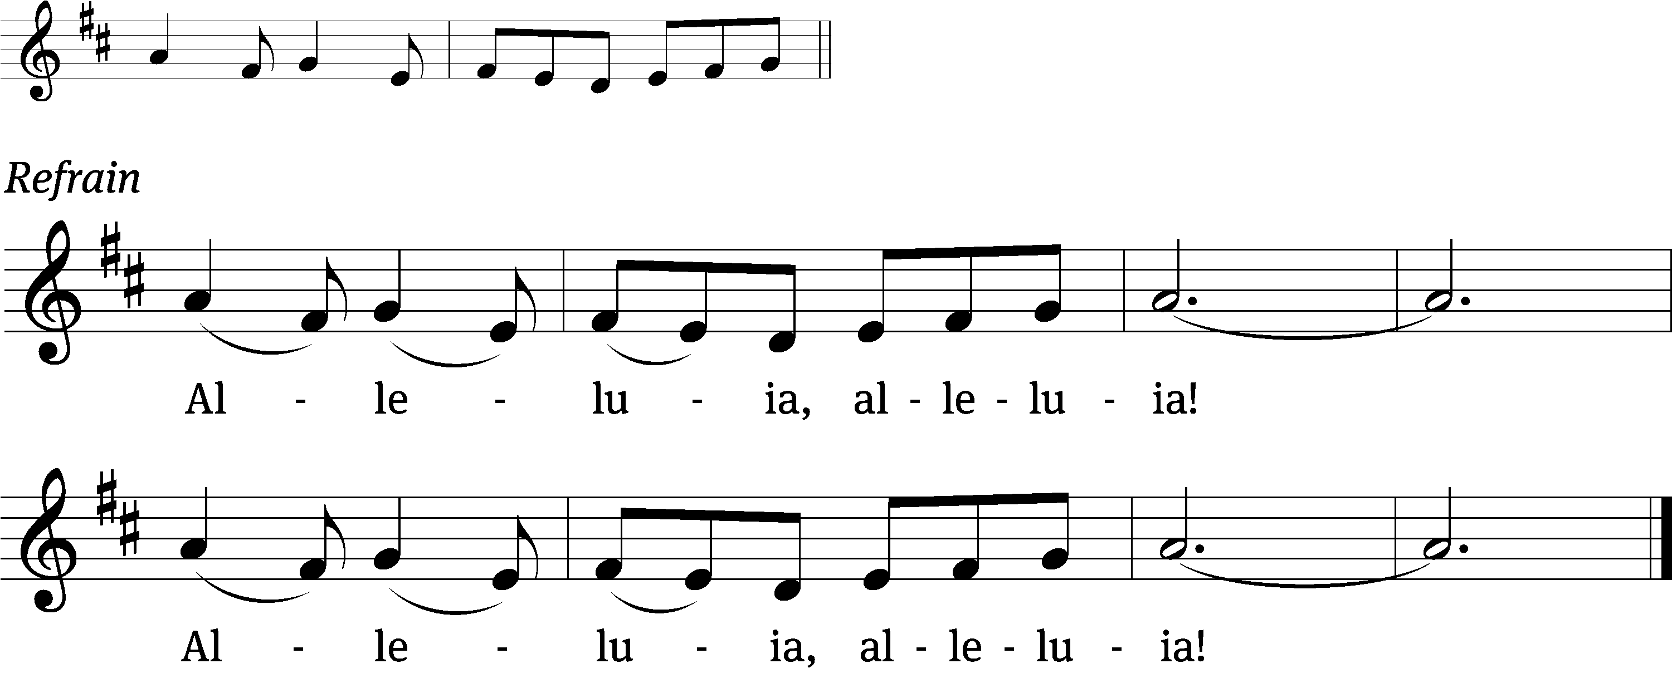

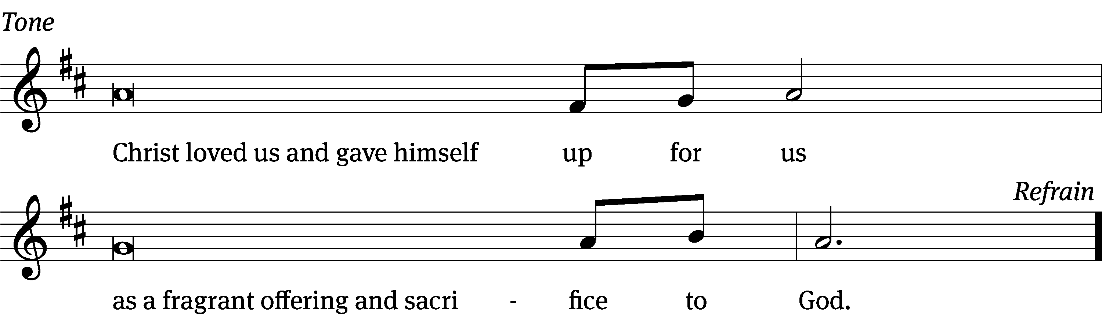

Tune: © 2010, 2021 GFTSMUSIC Publishing Company, Inc., admin. Music Services. Used by permission: OneLicense no. 722228

Gospel Matthew 5:21–37

21“You have heard that it was said to the people long ago, ‘You shall not murder, and anyone who murders will be subject to judgment.’ 22But I tell you that anyone who is angry with a brother or sister will be subject to judgment. Again, anyone who says to a brother or sister, ‘Raca,’ is answerable to the court. And anyone who says, ‘You fool!’ will be in danger of the fire of hell.

23“Therefore, if you are offering your gift at the altar and there remember that your brother or sister has something against you, 24leave your gift there in front of the altar. First go and be reconciled to them; then come and offer your gift.

25“Settle matters quickly with your adversary who is taking you to court. Do it while you are still together on the way, or your adversary may hand you over to the judge, and the judge may hand you over to the officer, and you may be thrown into prison. 26Truly I tell you, you will not get out until you have paid the last penny.

27“You have heard that it was said, ‘You shall not commit adultery.’ 28But I tell you that anyone who looks at a woman lustfully has already committed adultery with her in his heart. 29If your right eye causes you to stumble, gouge it out and throw it away. It is better for you to lose one part of your body than for your whole body to be thrown into hell. 30And if your right hand causes you to stumble, cut it off and throw it away. It is better for you to lose one part of your body than for your whole body to go into hell.

31“It has been said, ‘Anyone who divorces his wife must give her a certificate of divorce.’ 32But I tell you that anyone who divorces his wife, except for sexual immorality, makes her the victim of adultery, and anyone who marries a divorced woman commits adultery.

33“Again, you have heard that it was said to the people long ago, ‘Do not break your oath, but fulfill to the Lord the vows you have made.’ 34But I tell you, do not swear an oath at all: either by heaven, for it is God’s throne; 35or by the earth, for it is his footstool; or by Jerusalem, for it is the city of the Great King. 36And do not swear by your head, for you cannot make even one hair white or black. 37All you need to say is simply ‘Yes’ or ‘No’; anything beyond this comes from the evil one.

The Gospel of the Lord.

**Praise be to you, O Christ!**

Be seated

696 Take My Life and Let It Be CW 696

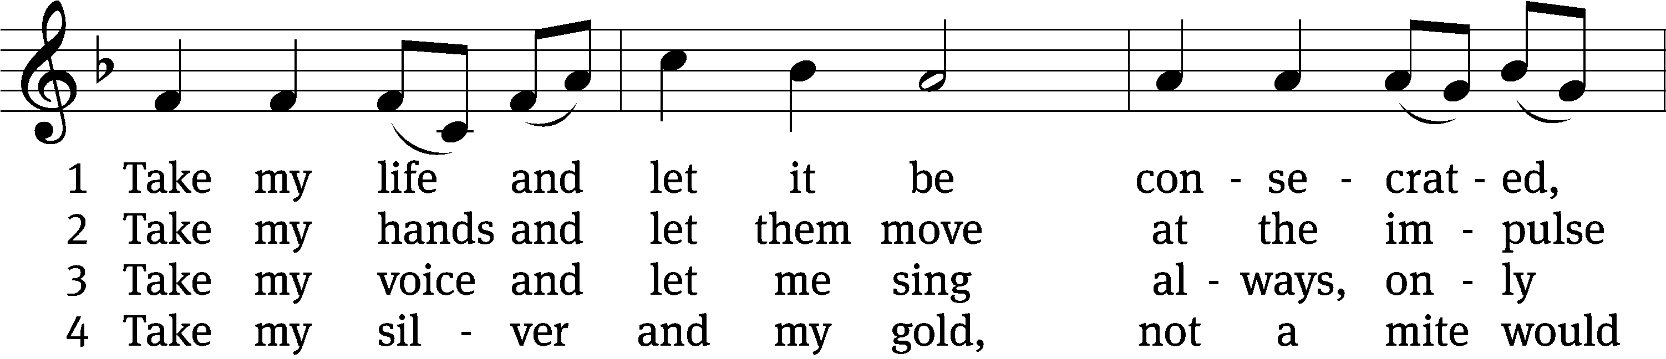

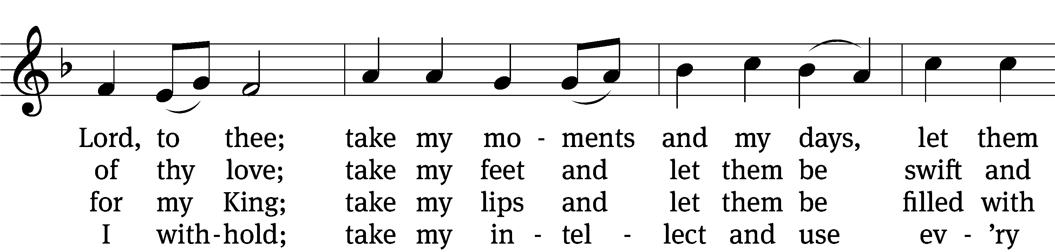

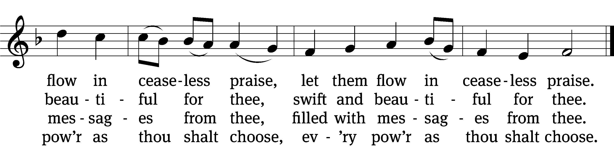

5 Take my will and make it thine,  
it shall be no longer mine;  
take my heart, it is thine own,  
it shall be thy royal throne,  
it shall be thy royal throne.

6 Take my love, my Lord, I pour  
at thy feet its treasure store;  
take myself, and I will be  
ever, only, all for thee,  
ever, only, all for thee.

Text: Frances R. Havergal, 1836–1879  
Text and tune: Public domain

Sermon

Stand

Nicene Creed

**We believe in one God, the Father, the Almighty,**

**maker of heaven and earth,**

**of all that is,**

**seen and unseen.**

**We believe in one Lord, Jesus Christ, the only Son of God,**

**eternally begotten of the Father,**

**God from God, Light from Light, true God from true God,**

**begotten, not made,**

**of one being with the Father.**

**Through him all things were made.**

**For us and for our salvation, he came down from heaven,**

**was incarnate of the Holy Spirit and the Virgin Mary,**

**and became truly human.**

**For our sake he was crucified under Pontius Pilate.**

**He suffered death and was buried.**

**On the third day he rose again in accordance with the Scriptures.**

**He ascended into heaven**

**and is seated at the right hand of the Father.**

**He will come again in glory to judge the living and the dead,**

**and his kingdom will have no end.**

**We believe in the Holy Spirit,**

**the Lord, the giver of life,**

**who proceeds from the Father and the Son,**

**who in unity with the Father and the Son**   
 **is worshiped and glorified,**

**who has spoken through the prophets.**

**We believe in one holy Christian and apostolic Church.**

**We acknowledge one baptism for the forgiveness of sins.**

**We look for the resurrection of the dead**

**and the life of the world to come. Amen.**

Be seated

Prayer of the Church

*Brief intercessory prayers may be added in a fitting place.*

Loving God and Lord, you created the universe that surrounds us and the globe on which we live. You control all things through your Son, who sits at your right hand in glory.

**Comfort us with the promise of your eternal presence.**

Give your Word power as it works in our hearts and minds. Clear away our confusion, and demolish our doubts. Send your Spirit to strengthen both our confidence in your promises and our desire to live according to your will.

**Take away our love of sinning, and restore us each day by your grace.**

The signs of the times warn us that the end of time is near. Protect us from scoffers who sneer at your truth. Spare us and Christians around the world from all forms of hate and persecution.

**Give us courage to carry the cross with patience and joy.**

Instill in the hearts of our children a desire to follow you as they prepare for future days. Help them distinguish between what is passing and what is eternal, between instant thrills and lasting joy. Encourage more young people to prepare for service in the public ministry of the gospel.

**Mold us and move us to be good examples for our youth.**

Hold in your care, Lord, those who are experiencing physical or emotional pain and all who are afflicted by disease or facing death. [Especially bless . . . *here name the person and the cause of the petition.*] Pour out your compassion on the grieving, and comfort the mourners who miss someone they loved.

**Move us to pray for these brothers and sisters and to help when we can.**

Hear us, Lord, as we pray in silence.

*Silent prayer*

Whether we pray together or alone, you have promised to hear and answer us. Give us patience to accept your blessings in whatever way you send them. In your love and wisdom, prepare us for the day when you will take us to be with you forever.

**Hear us for Jesus’ sake. Amen.**

Offering

# The Sacrament

Stand

Preface CW 199

The Lord be with you.

**And also with you.**

Lift up your hearts.

**We lift them up to the Lord.**

Let us give thanks to the Lord our God.

**It is right to give him thanks and praise.**

It is truly good and right that we should at all times and in all places give you thanks, O Lord, holy Father, almighty and everlasting God, through Jesus Christ our Lord, who lived among us as a human being and revealed his glory as your only Son, full of grace and truth. Therefore, with all the saints on earth and hosts of heaven, we praise your holy name and join their glorious song:

Holy, Holy, Holy CW 200

Holy, holy, holy Lord God of hosts,

heaven and earth are full, full of your glory.

Hosanna, hosanna in the highest.

Blessed is he who comes in the name of the Lord.

Hosanna, hosanna in the highest.

Hosanna, hosanna in the highest.

Prayer of Thanksgiving

Blessed are you, Lord God, eternal King and gracious Father. In love you made us the crown of your creation. In mercy you planned our salvation. In grace you sent your Son to redeem us from sin.

We remember and give you thanks that your eternal Son, Jesus Christ, became flesh and made his dwelling among us, that he willingly placed himself under law to redeem those under law, that he humbled himself by becoming obedient to death on a cross, that he has destroyed death and has brought life and immortality to light through the gospel.

Bless us as we receive your Son’s body and blood in this Sacrament. Forgive our sins, increase our faith, strengthen our fellowship, and deepen our longing for the day when Christ will welcome us to his eternal feast. Praise and thanks and honor and glory be to you, O God our Father, and to your Son and to the Holy Spirit, one God, now and forever.

**Amen.**

Lord’s Prayer

**Our Father in heaven,**

**hallowed be your name,**

**your kingdom come,**

**your will be done**

**on earth as in heaven.**

**Give us today our daily bread.**

**Forgive us our sins,**

**as we forgive those**

**who sin against us.**

**Lead us not into temptation,**

**but deliver us from evil.**

**For the kingdom, the power,**

**and the glory are yours**

**now and forever. Amen.**

Words of Institution

Our Lord Jesus Christ, on the night he was betrayed, took bread; and when he had given thanks, he broke it and gave it to his disciples, saying, “Take and eat; this is my T body, which is given for you. Do this in remembrance of me.”

Then he took the cup, gave thanks, and gave it to them, saying, “Drink from it, all of you; this is my T blood of the new covenant, which is poured out for you for the forgiveness of sins. Do this, whenever you drink it, in remembrance of me.”

The peace of the Lord be with you always.

**Amen.**

Lamb of God CW 202

Lamb of God, you take away the sin of the world; have mercy on us.

Lamb of God, you take away the sin of the world; have mercy on us.

Lamb of God, you take away the sin of the world; grant us, grant us peace.

Be seated

Distribution

As he distributes the elements, the minister says to the communicants:

Take and eat; this is the true body of our Lord and Savior Jesus Christ, given into death for your sins.

Take and drink; this is the true blood of our Lord and Savior Jesus Christ, poured out for the forgiveness of your sins.

As he dismisses the communicants, the minister says:

The true body and blood of our Lord Jesus Christ strengthen and preserve you to life everlasting. Go T in peace.

**Amen.**

697 May We Your Precepts, Lord, Fulfill CW 697

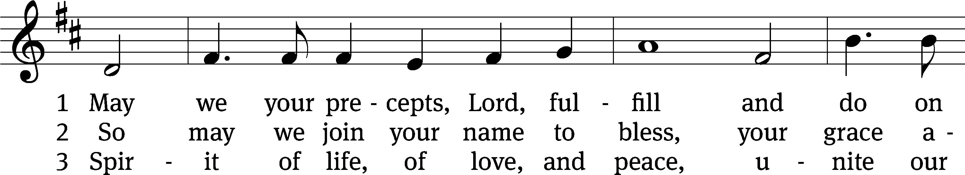

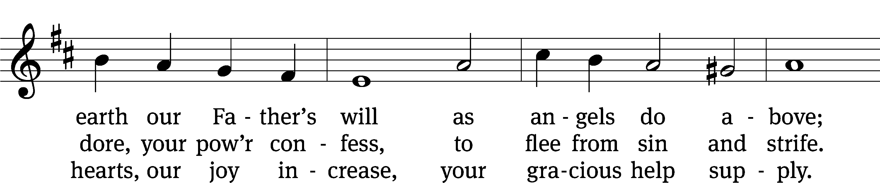

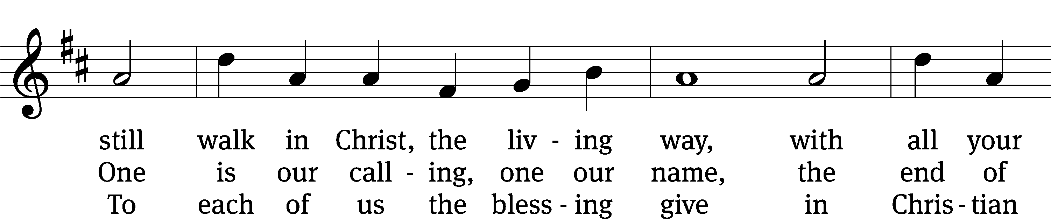

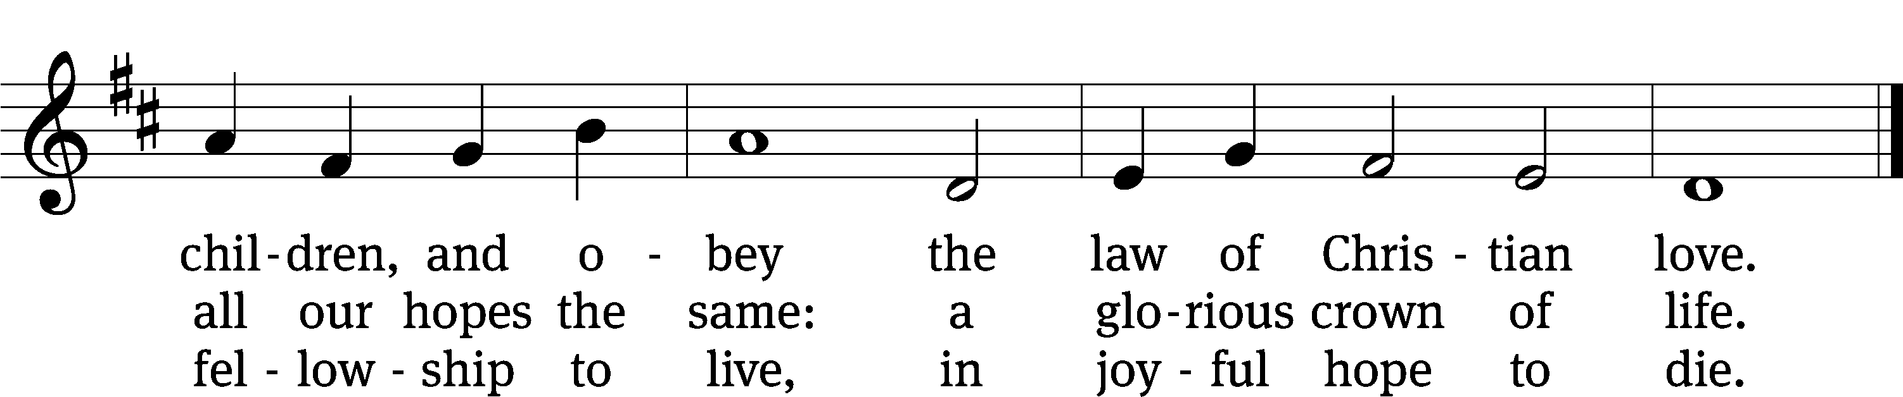

Text: Edward Osler, 1789–1863, alt.  
Tune: Lowell Mason, 1792–1872  
Text and tune: Public domain

Stand

Give thanks to the Lord, for he is good;

**his mercy endures forever.**

Whenever we eat this bread and drink this cup,

**we proclaim the Lord’s death until he comes.**

O God the Father, source of all goodness, in your loving-kindness you sent your Son to share our humanity. We thank you that through him you have given us pardon and peace in this Sacrament. We also pray that you will not forsake us but will rule our hearts and minds by your Holy Spirit so that we willingly serve you day after day; through Jesus Christ our Lord, who lives and reigns with you and the Holy Spirit, one God, now and forever.

**Amen.**

Blessing

The Lord bless you and keep you.

The Lord make his face shine on you and be gracious to you.

The Lord look on you with favor and T give you peace.

**Amen.**

803 Day by Day CW 803

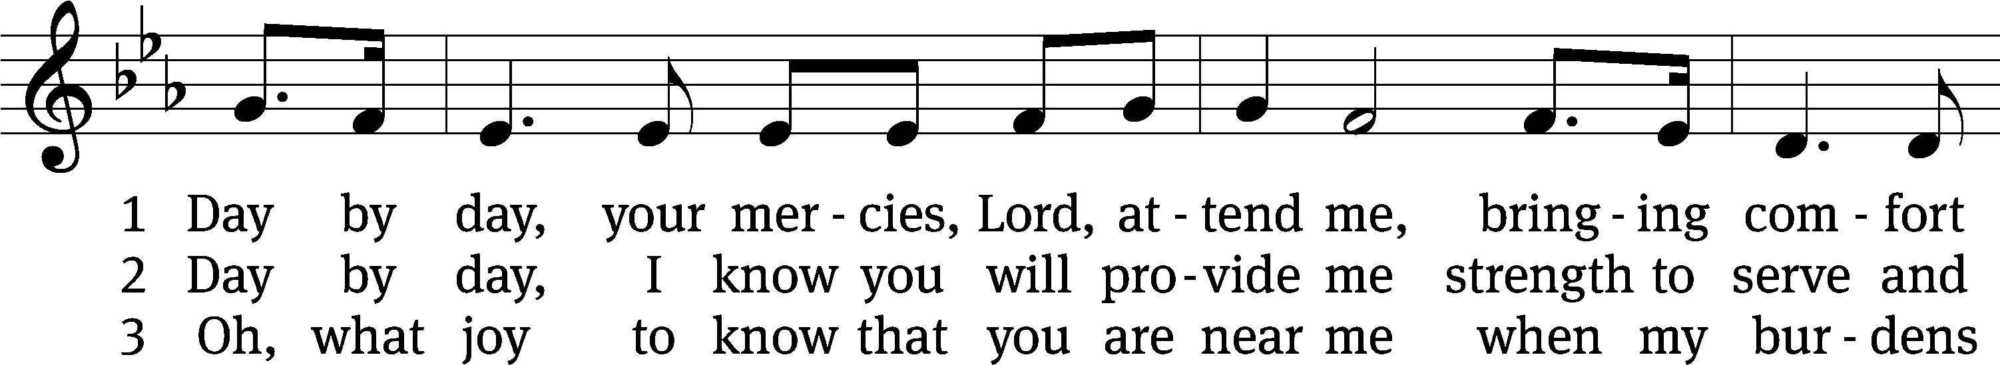

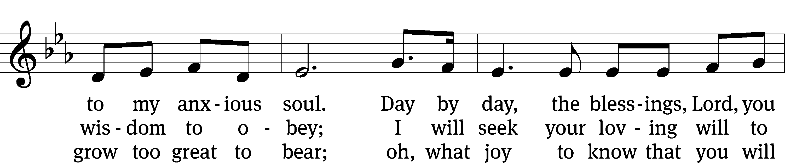

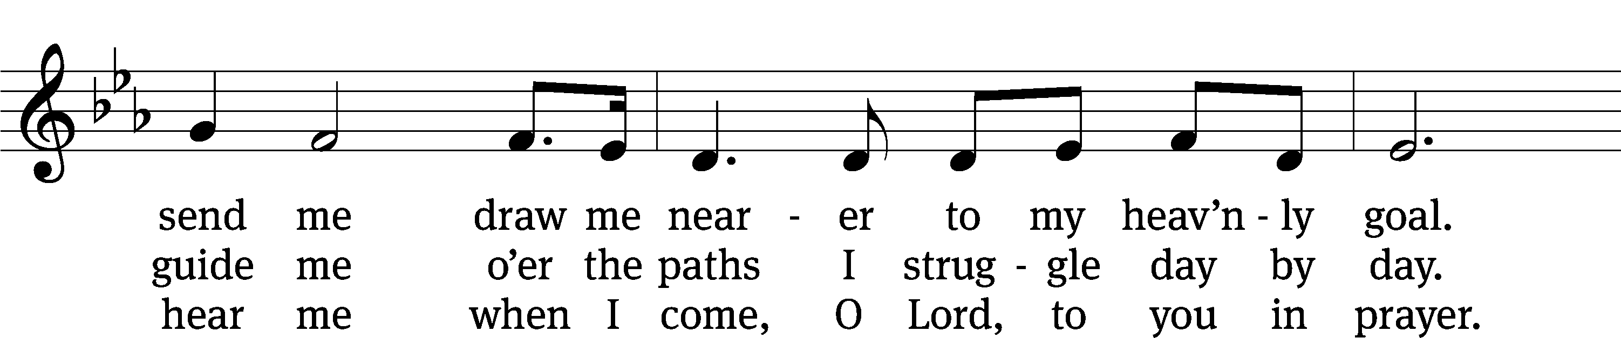

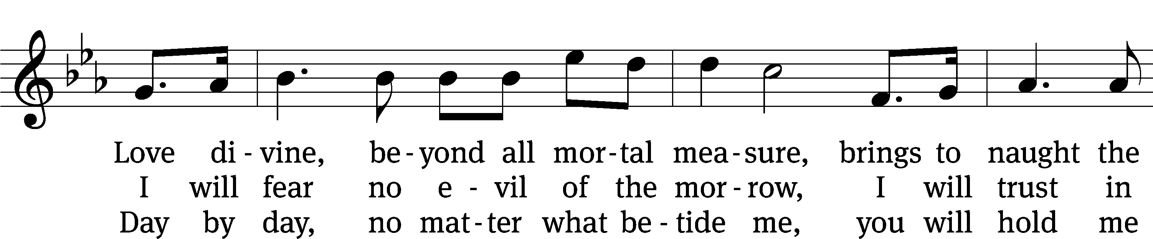

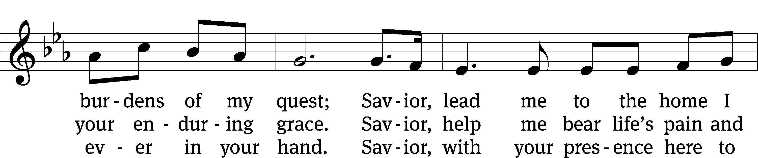

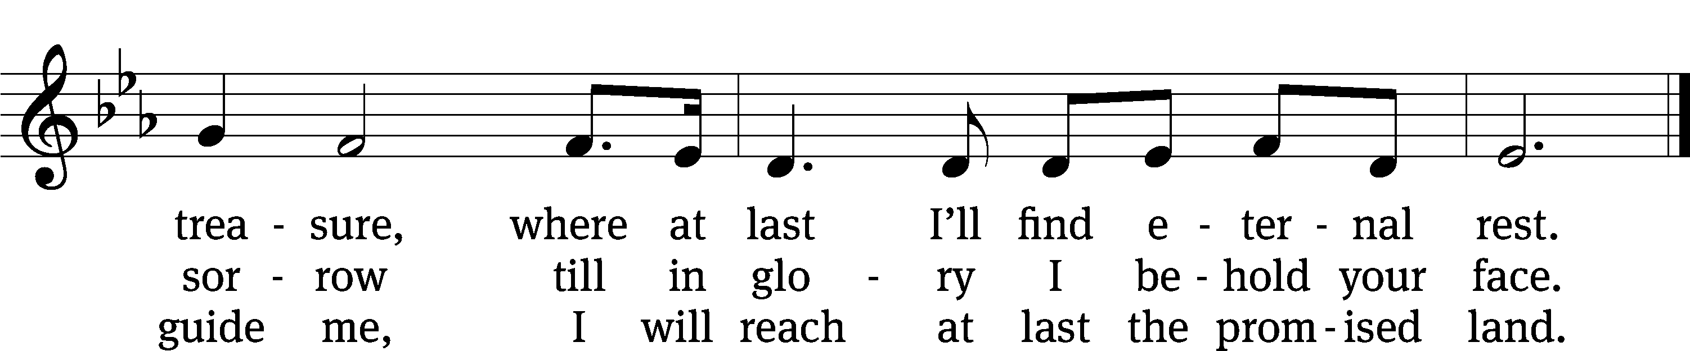

Text: tr. Robert Leaf, 1936–2005; Carolina Sandell Berg, 1832–1903  
Tune: Oskar Ahnfelt, 1813–1882  
Text: © 1992 Augsburg Fortress. Used by permission: OneLicense no. 722228  
Tune: Public domain

Acknowledgments

Setting Three from Christian Worship

Unless otherwise indicated, Scripture quotations are from The Holy Bible, New International Version®, NIV®. Copyright © 1973, 1978, 1984, 2011 by Biblica, Inc.TM Used by permission of Zondervan. All rights reserved worldwide.

Software distributed in partnership with Northwestern Publishing House.

Created by Christian Worship: Service Builder © 2023 Concordia Publishing House.