602 Great Is Thy Faithfulness CW 602

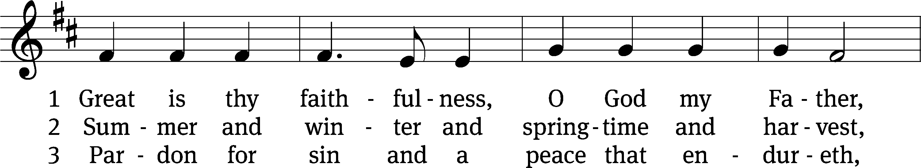

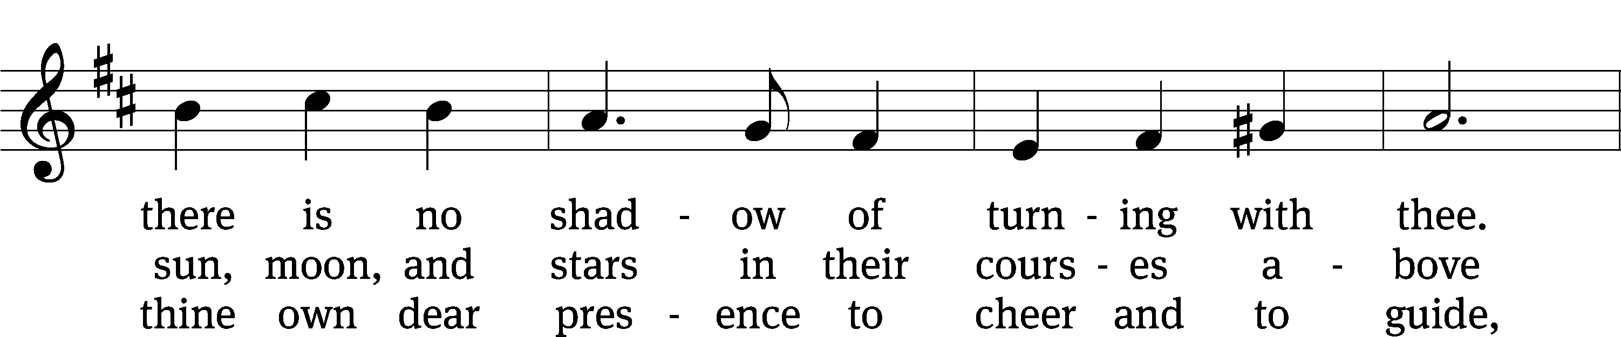

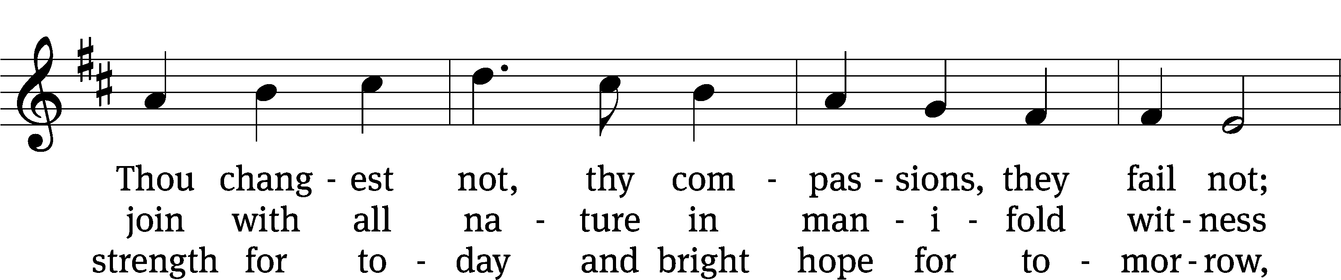

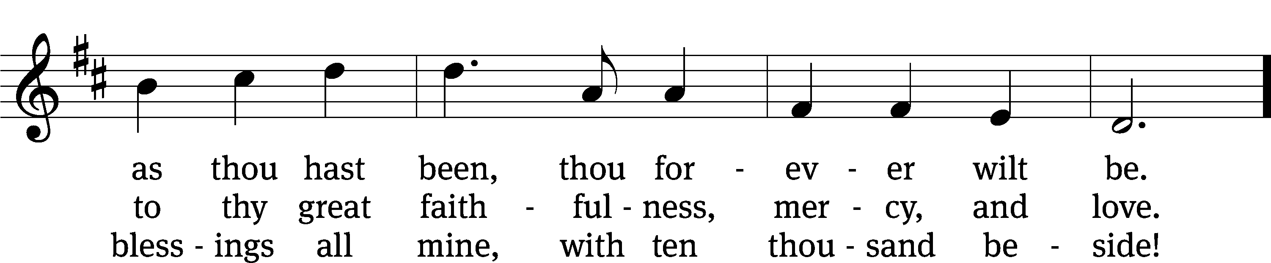

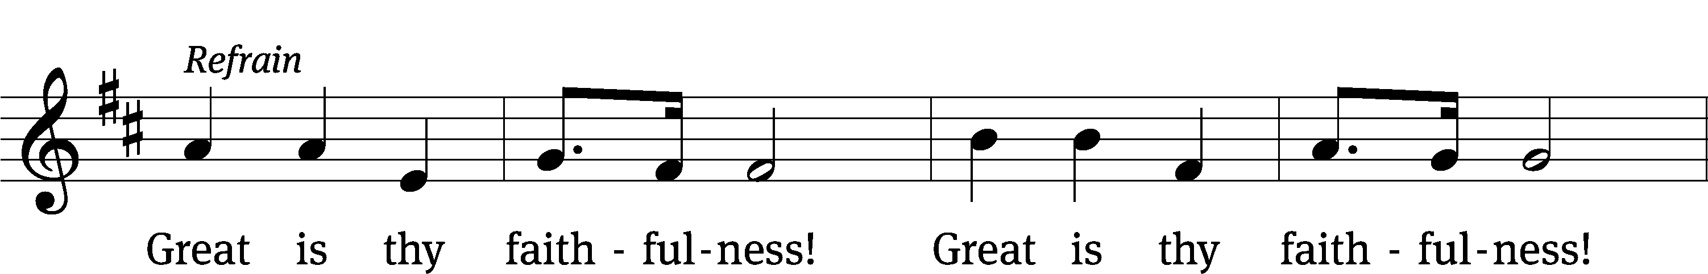

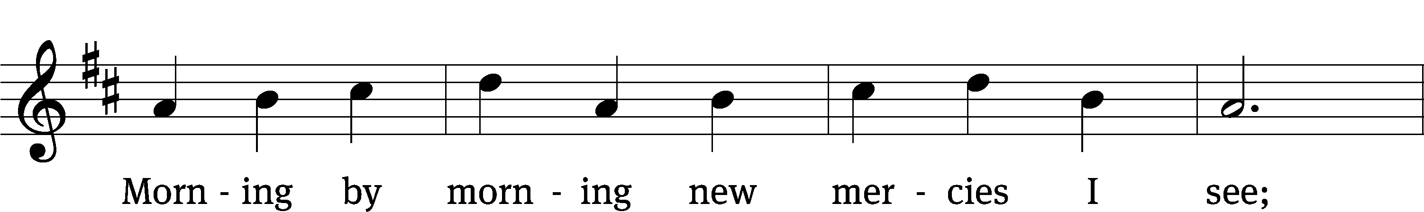

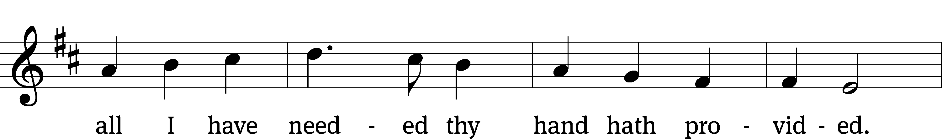

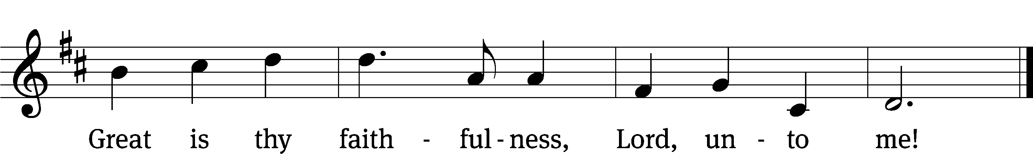

Text: Thomas O. Chisolm, 1866–1960  
Tune: William M. Runyan, 1870–1957  
Text and tune: Public domain

Stand

In the name of the Father and of the T Son and of the Holy Spirit.

**Amen.**

Confession CW 155

Blessed are they whose transgressions are forgiven, whose sins are covered.

**Blessed are they whose sin the Lord does not count against them.**

Let us confess our sins to the Lord.

**Almighty and merciful Father,**   
 **we have strayed from your ways like lost sheep.**

**We have followed what we have devised and desired in our hearts.**   
 **We have offended you and sinned against your holy law.**   
 **We have done those things that we should not have done,**   
 **and we have not done those things that we should have done.**   
 **Have mercy on us, Lord!**   
 **Spare us, forgive us, and restore us,**   
 **according to your promises in Christ Jesus.**

Silence for meditation and reflection

God, our merciful Father, has forgiven all our sins. He sent his Son, Jesus Christ, to be our Redeemer and Savior. Jesus paid the penalty for our guilt by his death on the cross and freed us from death by his resurrection from the grave. We have peace with God now and forever.

**Amen.**

Lord, Have Mercy

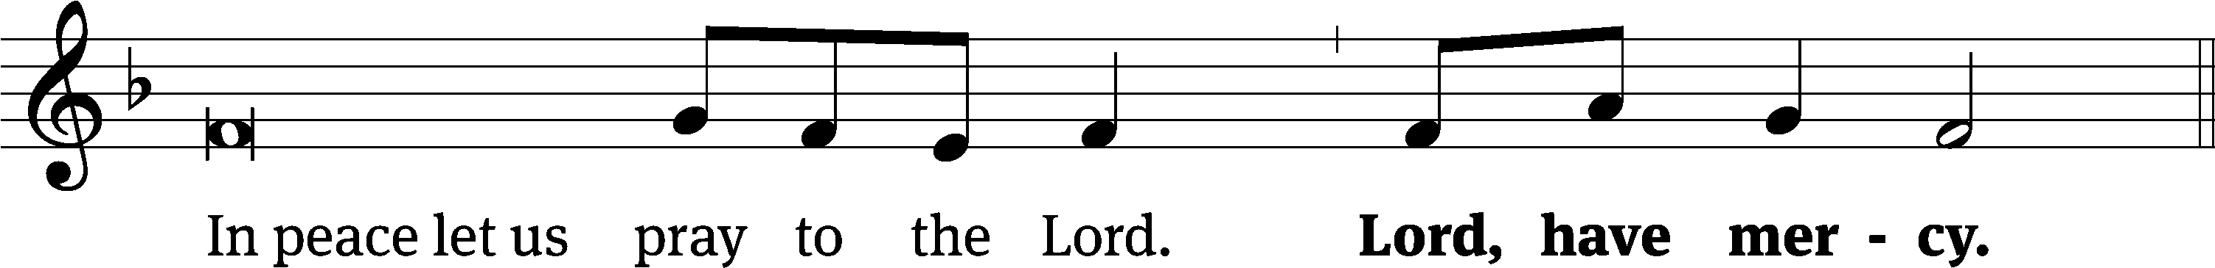

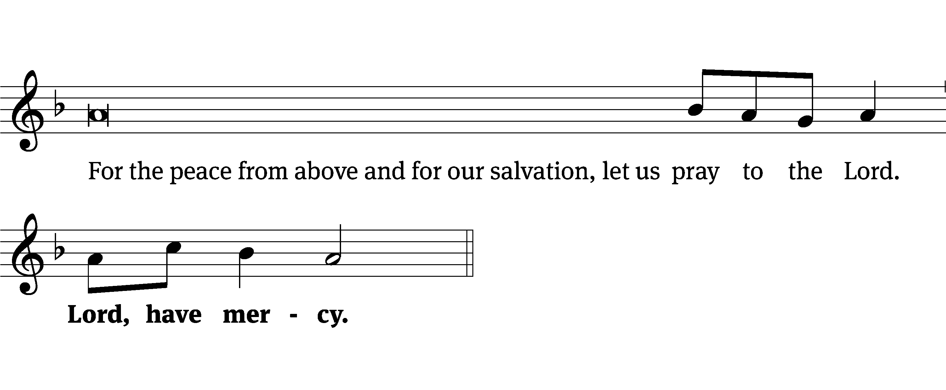

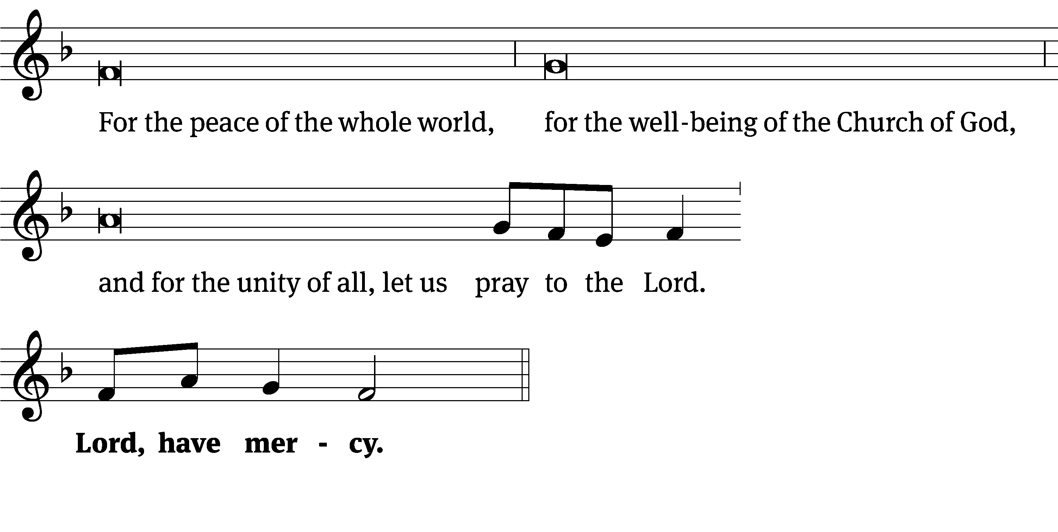

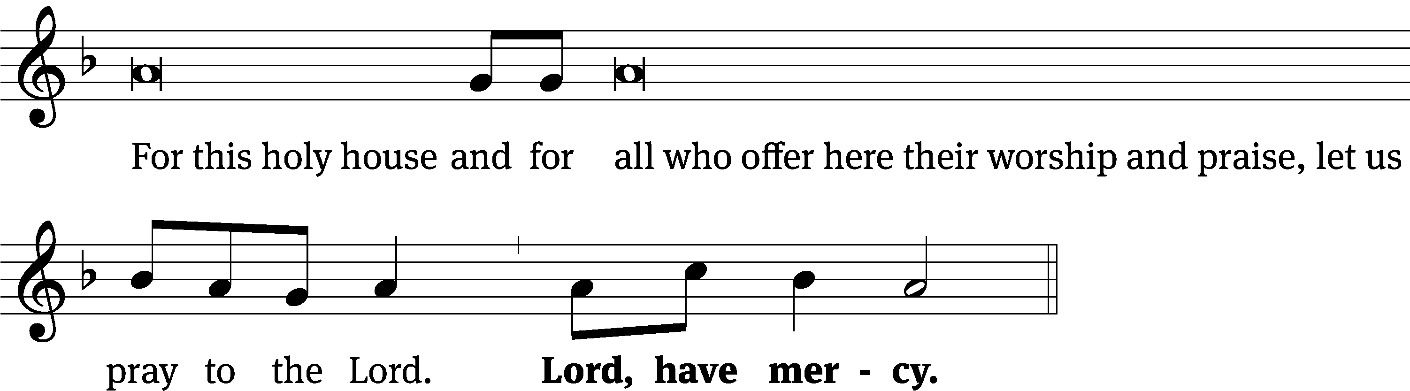

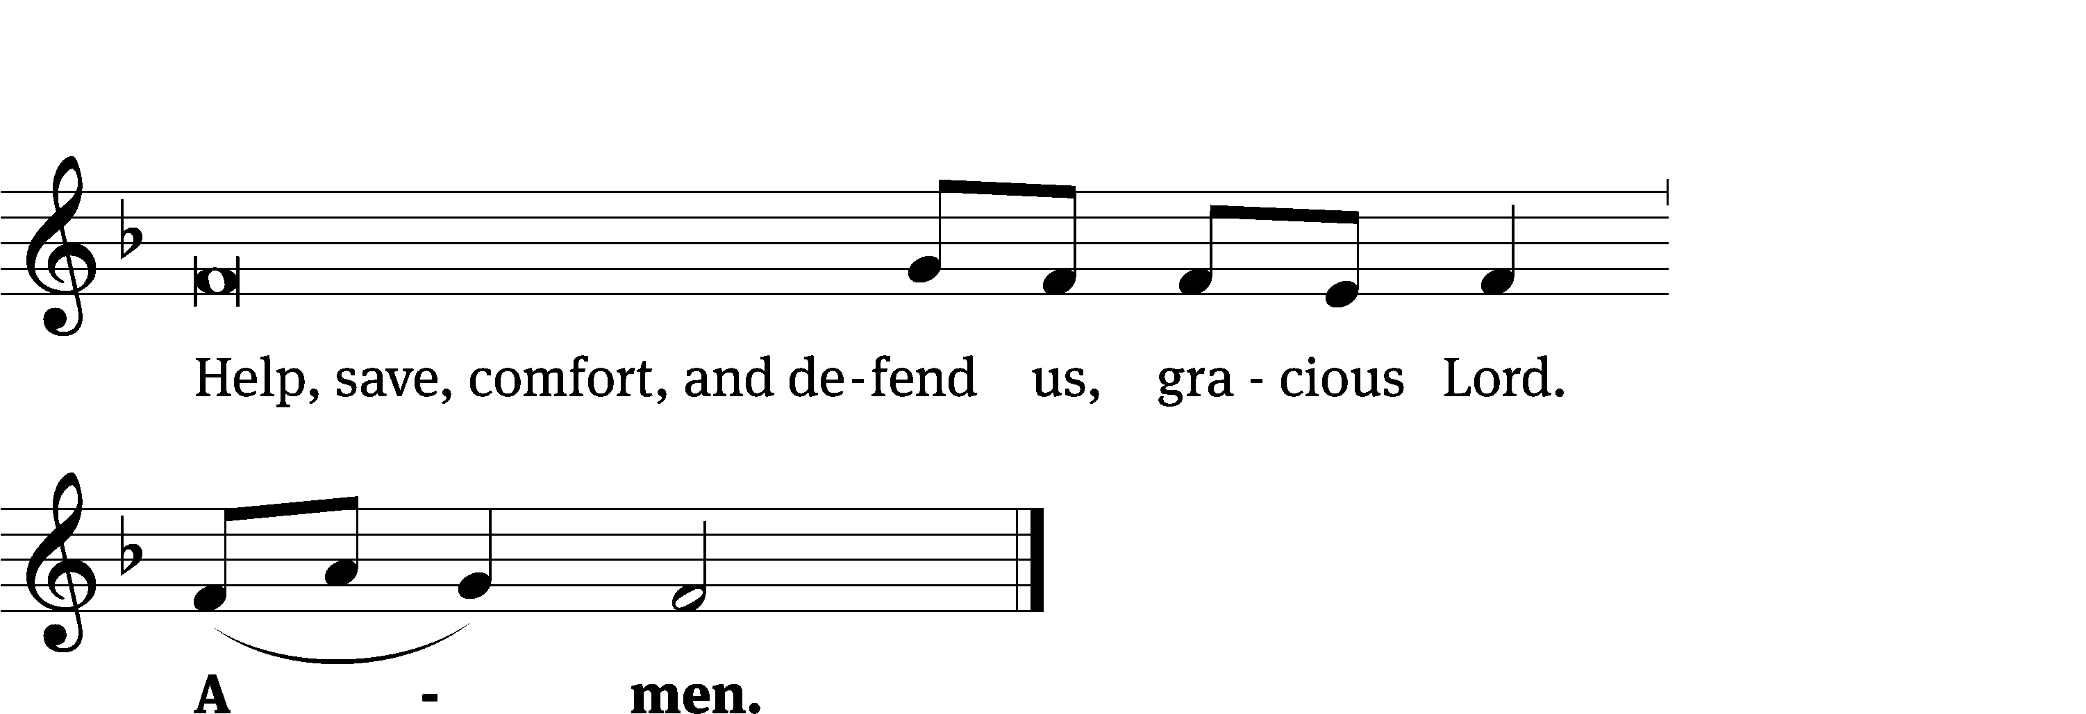

Tune: Kevin Becker  
Tune: © 2021 Northwestern Publishing House. Used by permission: OneLicense no. 722228

Glory Be to God on High CW 157

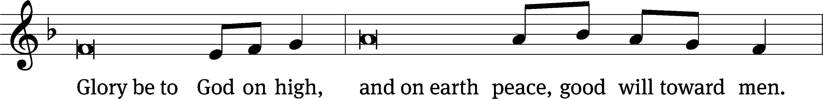

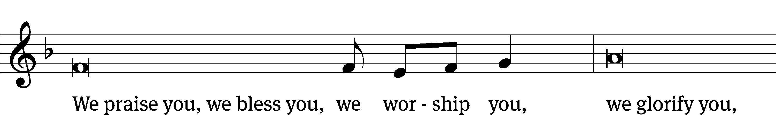

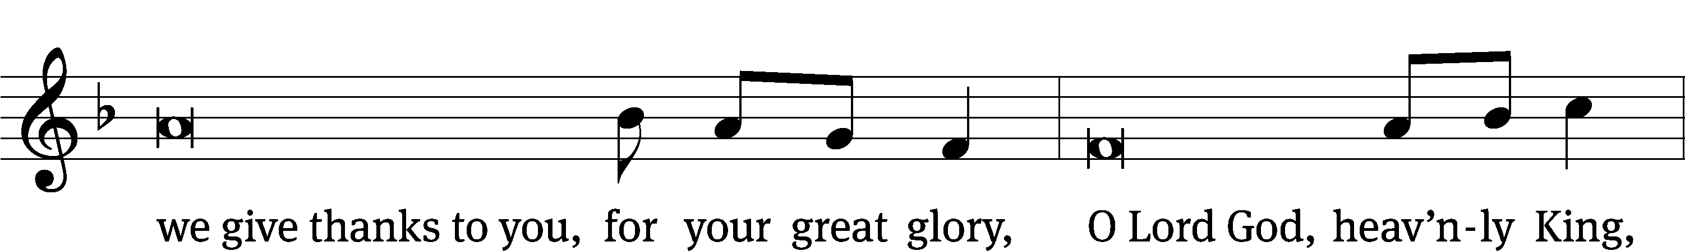

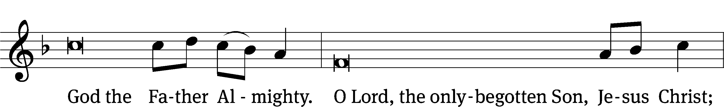

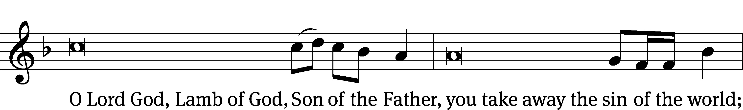

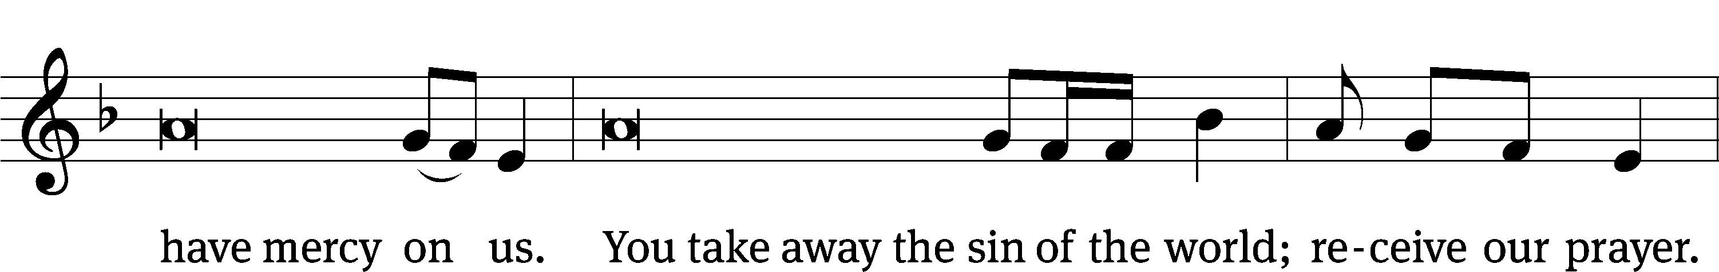

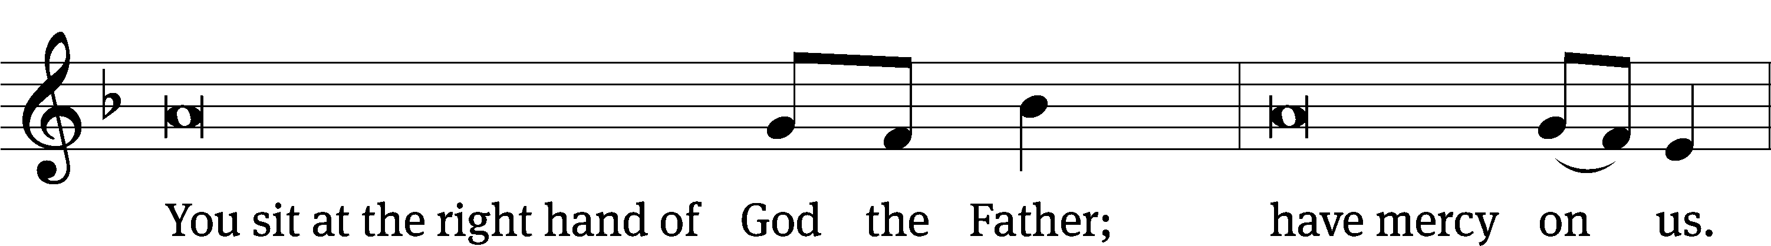

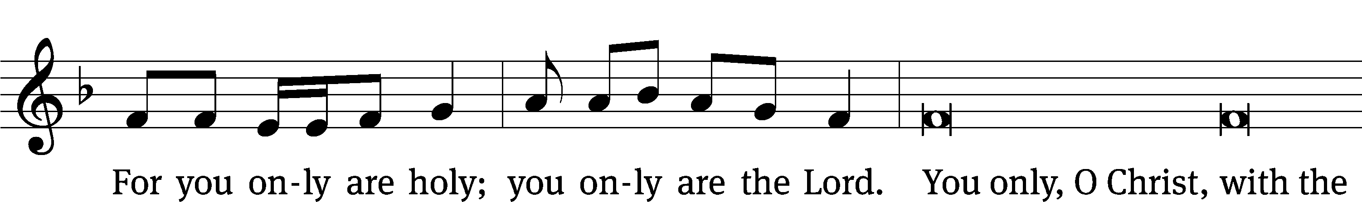

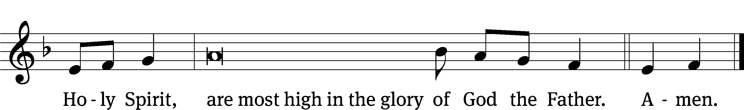

# The Word

The Lord be with you.

**And also with you.**

Prayer of the Day

Let us pray.

Lord God, you call us to work in your kingdom and promise to reward us according to your grace. Help us to rid our minds of worldly expectations and rejoice that you freely pour out the blessings of salvation to all people; through the merits of Jesus Christ our Lord, who lives and reigns with you and the Holy Spirit, one God, now and forever.

**Amen.**

Be seated

First Reading Jonah 3:10—4:11

10When God saw what they did and how they turned from their evil ways, he relented and did not bring on them the destruction he had threatened.

1But to Jonah this seemed very wrong, and he became angry. 2He prayed to the Lord, “Isn’t this what I said, Lord, when I was still at home? That is what I tried to forestall by fleeing to Tarshish. I knew that you are a gracious and compassionate God, slow to anger and abounding in love, a God who relents from sending calamity. 3Now, Lord, take away my life, for it is better for me to die than to live.”

4But the Lord replied, “Is it right for you to be angry?”

5Jonah had gone out and sat down at a place east of the city. There he made himself a shelter, sat in its shade and waited to see what would happen to the city. 6Then the Lord God provided a leafy plant and made it grow up over Jonah to give shade for his head to ease his discomfort, and Jonah was very happy about the plant. 7But at dawn the next day God provided a worm, which chewed the plant so that it withered. 8When the sun rose, God provided a scorching east wind, and the sun blazed on Jonah’s head so that he grew faint. He wanted to die, and said, “It would be better for me to die than to live.”

9But God said to Jonah, “Is it right for you to be angry about the plant?”

“It is,” he said. “And I’m so angry I wish I were dead.”

10But the Lord said, “You have been concerned about this plant, though you did not tend it or make it grow. It sprang up overnight and died overnight. 11And should I not have concern for the great city of Nineveh, in which there are more than a hundred and twenty thousand people who cannot tell their right hand from their left—and also many animals?”

The Word of the Lord.

**Thanks be to God.**

115A Not to Us, O LORD Psalm 115A

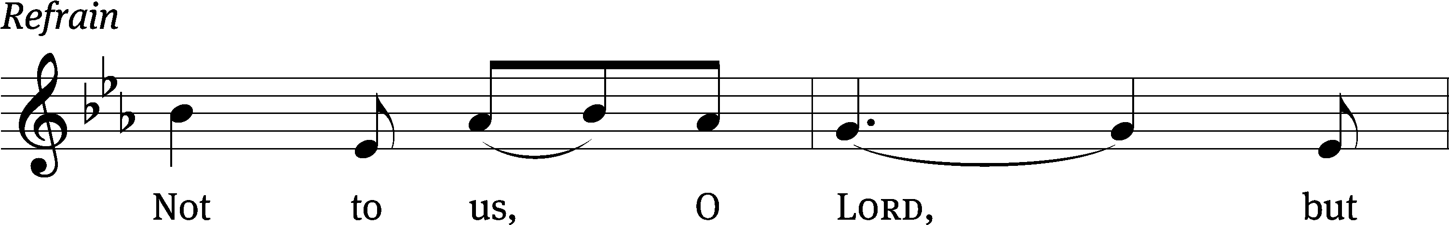

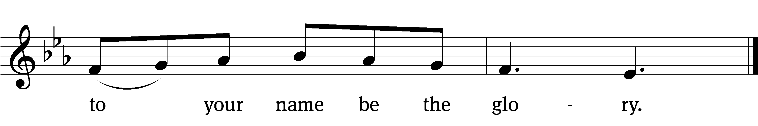



Why do the nations say, “Where / is their God?”  
 Our God is in heaven; he does whatever / pleases him.  
The Lord remembers us and will / bless us:  
 He will bless his people / Israel,  
he will bless those who / fear the Lord—  
 small and / great alike. *Refrain*

All you Israelites, trust / in the Lord—  
 he is their / help and shield.  
House of Aaron, trust / in the Lord—  
 he is their / help and shield.  
You who fear him, trust / in the Lord—  
 he is their / help and shield.  
**Glory be to the Father and** / **to the Son**  
 **and to the Holy** / **Spirit,**  
**as it was in the be-** / **ginning,**  
 **is now, and will be forever.** / **Amen.** *Refrain*

Tune: Michael D. Schultz  
Setting: Michael D. Schultz  
Music: © 2021 Northwestern Publishing House. Used by permission: OneLicense no. 722228

Second Reading Romans 9:6–16

6It is not as though God’s word had failed. For not all who are descended from Israel are Israel. 7Nor because they are his descendants are they all Abraham’s children. On the contrary, “It is through Isaac that your offspring will be reckoned.” 8In other words, it is not the children by physical descent who are God’s children, but it is the children of the promise who are regarded as Abraham’s offspring. 9For this was how the promise was stated: “At the appointed time I will return, and Sarah will have a son.”

10Not only that, but Rebekah’s children were conceived at the same time by our father Isaac. 11Yet, before the twins were born or had done anything good or bad—in order that God’s purpose in election might stand: 12not by works but by him who calls—she was told, “The older will serve the younger.” 13Just as it is written: “Jacob I loved, but Esau I hated.”

14What then shall we say? Is God unjust? Not at all! 15For he says to Moses,

“I will have mercy on whom I have mercy,  
 and I will have compassion on whom I have compassion.”

16It does not, therefore, depend on human desire or effort, but on God’s mercy.

The Word of the Lord.

**Thanks be to God.**

Stand

Gospel Acclamation Ephesians 2:8

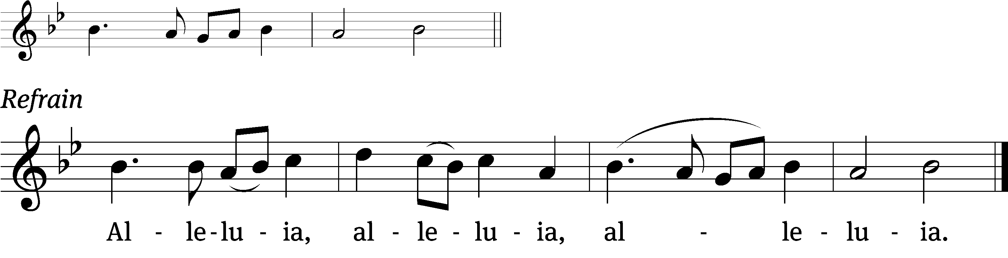

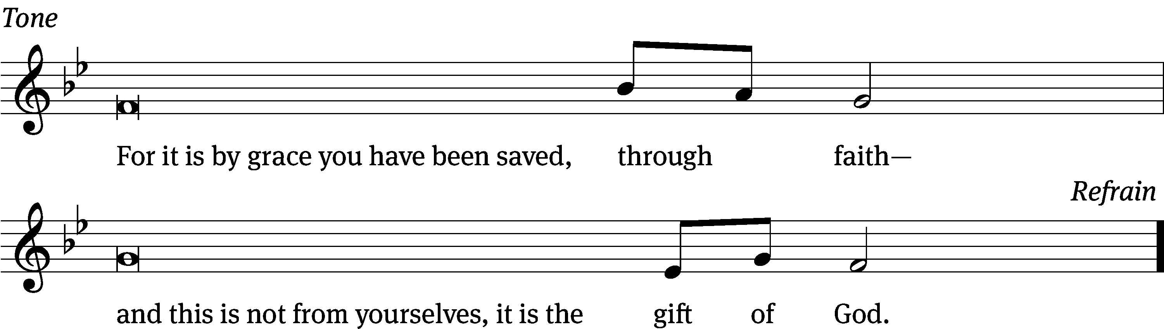

Tune: © 2021 Northwestern Publishing House. Used by permission: OneLicense no. 722228

Gospel Matthew 20:1–16

1“For the kingdom of heaven is like a landowner who went out early in the morning to hire workers for his vineyard. 2He agreed to pay them a denarius for the day and sent them into his vineyard.

3“About nine in the morning he went out and saw others standing in the marketplace doing nothing. 4He told them, ‘You also go and work in my vineyard, and I will pay you whatever is right.’ 5So they went.

“He went out again about noon and about three in the afternoon and did the same thing. 6About five in the afternoon he went out and found still others standing around. He asked them, ‘Why have you been standing here all day long doing nothing?’

7“ ‘Because no one has hired us,’ they answered.

“He said to them, ‘You also go and work in my vineyard.’

8“When evening came, the owner of the vineyard said to his foreman, ‘Call the workers and pay them their wages, beginning with the last ones hired and going on to the first.’

9“The workers who were hired about five in the afternoon came and each received a denarius. 10So when those came who were hired first, they expected to receive more. But each one of them also received a denarius. 11When they received it, they began to grumble against the landowner. 12‘These who were hired last worked only one hour,’ they said, ‘and you have made them equal to us who have borne the burden of the work and the heat of the day.’

13“But he answered one of them, ‘I am not being unfair to you, friend. Didn’t you agree to work for a denarius? 14Take your pay and go. I want to give the one who was hired last the same as I gave you. 15Don’t I have the right to do what I want with my own money? Or are you envious because I am generous?’

16“So the last will be first, and the first will be last.”

The Gospel of the Lord.

**Praise be to you, O Christ!**

Be seated

575 By Grace I’m Saved CW 575

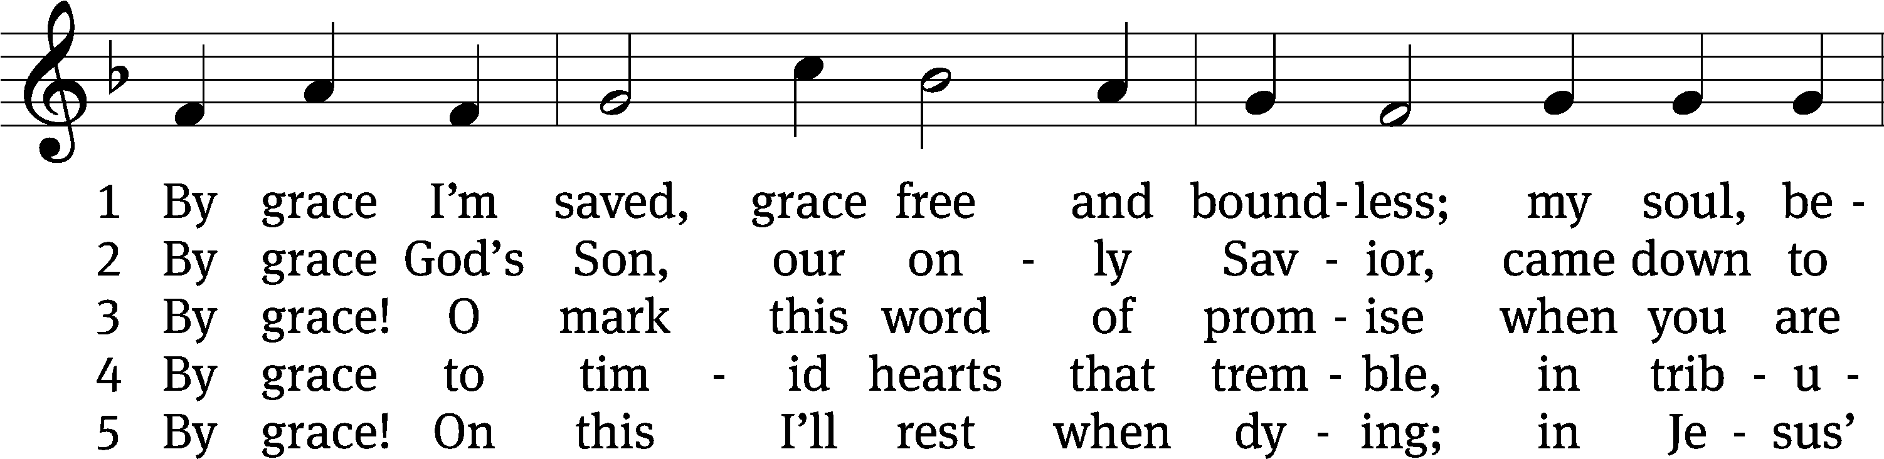

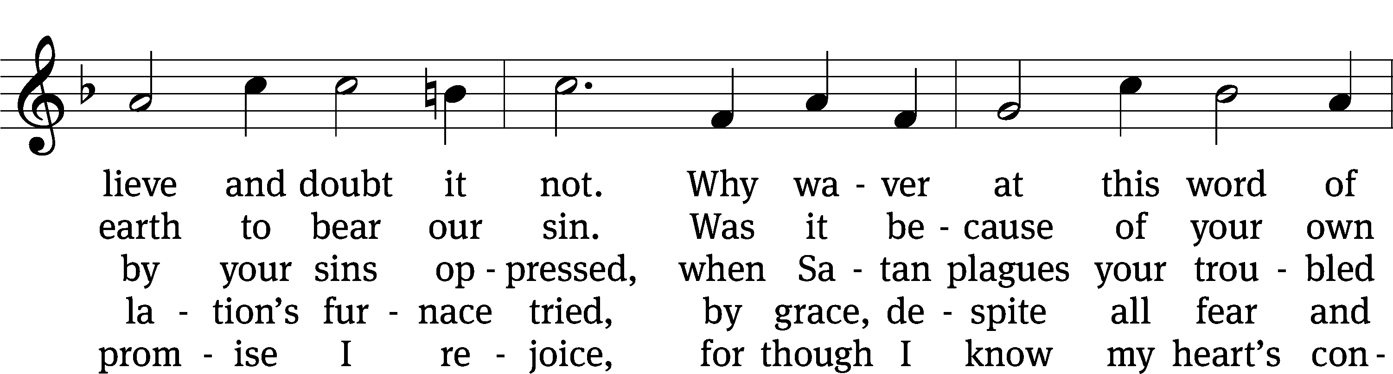

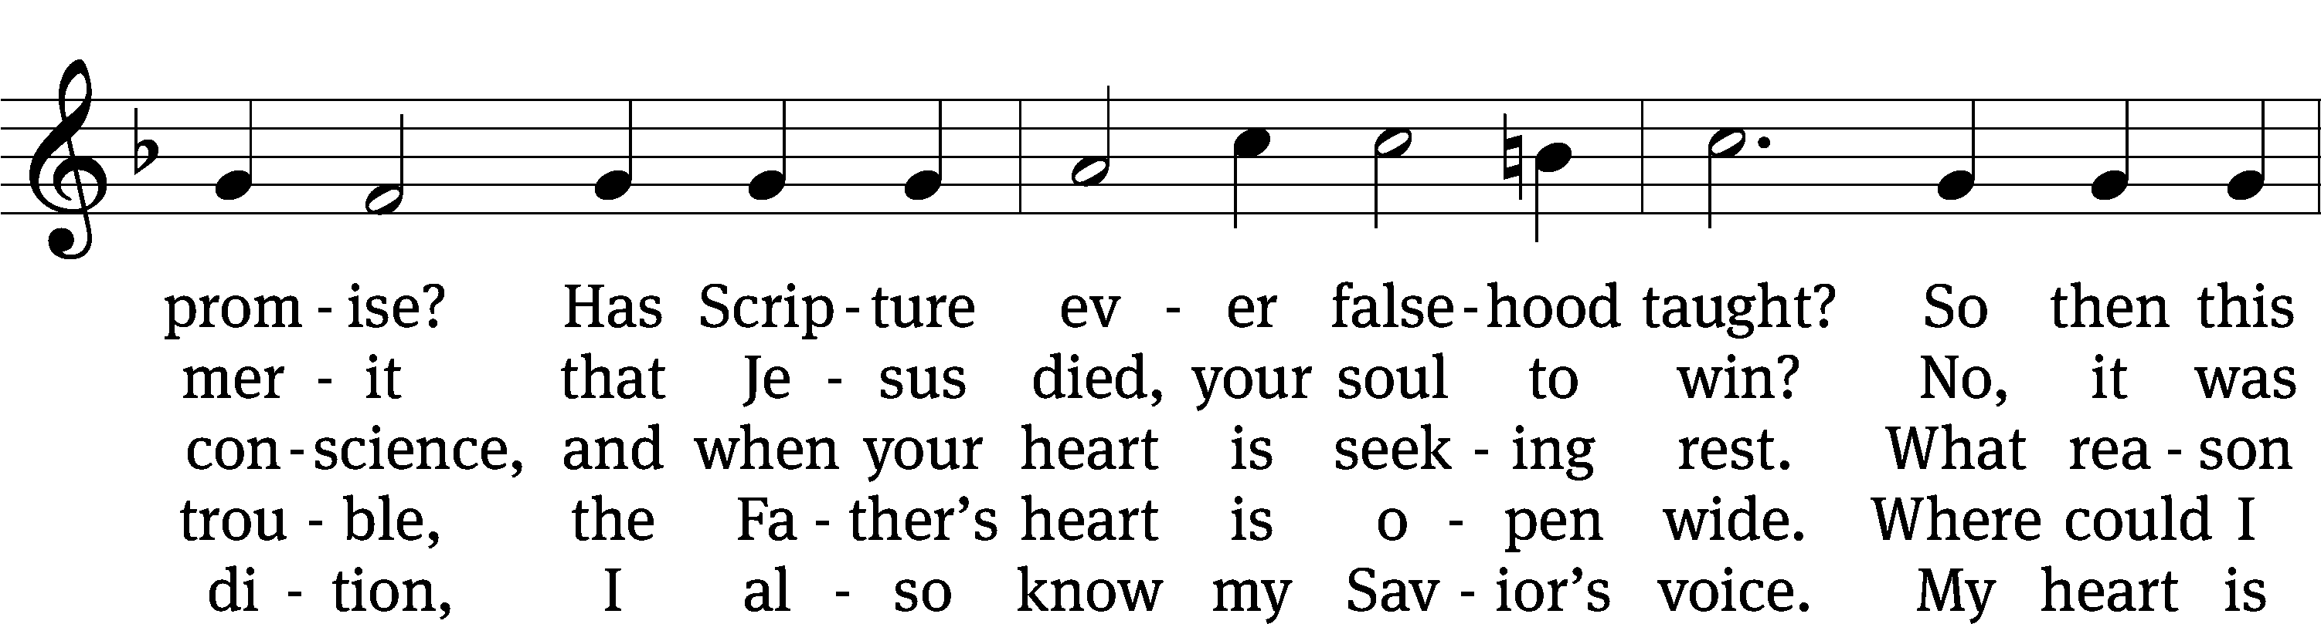

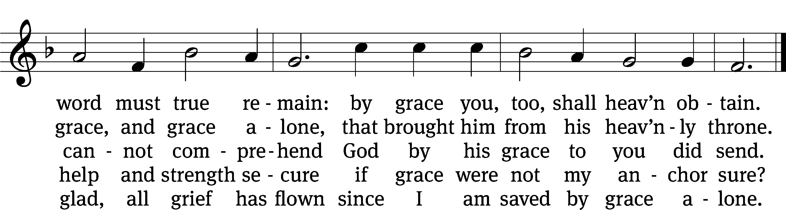

Text: tr. The Lutheran Hymnal, 1941, alt.; Christian L. Scheidt, 1709–1761, abr.  
Tune: Cornelius H. Dretzel, 1697–1775  
Text and tune: Public domain

Sermon

Stand

Nicene Creed

**We believe in one God, the Father, the Almighty,**

**maker of heaven and earth,**

**of all that is,**

**seen and unseen.**

**We believe in one Lord, Jesus Christ, the only Son of God,**

**eternally begotten of the Father,**

**God from God, Light from Light, true God from true God,**

**begotten, not made,**

**of one being with the Father.**

**Through him all things were made.**

**For us and for our salvation, he came down from heaven,**

**was incarnate of the Holy Spirit and the Virgin Mary,**

**and became truly human.**

**For our sake he was crucified under Pontius Pilate.**

**He suffered death and was buried.**

**On the third day he rose again in accordance with the Scriptures.**

**He ascended into heaven**

**and is seated at the right hand of the Father.**

**He will come again in glory to judge the living and the dead,**

**and his kingdom will have no end.**

**We believe in the Holy Spirit,**

**the Lord, the giver of life,**

**who proceeds from the Father and the Son,**

**who in unity with the Father and the Son**   
 **is worshiped and glorified,**

**who has spoken through the prophets.**

**We believe in one holy Christian and apostolic Church.**

**We acknowledge one baptism for the forgiveness of sins.**

**We look for the resurrection of the dead**

**and the life of the world to come. Amen.**

Be seated

Offering

# The Sacrament

Stand

Preface CW 165





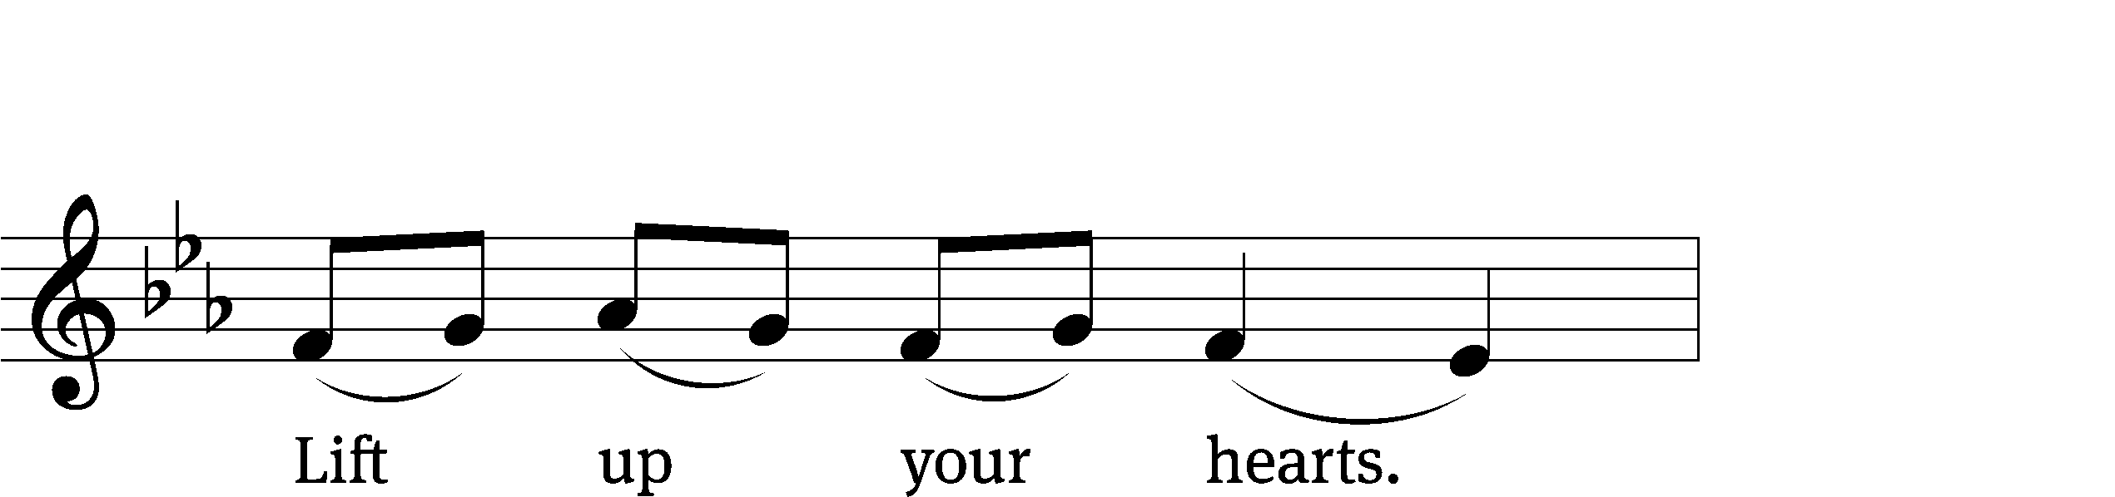



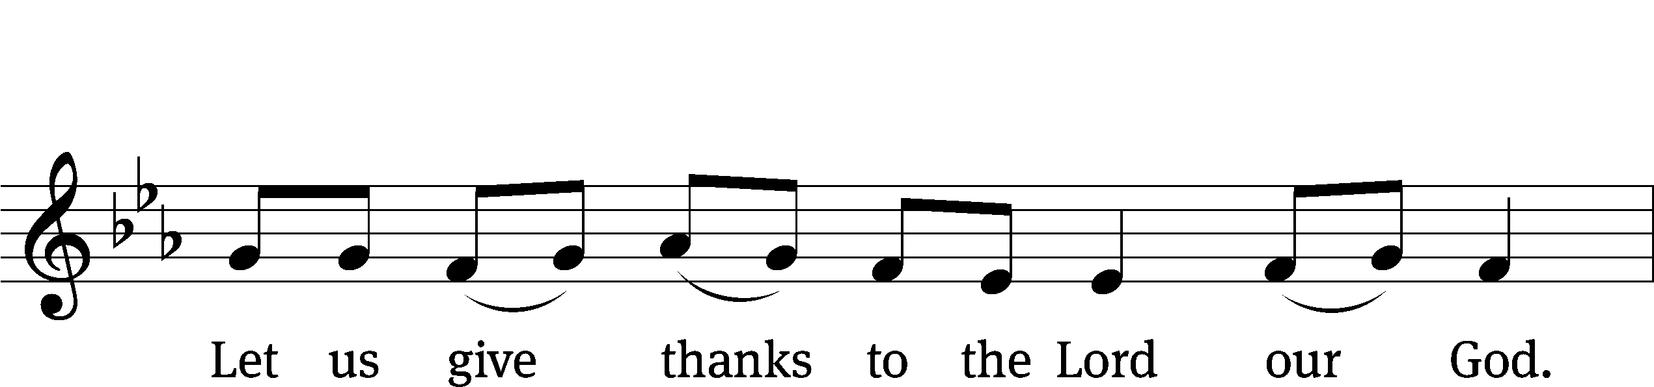

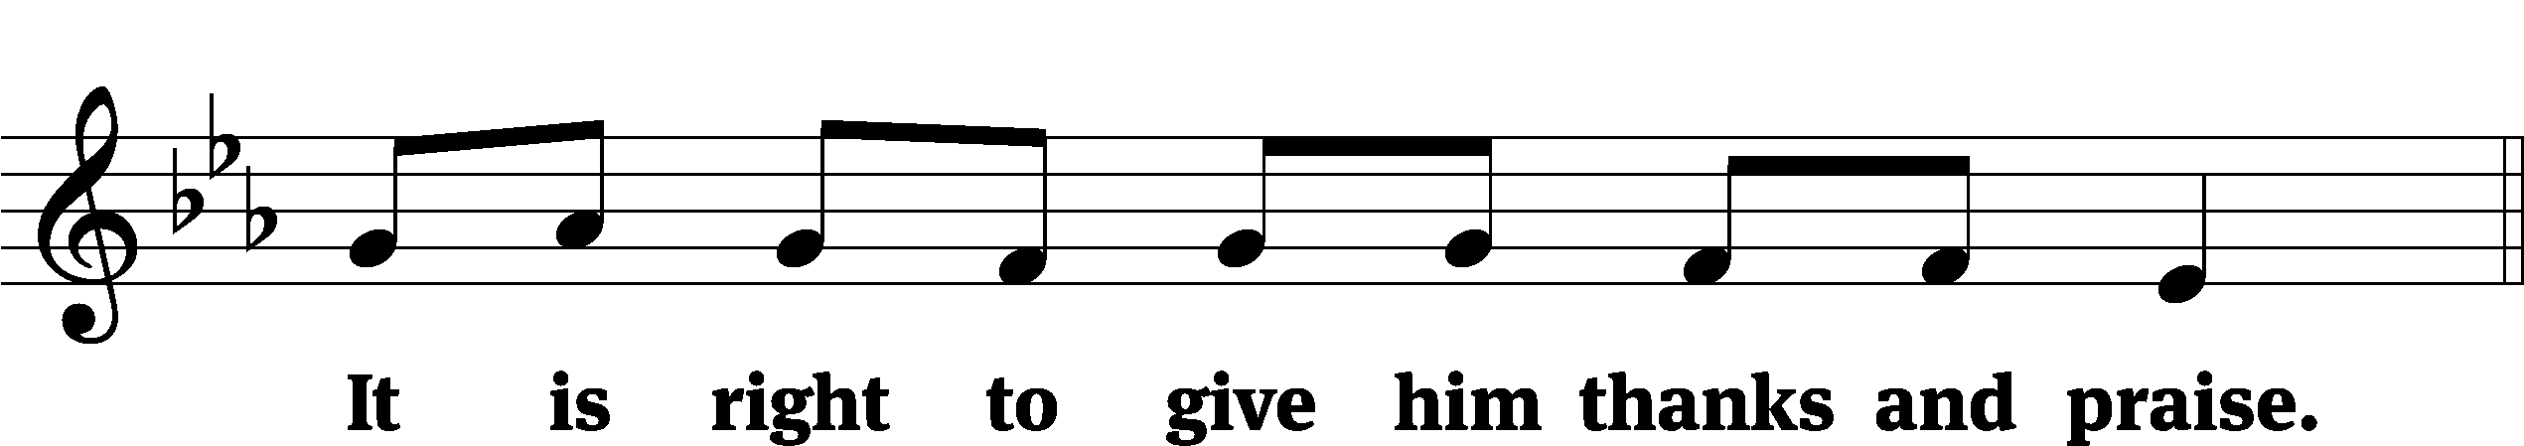

It is truly good and right that we should at all times and in all places give you thanks, O Lord, holy Father, almighty and everlasting God, through Jesus Christ our Lord, who promised that wherever two or three come together in his name, there he is with them to shepherd his flock until he comes again in glory. Therefore, with all the saints on earth and hosts of heaven, we praise your holy name and join their glorious song:

Holy, Holy, Holy CW 167

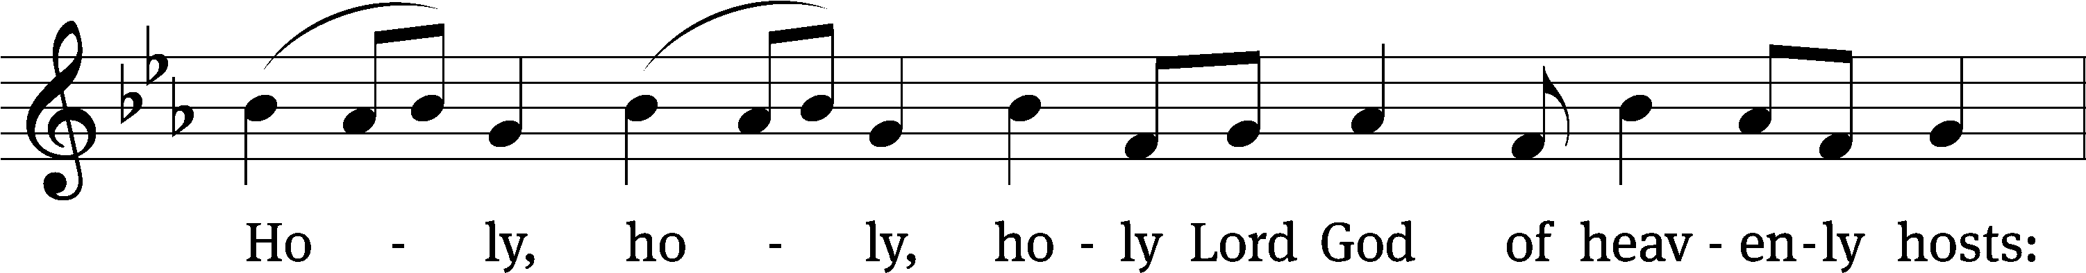

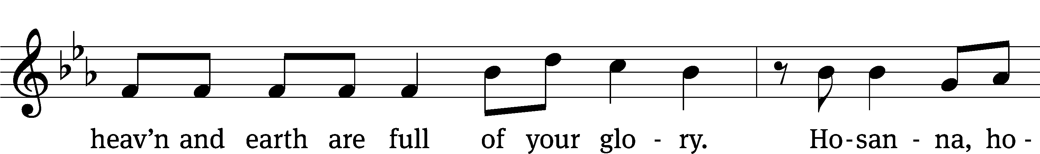

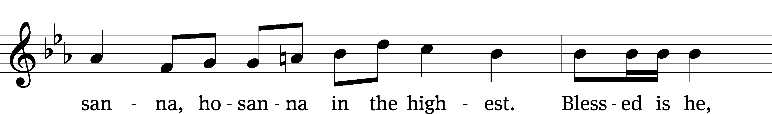

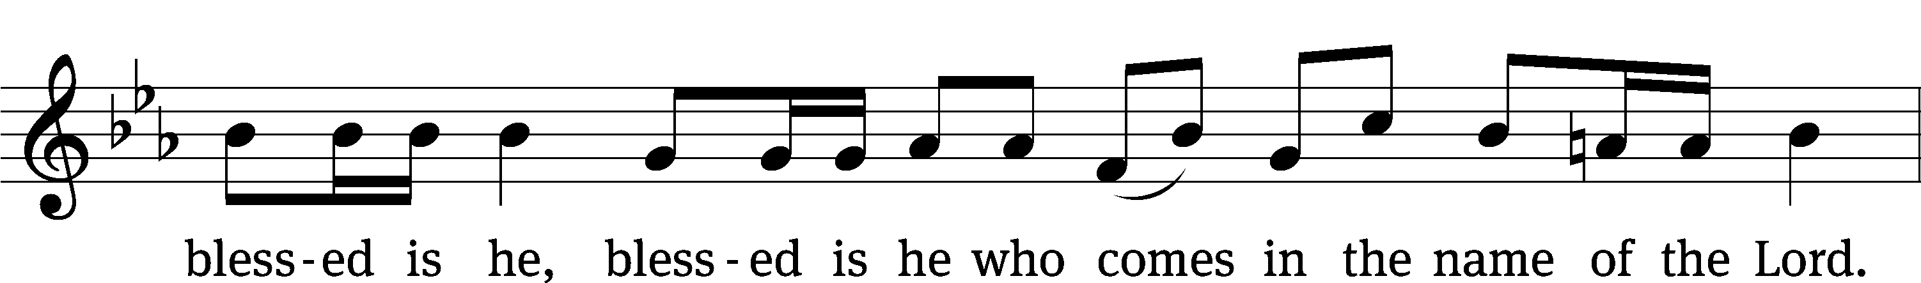

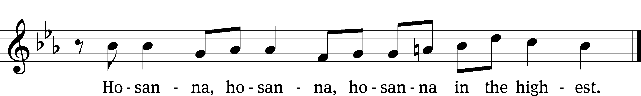

Prayer of Thanksgiving

We give thanks to you, O God, through your dear Son, Jesus Christ, whom you sent to be our Savior, our Redeemer, and the messenger of your grace. Through him you made all things; in him you are well pleased. He is the incarnate Word, conceived by the Holy Spirit and born of the Virgin Mary. To fulfill your promises, he stretched out his hands on the cross and released from eternal death all who believe in you.

As we remember Jesus’ death and resurrection, we thank you that you have gathered us together to receive your Son’s body and blood. Send us your Spirit, unite us as one, and strengthen our faith so that we may praise you in your Son, Jesus Christ. Through him, we glorify and honor you, O God our Father, with the Holy Spirit, one God, now and forever.

**Amen.**

Lord’s Prayer

**Our Father in heaven,**

**hallowed be your name,**

**your kingdom come,**

**your will be done**

**on earth as in heaven.**

**Give us today our daily bread.**

**Forgive us our sins,**

**as we forgive those**

**who sin against us.**

**Lead us not into temptation,**

**but deliver us from evil.**

**For the kingdom, the power,**

**and the glory are yours**

**now and forever. Amen.**

Words of Institution

Our Lord Jesus Christ, on the night he was betrayed, took bread; and when he had given thanks, he broke it and gave it to his disciples, saying, “Take and eat; this is my T body, which is given for you. Do this in remembrance of me.”

Then he took the cup, gave thanks, and gave it to them, saying, “Drink from it, all of you; this is my T blood of the new covenant, which is poured out for you for the forgiveness of sins. Do this, whenever you drink it, in remembrance of me.”

The peace of the Lord be with you always.

**Amen.**

O Christ, Lamb of God CW 169

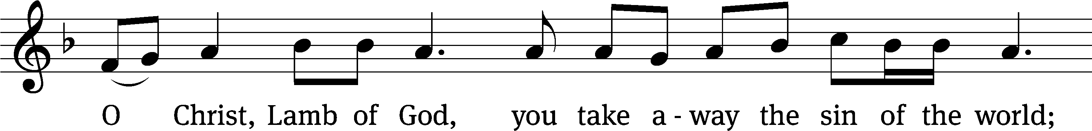

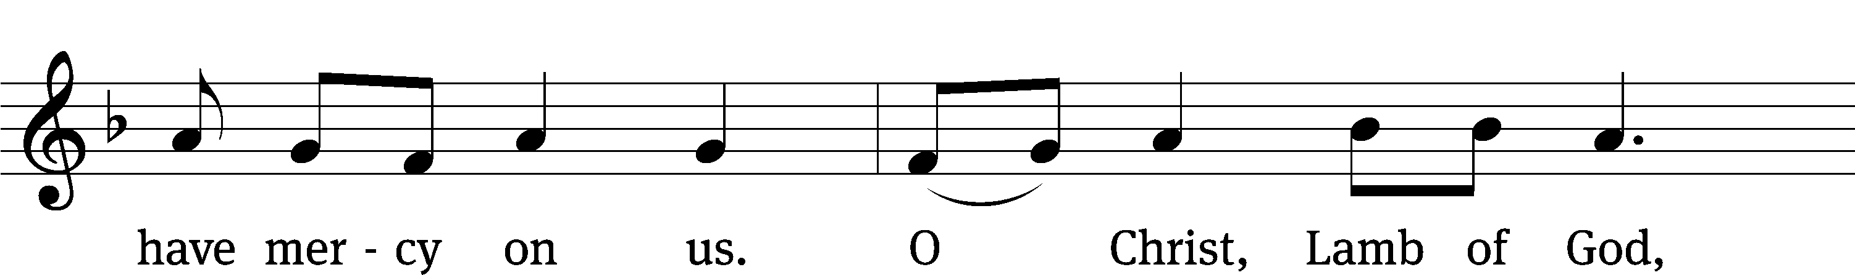

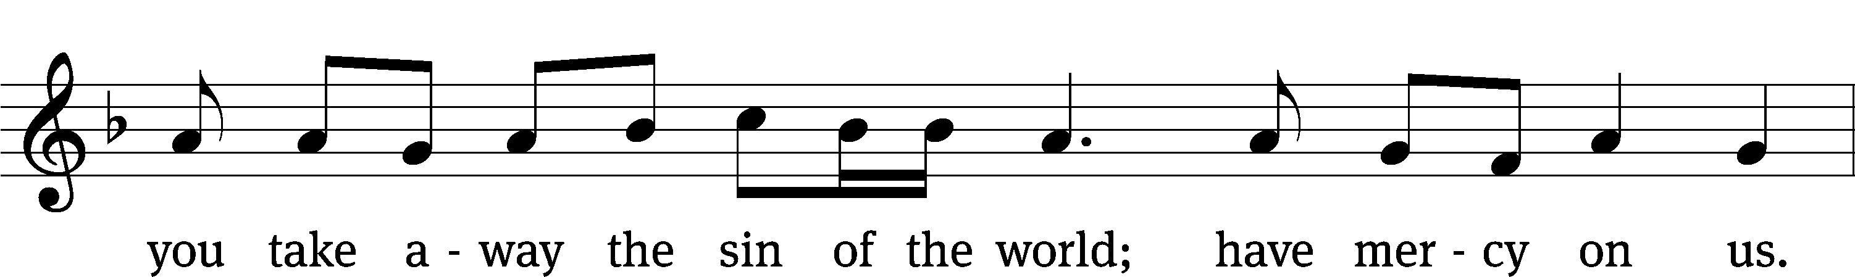

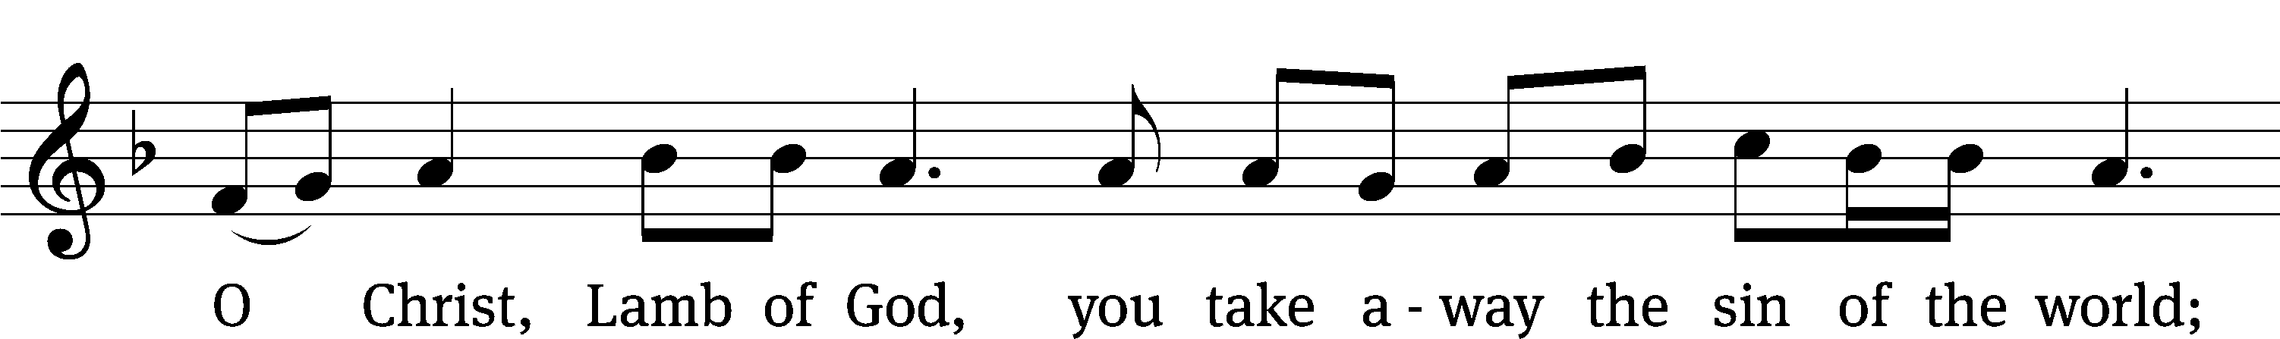

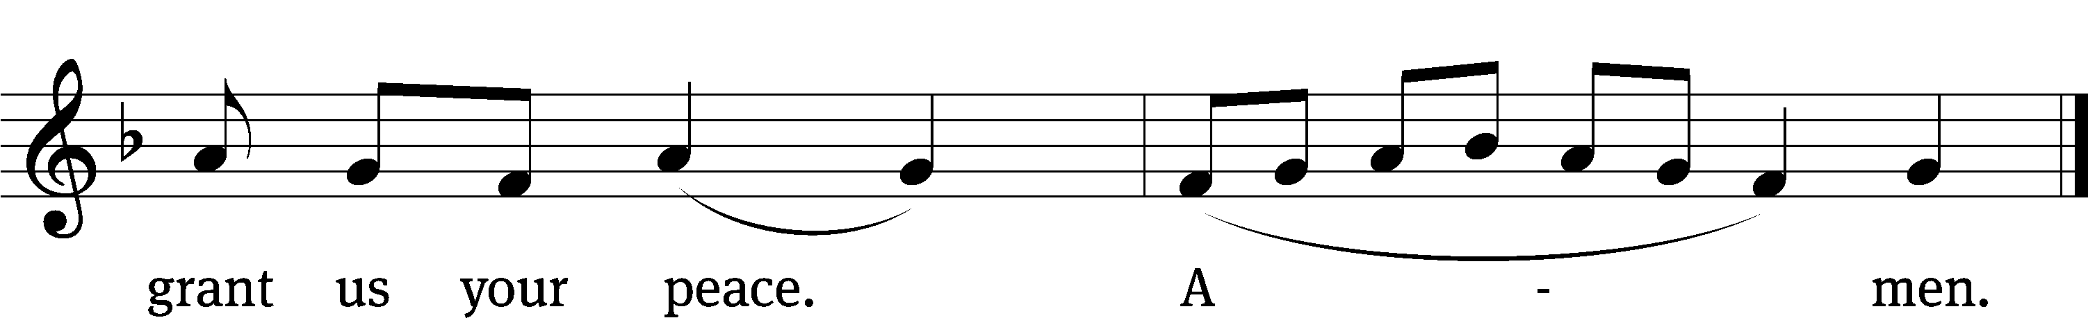

Be seated

Distribution

As he distributes the elements, the minister says to the communicants:

Take and eat; this is the true body of our Lord and Savior Jesus Christ, given into death for your sins.

Take and drink; this is the true blood of our Lord and Savior Jesus Christ, poured out for the forgiveness of your sins.

As he dismisses the communicants, the minister says:

The true body and blood of our Lord Jesus Christ strengthen and preserve you to life everlasting. Go T in peace.

**Amen.**

560 Your Works, Not Mine, O Christ CW 560

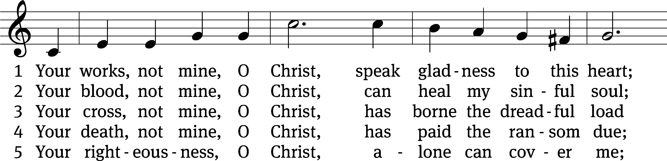

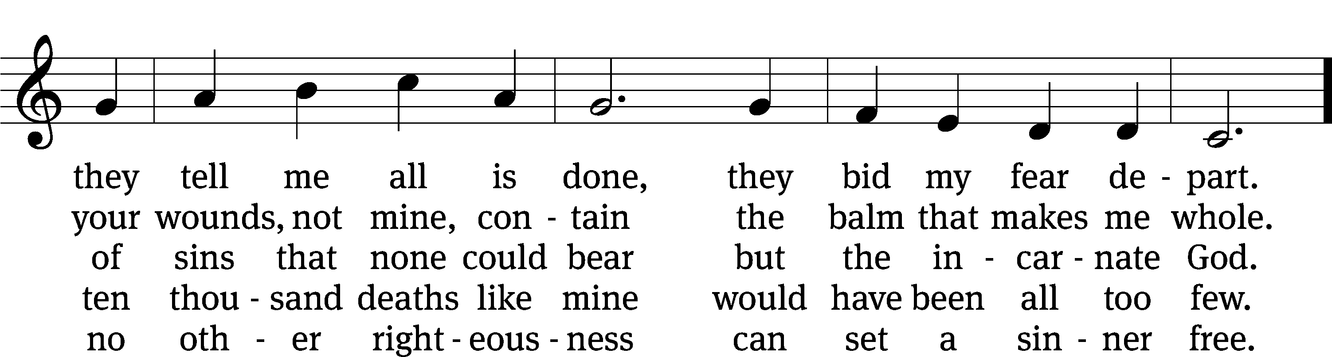

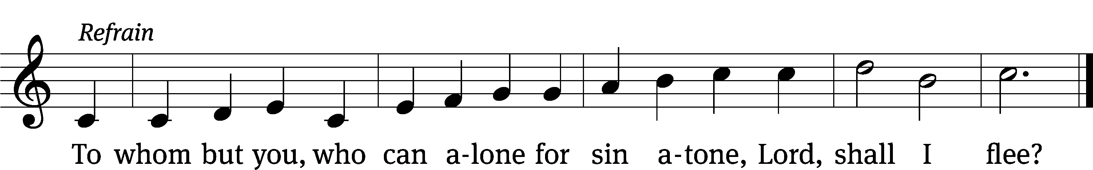

Text: Horatius Bonar, 1808–1889, alt.  
Tune: The Parish Choir, London, 1850  
Text and tune: Public domain

Stand

Give thanks to the Lord, for he is good;

**his mercy endures forever.**

Whenever we eat this bread and drink this cup,

**we proclaim the Lord’s death until he comes.**

We give thanks, almighty God, that you have refreshed us with this saving gift. We pray that through it you will strengthen our faith in you and increase our love for one another. We ask this in the name of Jesus Christ our Lord, who lives and reigns with you and the Holy Spirit, one God, now and forever.

**Amen.**

Blessing

The Lord bless you and keep you.

The Lord make his face shine on you and be gracious to you.

The Lord look on you with favor and T give you peace.

**Amen.**

582 Not unto Us CW 582

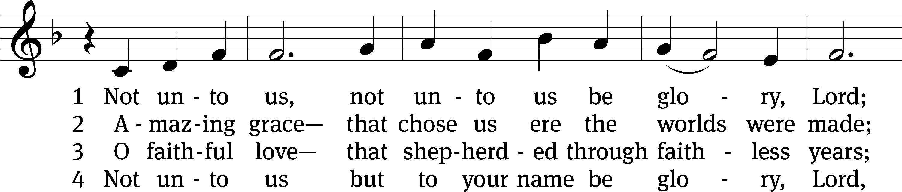

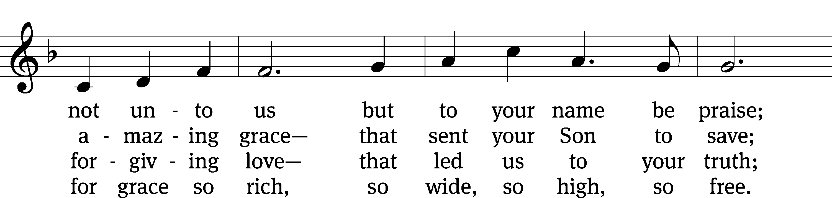

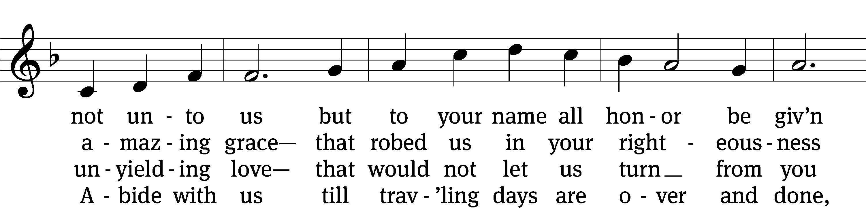

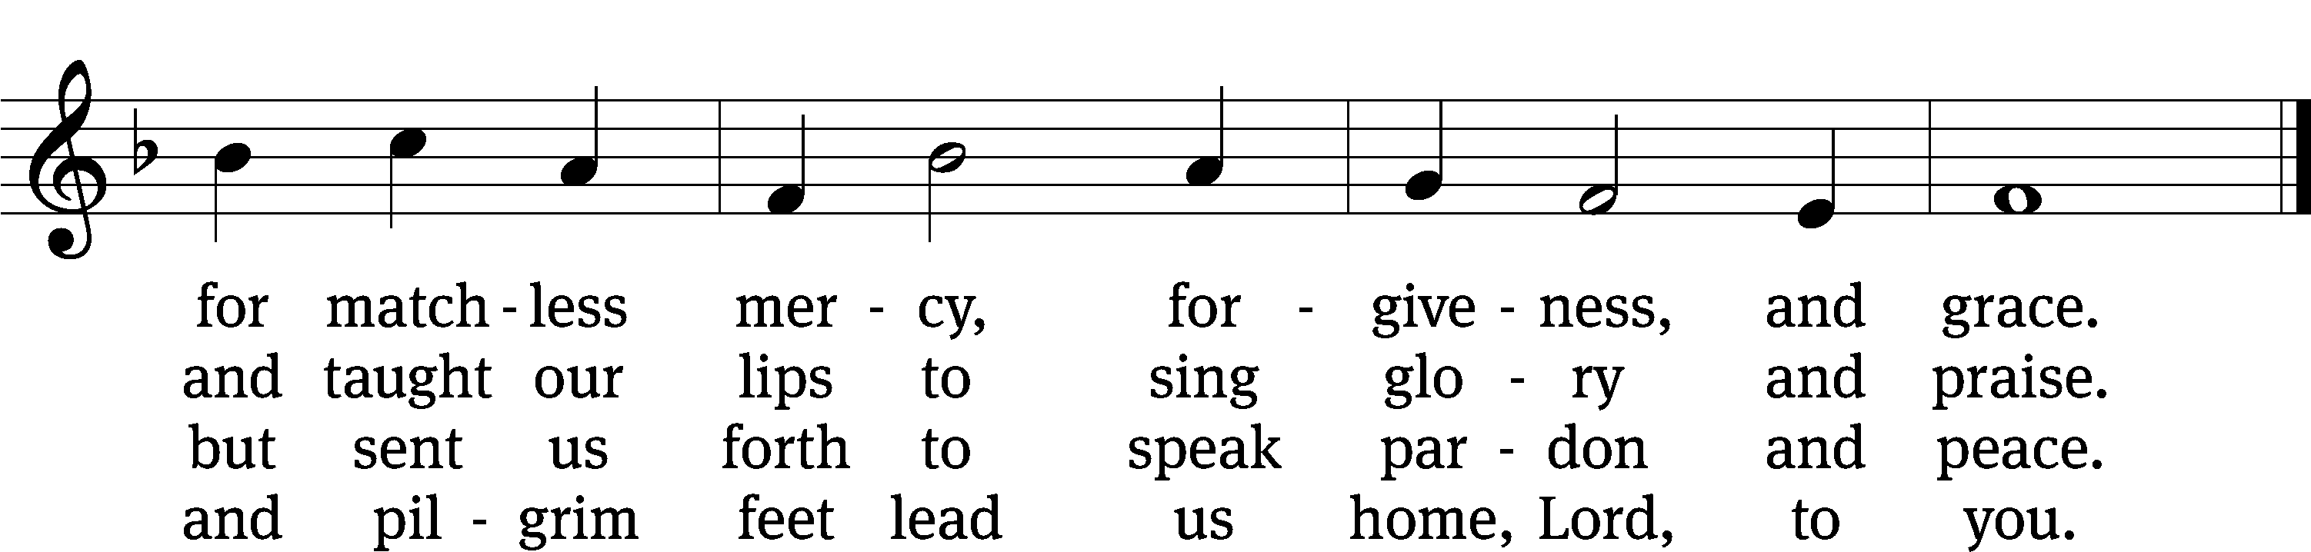

Text: Kurt J. Eggert, 1923–1993, alt.  
Tune: Kurt J. Eggert, 1923–1993  
Text and tune: © 1975 Kurt J. Eggert, admin. Northwestern Publishing House. Used by permission: OneLicense no. 722228

Acknowledgments

Setting One from Christian Worship

Unless otherwise indicated, Scripture quotations are from The Holy Bible, New International Version®, NIV®. Copyright © 1973, 1978, 1984, 2011 by Biblica, Inc.TM Used by permission of Zondervan. All rights reserved worldwide.

Software distributed in partnership with Northwestern Publishing House.

Created by Christian Worship: Service Builder © 2023 Concordia Publishing House.