613 The God of Abraham Praise CW 613
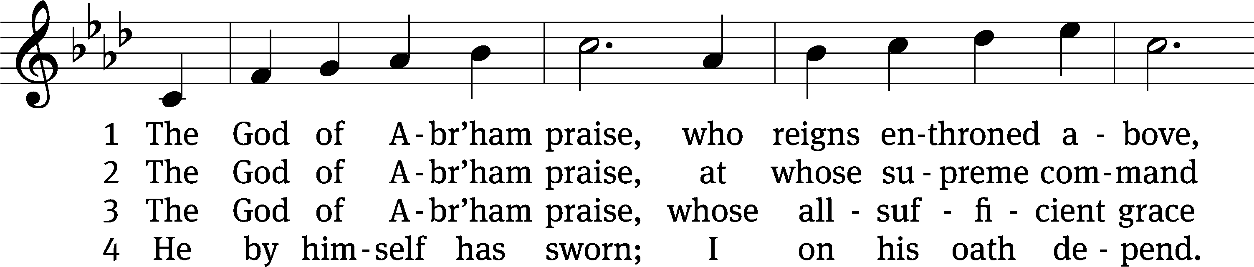
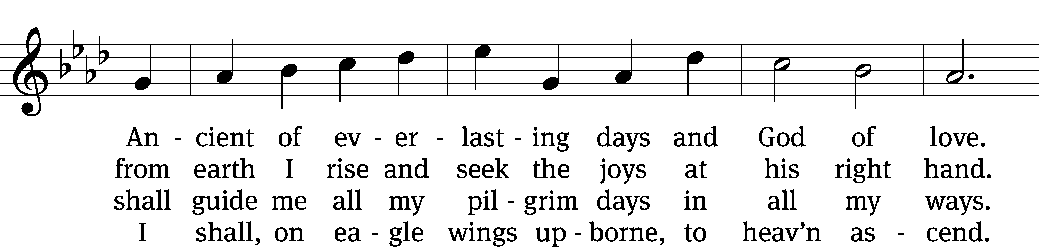
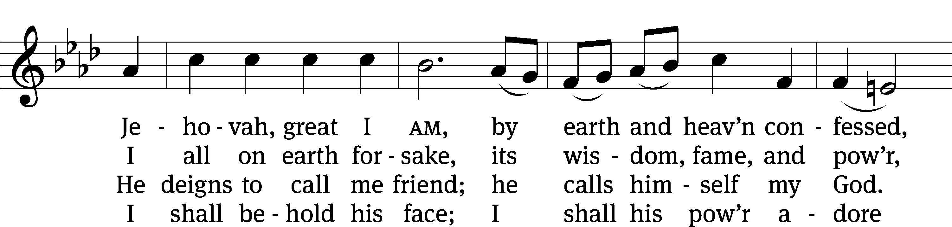
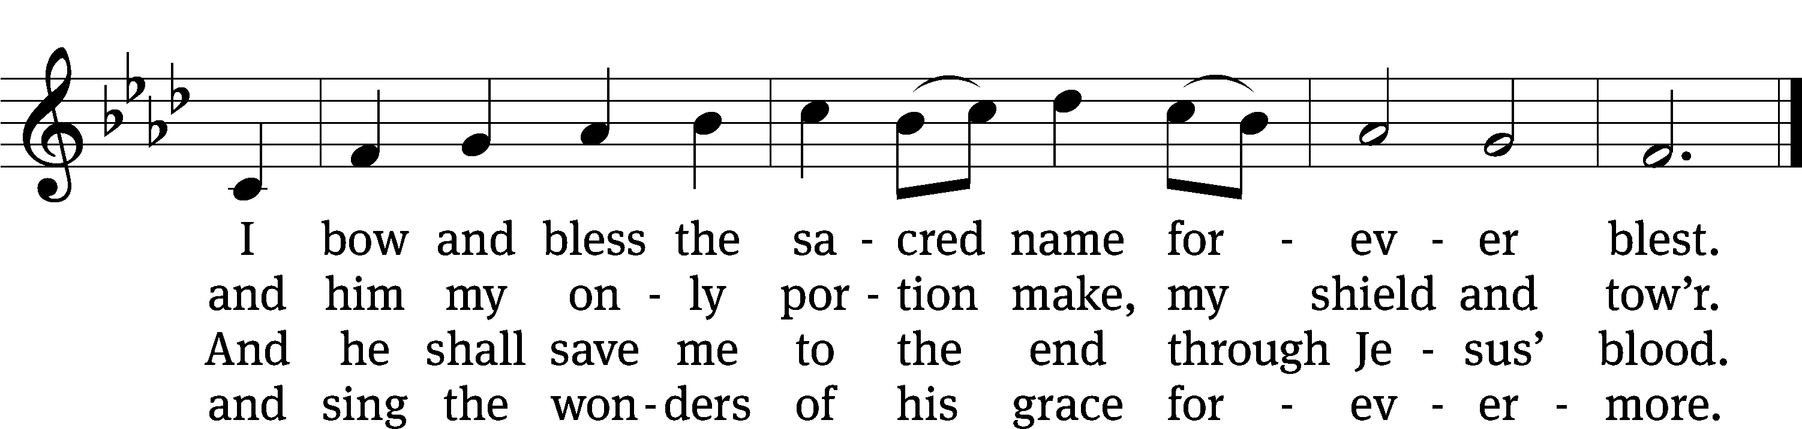
Text: Thomas Olivers, 1725–1799, alt.
Tune: Hebrew
Text and tune: Public domain

Stand

In the name of the Father and of the T Son and of the Holy Spirit.
Amen.

Confession
If we claim to be without sin, we deceive ourselves and the truth is not in us.
If we confess our sins, God is faithful and just
and will forgive us our sins
and purify us from all unrighteousness.

Let us confess our sins to the Lord.
Holy God, gracious Father,
I am sinful by nature
and have sinned against you in my thoughts, words, and actions.
I have not loved you with my whole heart;
I have not loved others as I should.
I deserve your punishment both now and forever.
But Jesus, my Savior, paid for my sins
with his innocent suffering and death.
Trusting in him, I pray: God, have mercy on me, a sinner.

Silence for meditation and reflection

Our gracious Father in heaven has been merciful to us. He sent his only Son, Jesus Christ, who gave his life as the atoning sacrifice for the sins of the whole world. Therefore, as a called servant of Christ and by his authority, I forgive you all your sins in the name of the Father and of the T Son and of the Holy Spirit.
Amen.

Lord, Have Mercy CW 190
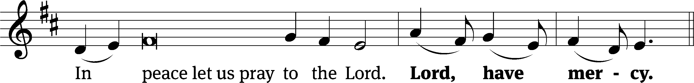
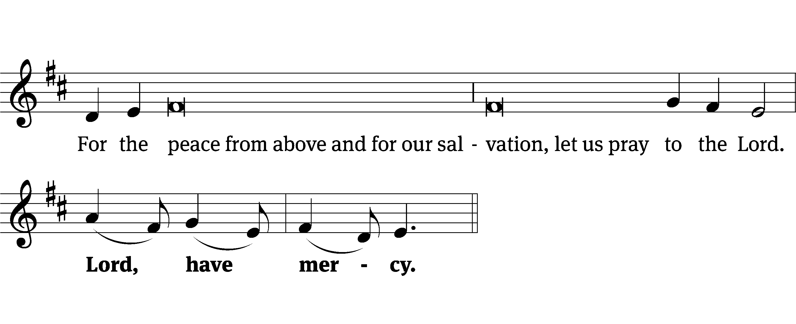
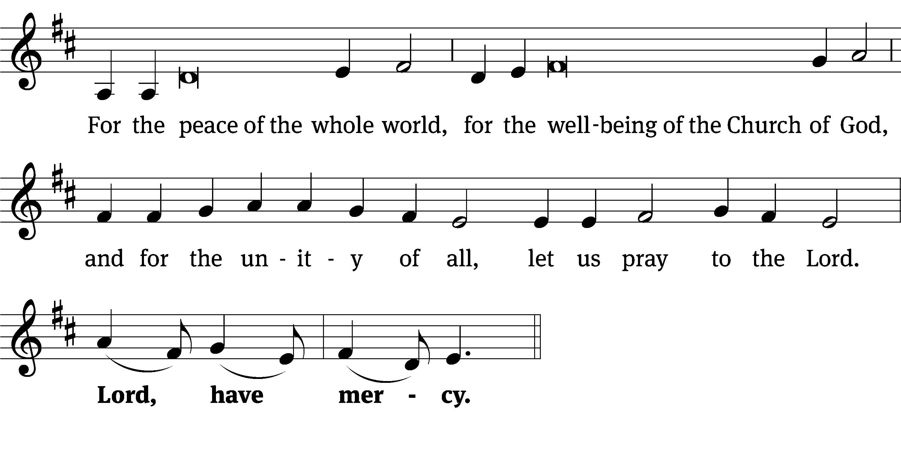
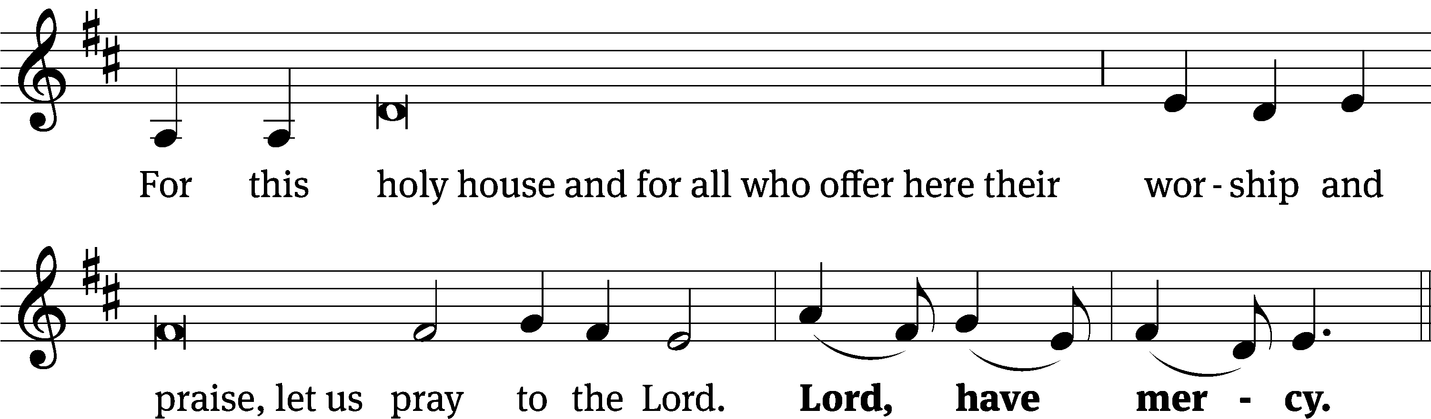
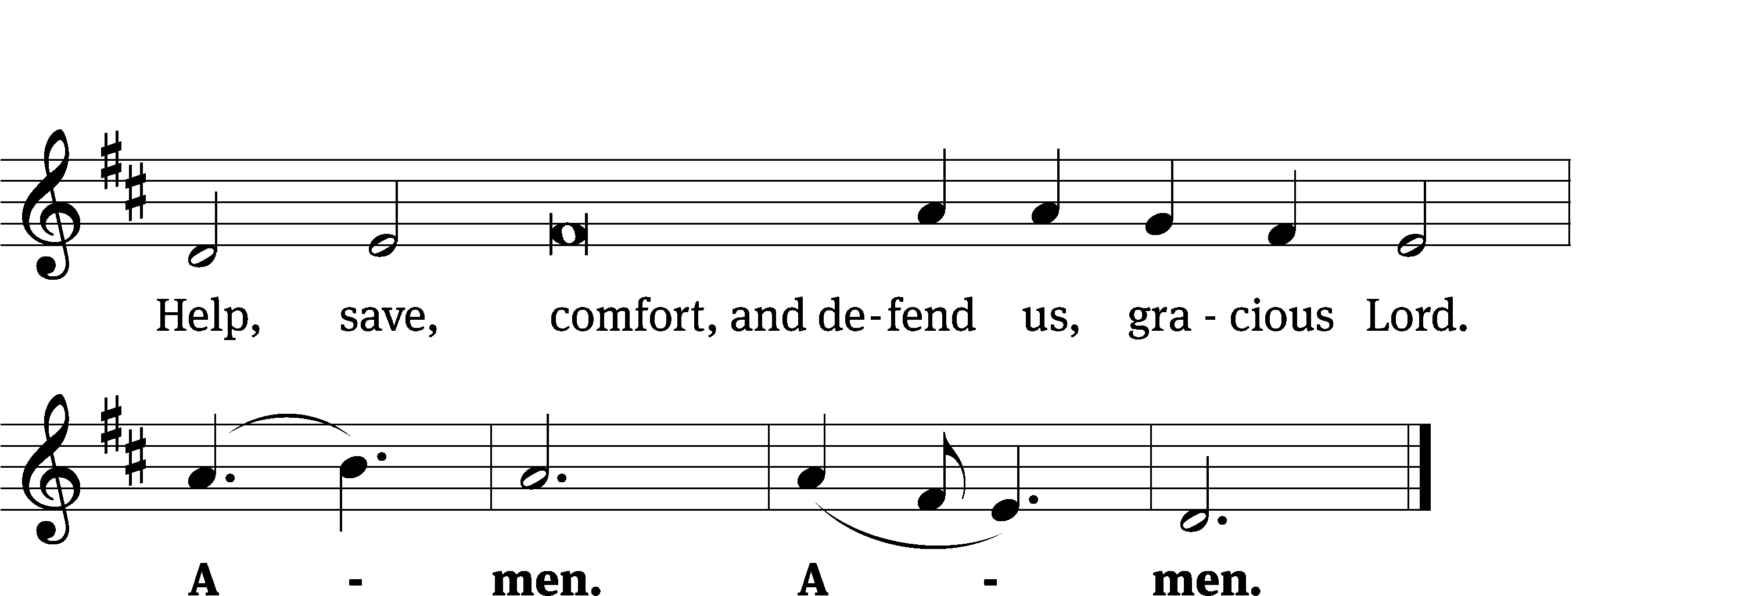
Tune: David Kauffman; William Gokelman
Tune: © 2021 GFTSMUSIC Publishing Company, Inc., admin. Music Services. Used by permission: OneLicense no. 722228

The Word

The Lord be with you.
And also with you.

Prayer of the Day
Let us pray.

Almighty God, you see that we have no power to defend ourselves. Guard and keep us both outwardly and inwardly from all adversities that may happen to the body and all evil thoughts that may assault and hurt the soul; through your Son, Jesus Christ our Lord, who lives and reigns with you and the Holy Spirit, one God, now and forever.
Amen.

Be seated

First Reading Genesis 12:1–8
¹The Lord had said to Abram, “Go from your country, your people and your father’s household to the land I will show you.
²“I will make you into a great nation,
and I will bless you;
I will make your name great,
and you will be a blessing.
³I will bless those who bless you,
and whoever curses you I will curse;
and all peoples on earth
will be blessed through you.”
⁴So Abram went, as the Lord had told him; and Lot went with him. Abram was seventy-five years old when he set out from Harran. ⁵He took his wife Sarai, his nephew Lot, all the possessions they had accumulated and the people they had acquired in Harran, and they set out for the land of Canaan, and they arrived there.
⁶Abram traveled through the land as far as the site of the great tree of Moreh at Shechem. At that time the Canaanites were in the land. ⁷The Lord appeared to Abram and said, “To your offspring I will give this land.” So he built an altar there to the Lord, who had appeared to him.
⁸From there he went on toward the hills east of Bethel and pitched his tent, with Bethel on the west and Ai on the east. There he built an altar to the Lord and called on the name of the Lord.

The Word of the Lord.
Thanks be to God.

121A I Lift Up My Eyes to the Mountains Psalm 121A
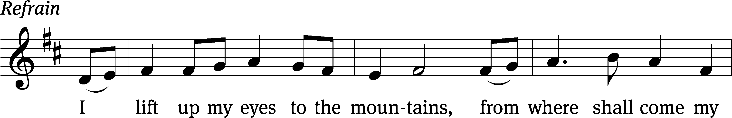
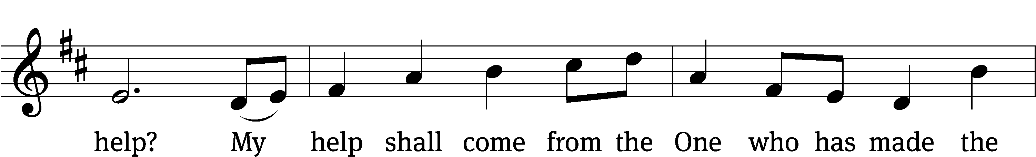
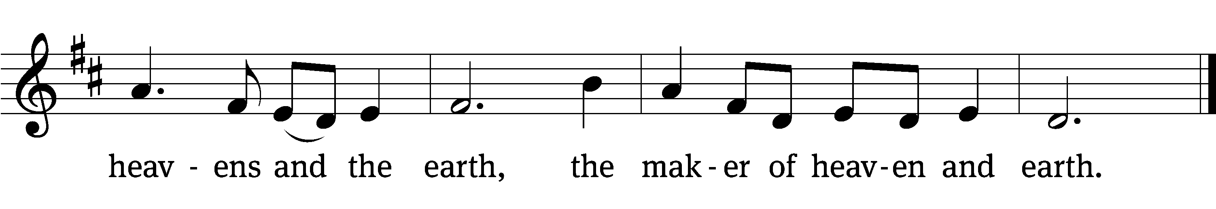
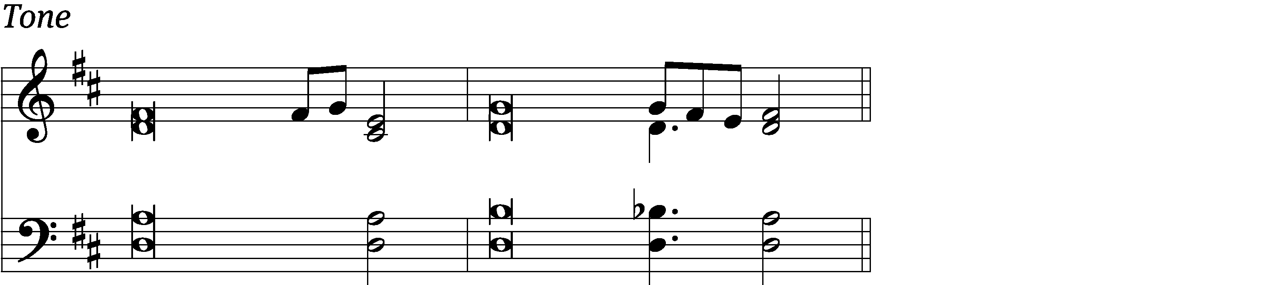

I lift up my eyes to the / mountains—
where does my help / come from?
My help comes / from the Lord,
the maker of / heaven and earth.
He will not let your / foot slip—
he who watches over you will not / slumber;
indeed, he who watches over / Israel
will neither / slumber nor sleep. Refrain

The Lord watches / over you—
the Lord is your shade / at your right hand.
The Lord will keep you / from all harm—
he will watch / over your life;
the Lord will watch over your coming and / going
both now and for- / evermore.
Glory be to the Father and / to the Son
and to the Holy / Spirit,
as it was in the be- / ginning,
is now, and will be forever. / Amen. Refrain
Tune: Marty Haugen
Tune: © 2000 GIA Publications, Inc. Used by permission: OneLicense no. 722228
Setting: © 2021 Northwestern Publishing House. Used by permission: OneLicense no. 722228

Second Reading Romans 4:1–5,13–17
¹What then shall we say that Abraham, our forefather according to the flesh, discovered in this matter? ²If, in fact, Abraham was justified by works, he had something to boast about—but not before God. ³What does Scripture say? “Abraham believed God, and it was credited to him as righteousness.”
⁴Now to the one who works, wages are not credited as a gift but as an obligation. ⁵However, to the one who does not work but trusts God who justifies the ungodly, their faith is credited as righteousness.
¹³It was not through the law that Abraham and his offspring received the promise that he would be heir of the world, but through the righteousness that comes by faith. ¹⁴For if those who depend on the law are heirs, faith means nothing and the promise is worthless, ¹⁵because the law brings wrath. And where there is no law there is no transgression.
¹⁶Therefore, the promise comes by faith, so that it may be by grace and may be guaranteed to all Abraham’s offspring—not only to those who are of the law but also to those who have the faith of Abraham. He is the father of us all. ¹⁷As it is written: “I have made you a father of many nations.” He is our father in the sight of God, in whom he believed—the God who gives life to the dead and calls into being things that were not.

The Word of the Lord.
Thanks be to God.

Stand

Gospel Acclamation John 3:16
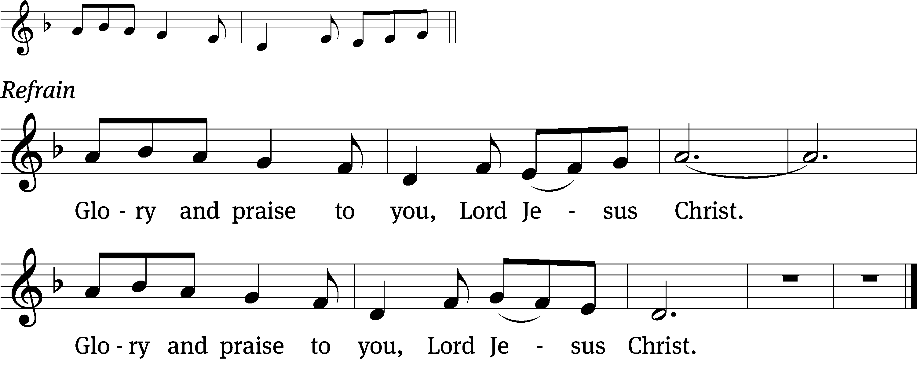
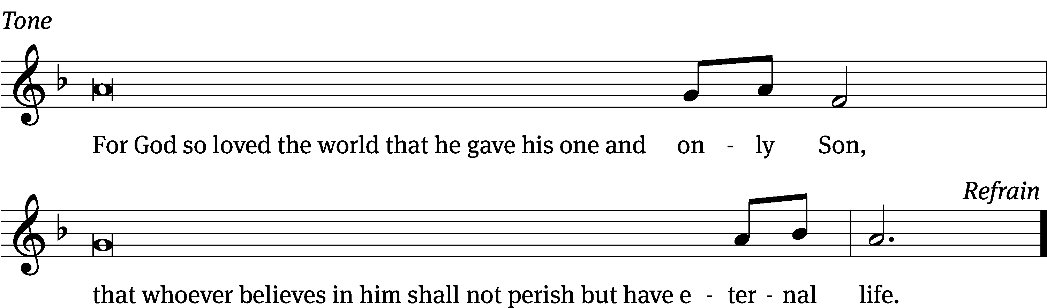
Tune: © 2010, 2021 GFTSMUSIC Publishing Company, Inc., admin. Music Services. Used by permission: OneLicense no. 722228

Gospel John 3:1–17
¹Now there was a Pharisee, a man named Nicodemus who was a member of the Jewish ruling council. ²He came to Jesus at night and said, “Rabbi, we know that you are a teacher who has come from God. For no one could perform the signs you are doing if God were not with him.”
³Jesus replied, “Very truly I tell you, no one can see the kingdom of God unless they are born again.”
⁴“How can someone be born when they are old?” Nicodemus asked. “Surely they cannot enter a second time into their mother’s womb to be born!”
⁵Jesus answered, “Very truly I tell you, no one can enter the kingdom of God unless they are born of water and the Spirit. ⁶Flesh gives birth to flesh, but the Spirit gives birth to spirit. ⁷You should not be surprised at my saying, ‘You must be born again.’ ⁸The wind blows wherever it pleases. You hear its sound, but you cannot tell where it comes from or where it is going. So it is with everyone born of the Spirit.”
⁹“How can this be?” Nicodemus asked.
¹⁰“You are Israel’s teacher,” said Jesus, “and do you not understand these things? ¹¹Very truly I tell you, we speak of what we know, and we testify to what we have seen, but still you people do not accept our testimony. ¹²I have spoken to you of earthly things and you do not believe; how then will you believe if I speak of heavenly things? ¹³No one has ever gone into heaven except the one who came from heaven—the Son of Man. ¹⁴Just as Moses lifted up the snake in the wilderness, so the Son of Man must be lifted up, ¹⁵that everyone who believes may have eternal life in him.”
¹⁶For God so loved the world that he gave his one and only Son, that whoever believes in him shall not perish but have eternal life. ¹⁷For God did not send his Son into the world to condemn the world, but to save the world through him.

The Gospel of the Lord.
Praise be to you, O Christ!

Be seated

570 God Loved the World So That He Gave CW 570
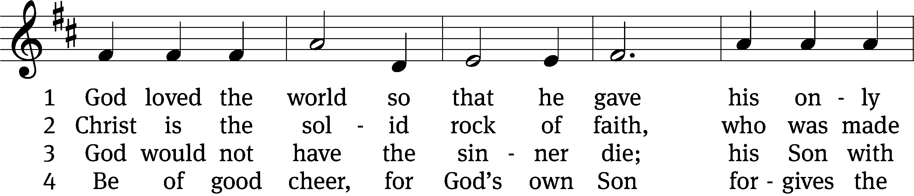
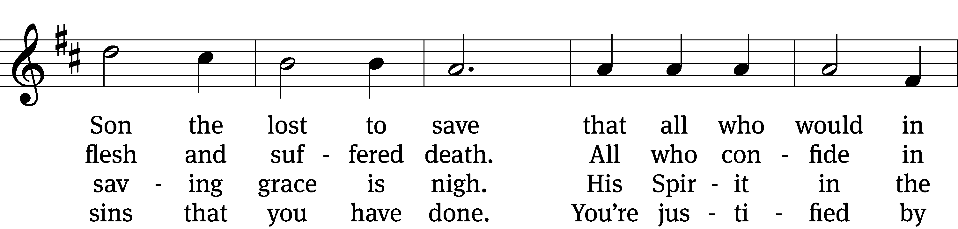
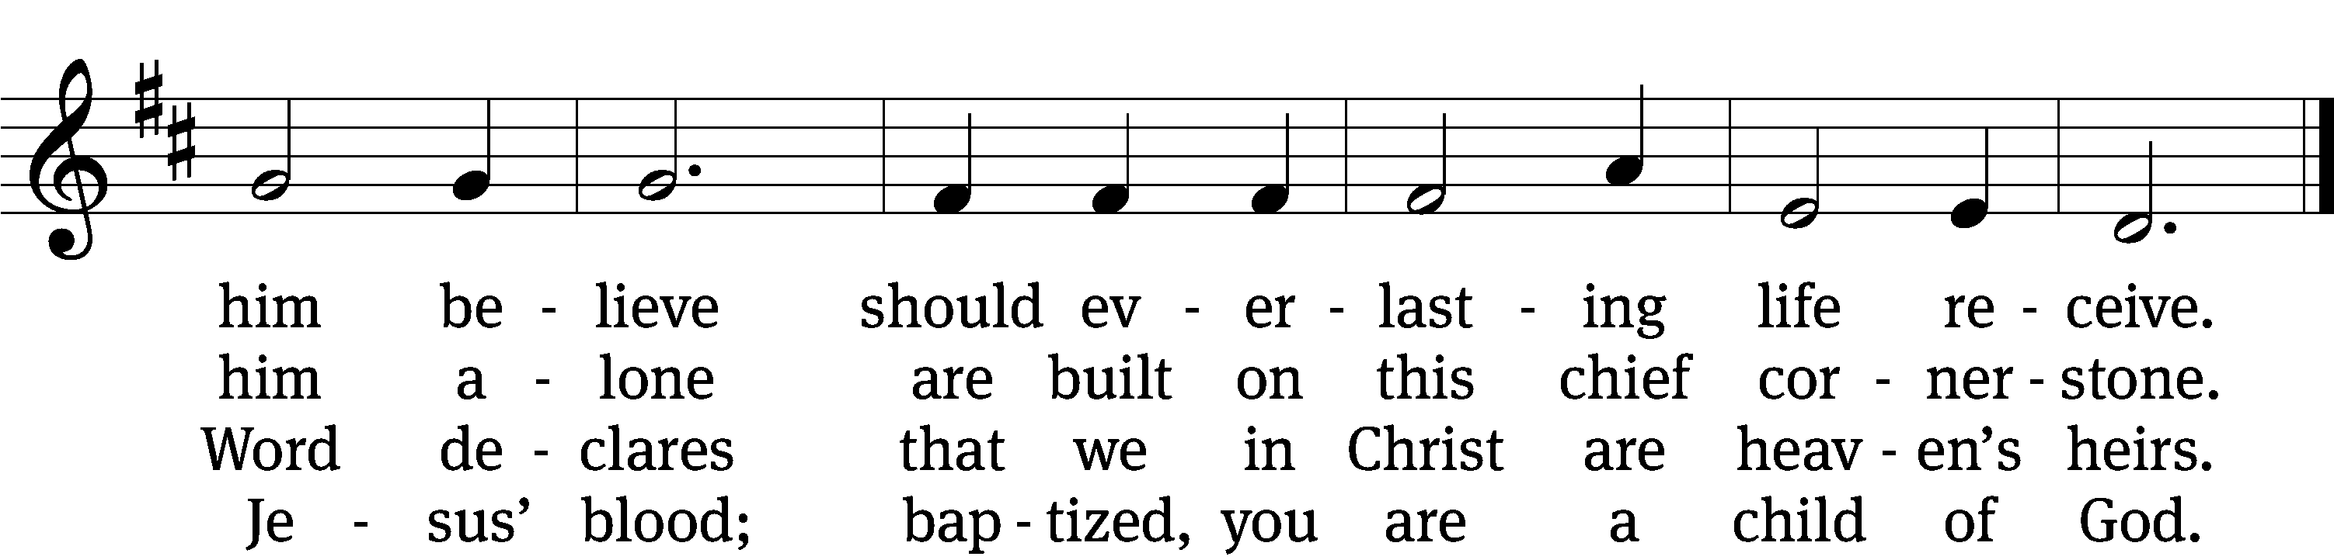

5 If you are sick, if death is near,
this truth your troubled heart can cheer:
Christ Jesus saves my soul from death;
this is the anchor of my faith!

6 Glory to God the Father, Son,
and Holy Spirit, Three in One!
To you, O blessèd Trinity,
be praise now and eternally!
Text: tr. August Crull, 1845–1923, alt.; Heiliges Lippen- und Hertzens- Opffer, Stettin, c. 1778
Tune: George J. Elvey, 1816–1893
Text and tune: Public domain

Sermon

Stand

Apostles’ Creed
I believe in God, the Father Almighty,
maker of heaven and earth.

I believe in Jesus Christ, his only Son, our Lord,
who was conceived by the Holy Spirit,
born of the Virgin Mary,
suffered under Pontius Pilate,
was crucified, died, and was buried.
He descended into hell.
The third day he rose again from the dead.
He ascended into heaven
and is seated at the right hand of God the Father Almighty.
From there he will come to judge the living and the dead.

I believe in the Holy Spirit,
the holy Christian Church,
the communion of saints,
the forgiveness of sins,
the resurrection of the body,
and the life everlasting. Amen.

Be seated

Prayer of the Church
Brief intercessory prayers may be added in a fitting place.

Loving God and Lord, you created the universe that surrounds us and the globe on which we live. You control all things through your Son, who sits at your right hand in glory.
Comfort us with the promise of your eternal presence.

Give your Word power as it works in our hearts and minds. Clear away our confusion, and demolish our doubts. Send your Spirit to strengthen both our confidence in your promises and our desire to live according to your will.
Take away our love of sinning, and restore us each day by your grace.

The signs of the times warn us that the end of time is near. Protect us from scoffers who sneer at your truth. Spare us and Christians around the world from all forms of hate and persecution.
Give us courage to carry the cross with patience and joy.

Instill in the hearts of our children a desire to follow you as they prepare for future days. Help them distinguish between what is passing and what is eternal, between instant thrills and lasting joy. Encourage more young people to prepare for service in the public ministry of the gospel.
Mold us and move us to be good examples for our youth.

Hold in your care, Lord, those who are experiencing physical or emotional pain and all who are afflicted by disease or facing death. [Especially bless . . . here name the person and the cause of the petition.] Pour out your compassion on the grieving, and comfort the mourners who miss someone they loved.
Move us to pray for these brothers and sisters and to help when we can.

Hear us, Lord, as we pray in silence.

Silent prayer

Whether we pray together or alone, you have promised to hear and answer us. Give us patience to accept your blessings in whatever way you send them. In your love and wisdom, prepare us for the day when you will take us to be with you forever.
Hear us for Jesus’ sake. Amen.

Offering

Prayer
Blessed Lord, you have given us your Holy Scriptures for our learning. May we so hear them, read, learn, and take them to heart that, being strengthened and comforted by your holy Word, we may cling to the blessed hope of everlasting life; through Jesus Christ our Lord, who lives and reigns with you and the Holy Spirit, one God, now and forever.
Amen.

Lord’s Prayer - Modern
Our Father in heaven,
hallowed be your name,
your kingdom come,
your will be done
on earth as in heaven.
Give us today our daily bread.
Forgive us our sins,
as we forgive those
who sin against us.
Lead us not into temptation,
but deliver us from evil.
For the kingdom, the power,
and the glory are yours
now and forever. Amen.

Blessing
The Lord bless you and keep you.
The Lord make his face shine on you and be gracious to you.
The Lord look on you with favor and T give you peace.
Amen.

627 To God Be the Glory CW 627
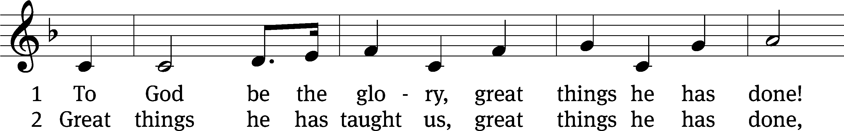
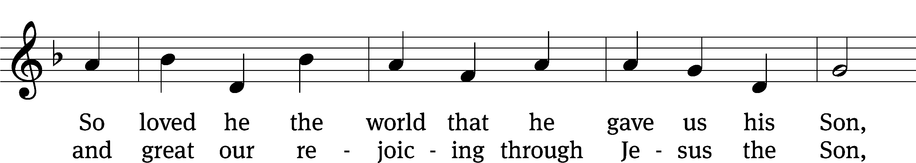
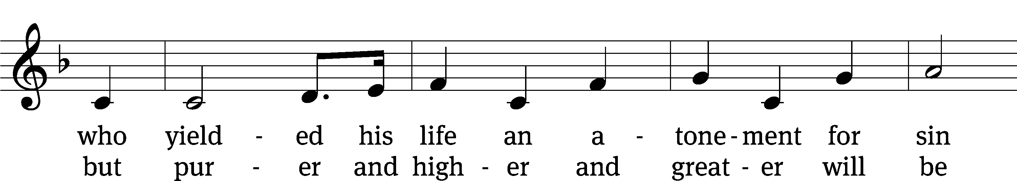
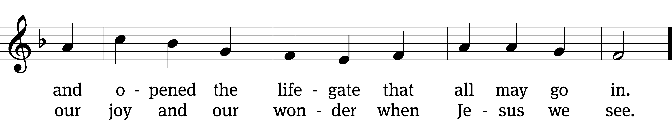
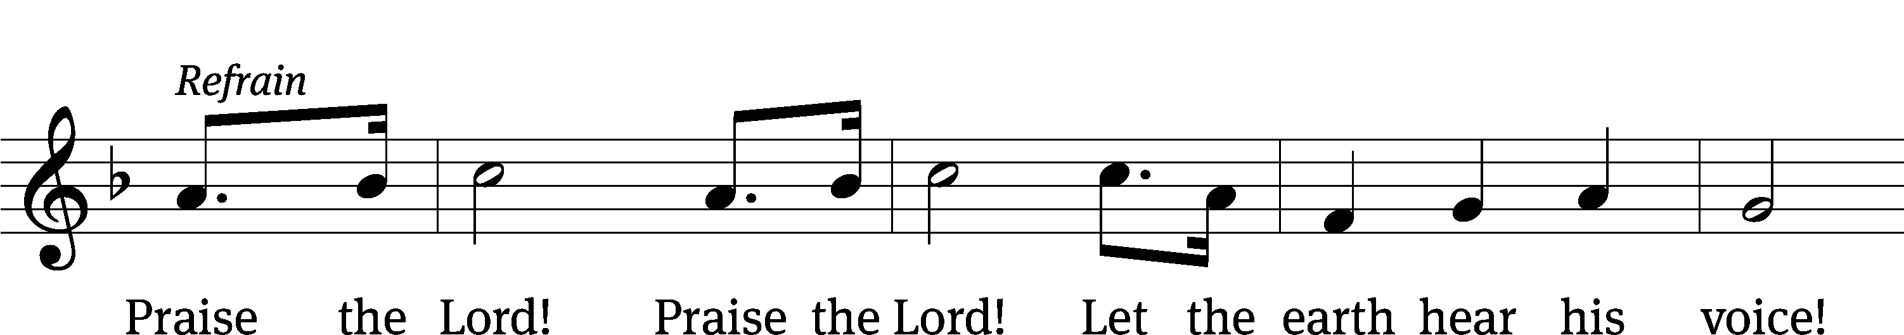
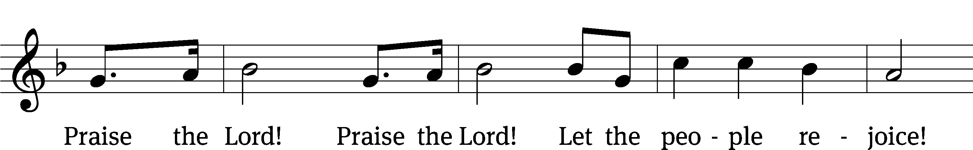
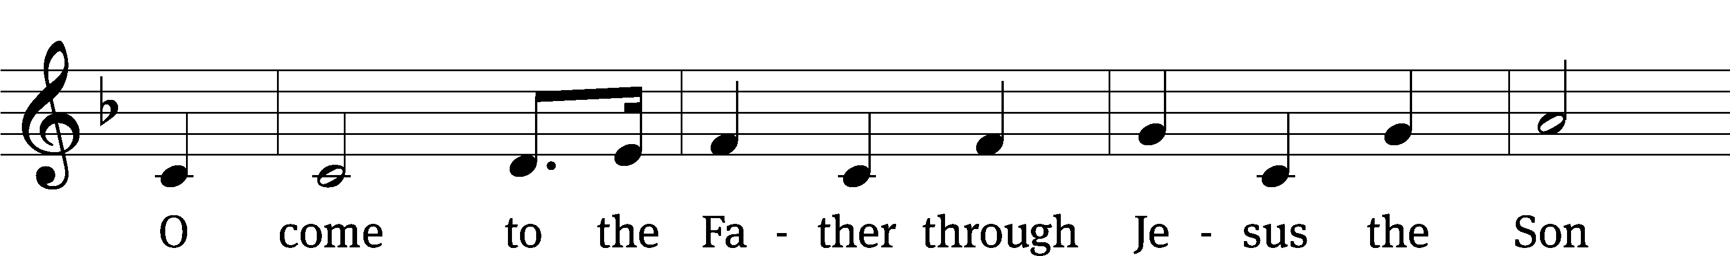
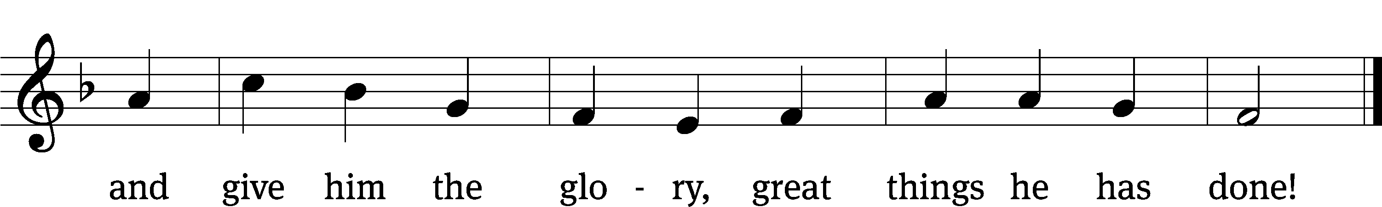
Text: Fanny J. Crosby, 1820–1915, abr., alt.
Tune: William H. Doane, 1832–1915
Text and tune: Public domain

Acknowledgments
Setting Three from Christian Worship
Unless otherwise indicated, Scripture quotations are from The Holy Bible, New International Version®, NIV®. Copyright © 1973, 1978, 1984, 2011 by Biblica, Inc.TM Used by permission of Zondervan. All rights reserved worldwide.
Software distributed in partnership with Northwestern Publishing House.
Created by Christian Worship: Service Builder © 2023 Concordia Publishing House.

