630 Thy Strong Word CW 630
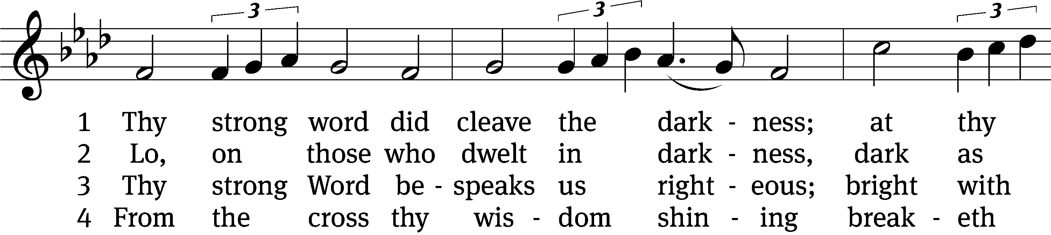
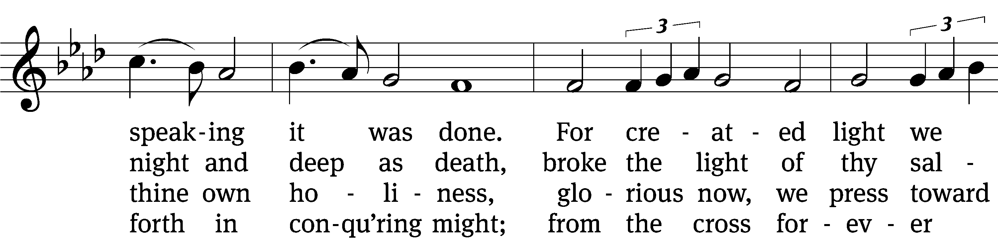
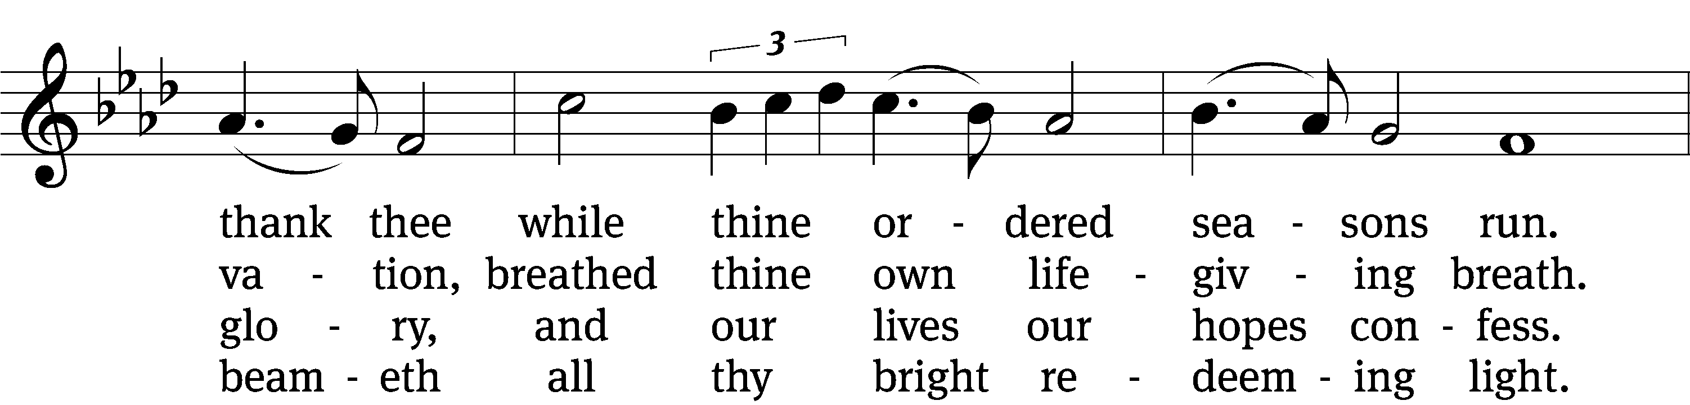
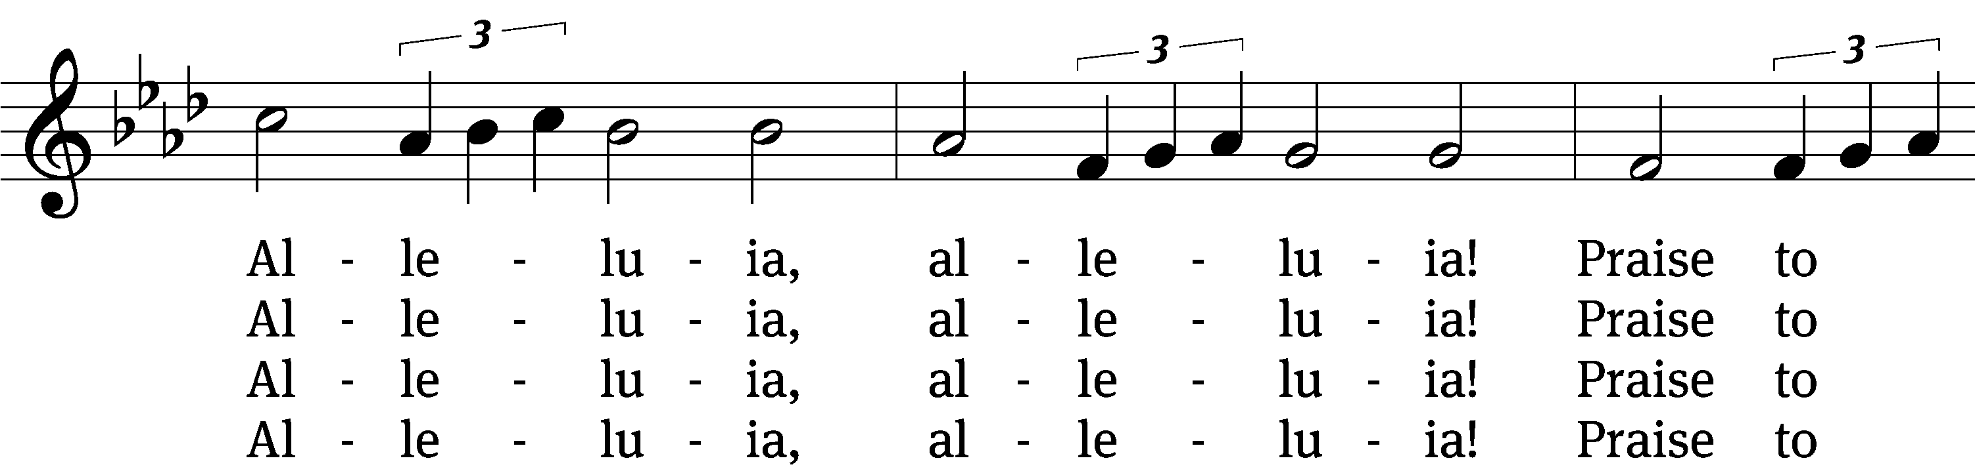
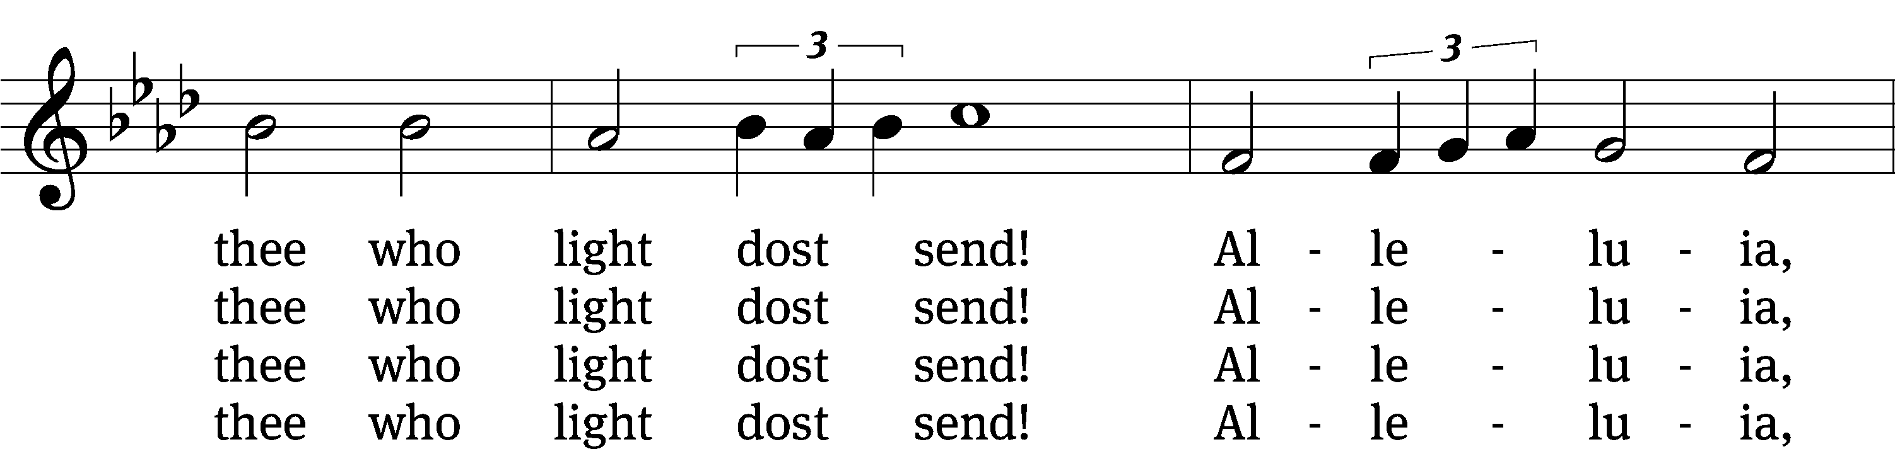
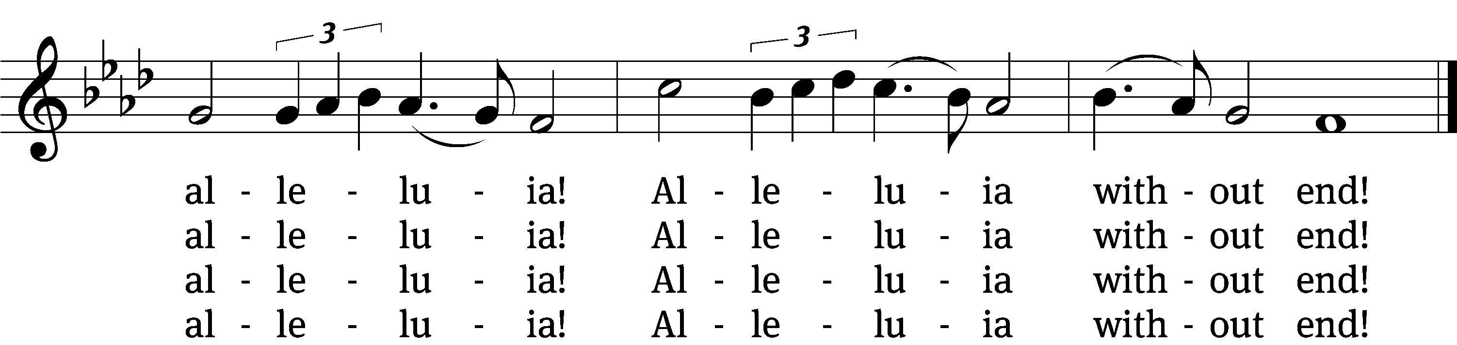

5 Give us lips to sing thy glory,
tongues thy mercy to proclaim,
throats to shout the hope that fills us,
mouths to speak thy holy name.
Alleluia, alleluia!
May the light which thou dost send
fill our songs with alleluias,
alleluias without end!

6 God the Father, light-creator,
to thee laud and honor be.
To thee, Light from Light begotten,
praise be sung eternally.
Holy Spirit, light-revealer,
glory, glory be to thee.
Mortals, angels, now and ever
praise the holy Trinity!
Text: Martin H. Franzmann, 1907–1976
Tune: Thomas J. Williams, 1869–1944
Text: © 1969 Concordia Publishing House. Used by permission: OneLicense no. 722228
Tune: Public domain

Stand

In the name of the Father and of the T Son and of the Holy Spirit.
Amen.

Confession CW 154
If we claim to be without sin, we deceive ourselves and the truth is not in us.
If we confess our sins, God is faithful and just
and will forgive us our sins
and purify us from all unrighteousness.

Let us confess our sins to the Lord.
Holy God, gracious Father,
I am sinful by nature
and have sinned against you in my thoughts, words, and actions.
I have not loved you with my whole heart;
I have not loved others as I should.
I deserve your punishment both now and forever.
But Jesus, my Savior, paid for my sins
with his innocent suffering and death.
Trusting in him, I pray: God, have mercy on me, a sinner.

Silence for meditation and reflection

Our gracious Father in heaven has been merciful to us. He sent his only Son, Jesus Christ, who gave his life as the atoning sacrifice for the sins of the whole world. Therefore, as a called servant of Christ and by his authority, I forgive you all your sins in the name of the Father and of the T Son and of the Holy Spirit.
Amen.

Lord, Have Mercy
In peace let us pray to the Lord.
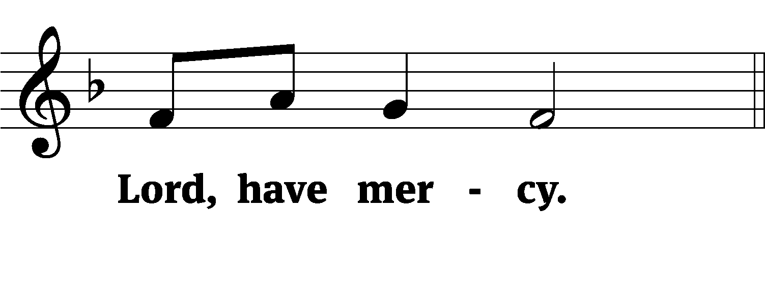
For the peace from above and for our salvation, let us pray to the Lord.
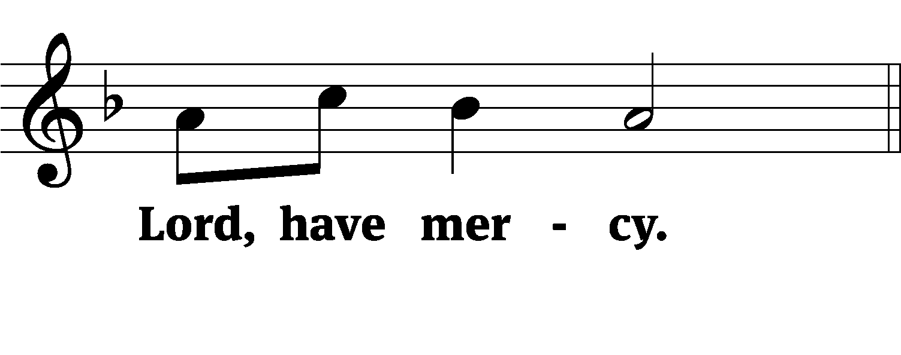
For the peace of the whole world, for the well-being of the Church of God, and for the unity of all, let us pray to the Lord.
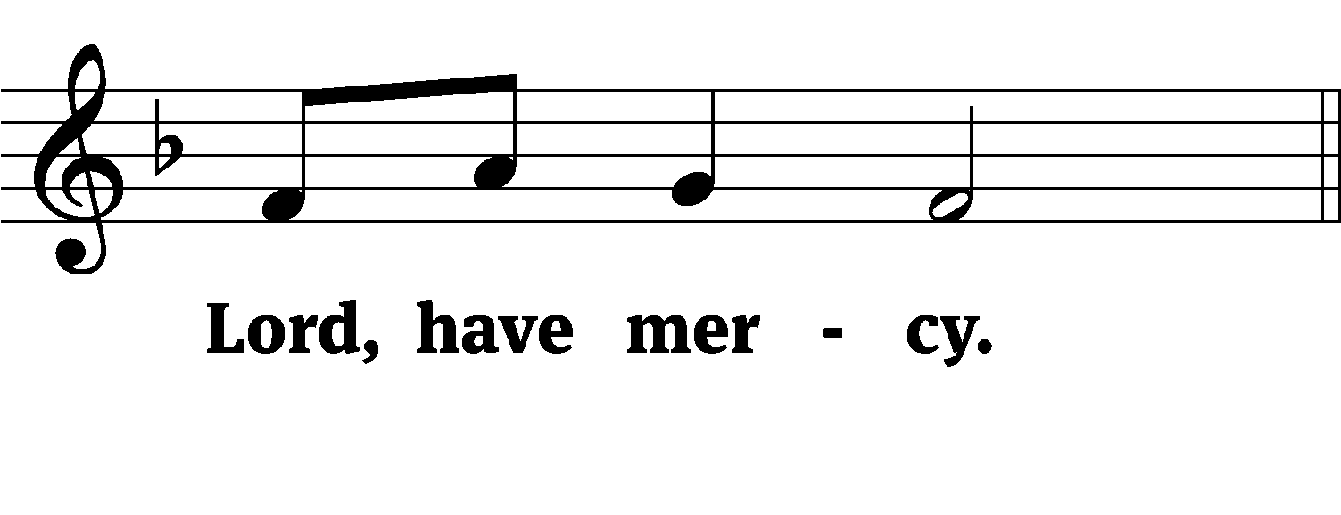
For this holy house and for all who offer here their worship and praise, let us pray to the Lord.
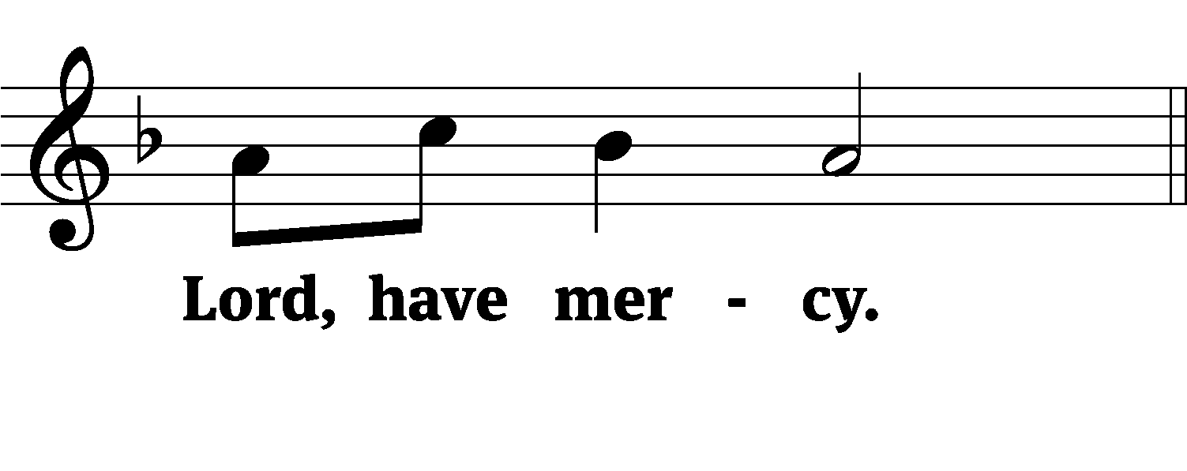
Help, save, comfort, and defend us, gracious Lord.
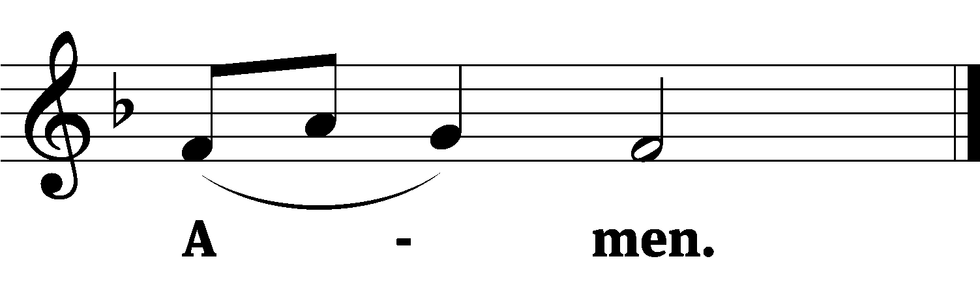

Tune: © 2021 Northwestern Publishing House. Used by permission: OneLicense no. 722228

Glory Be to God CW 157
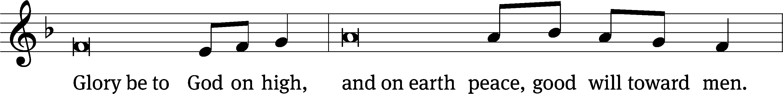
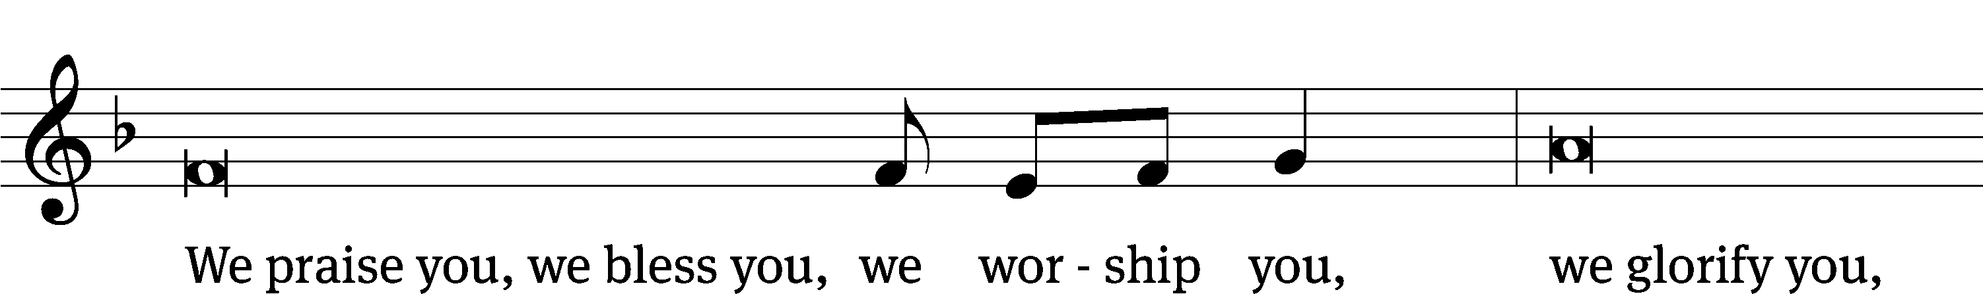
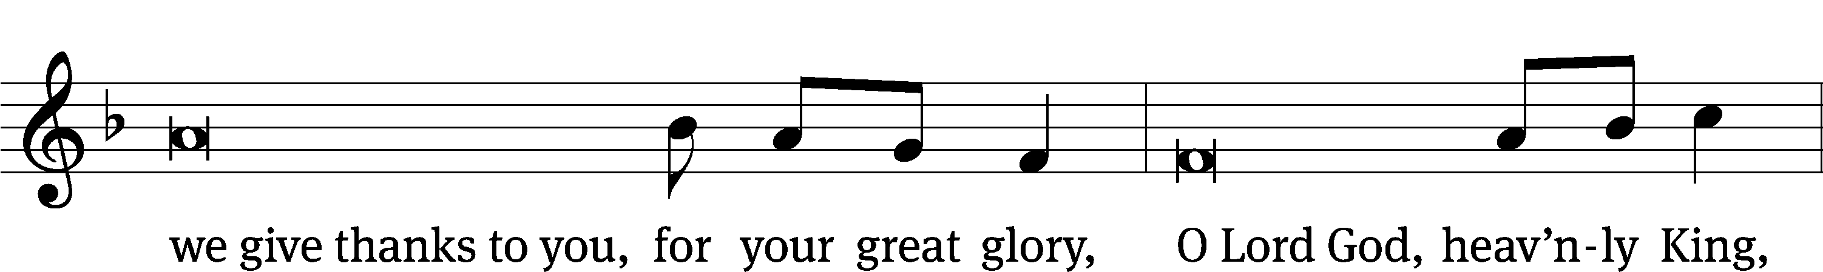
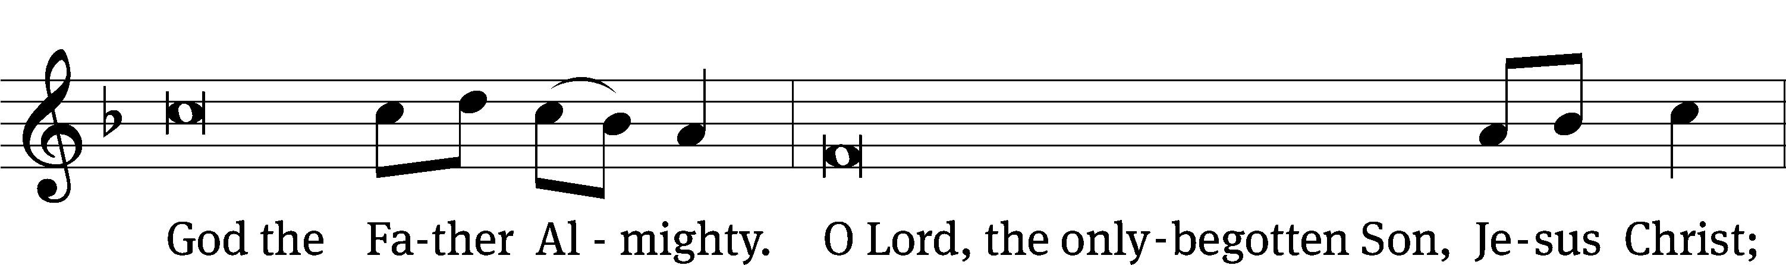
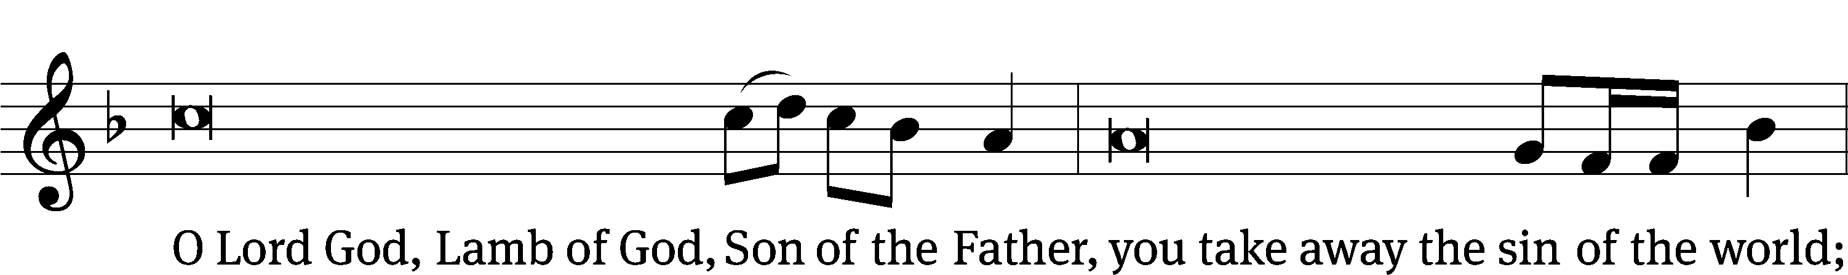
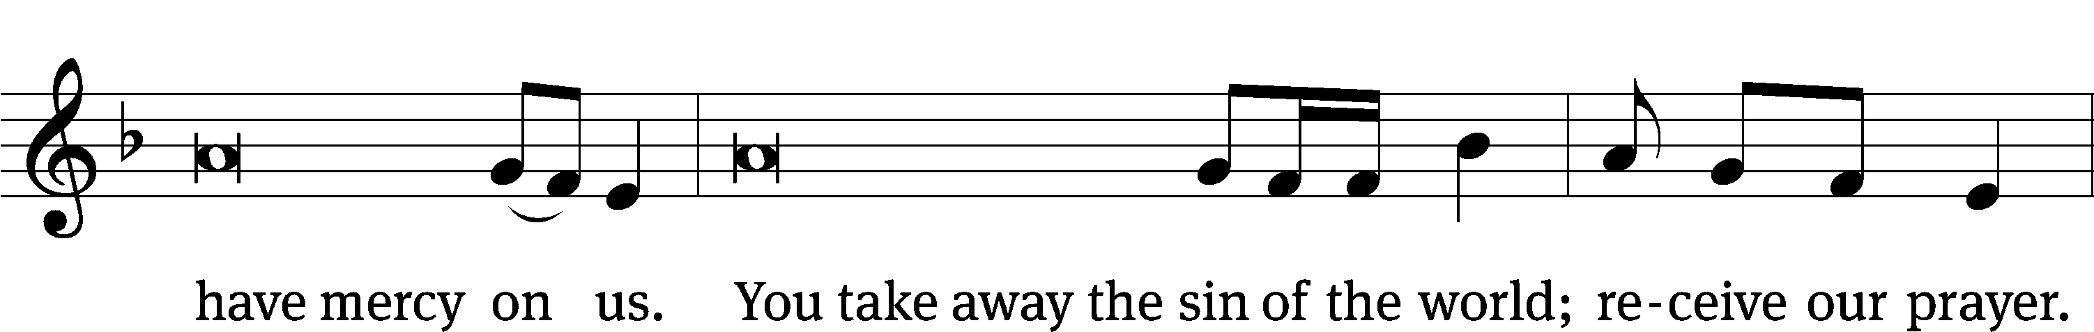
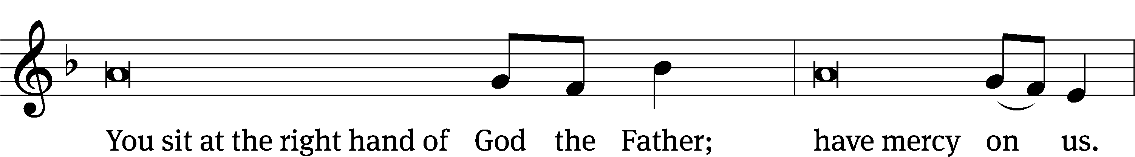
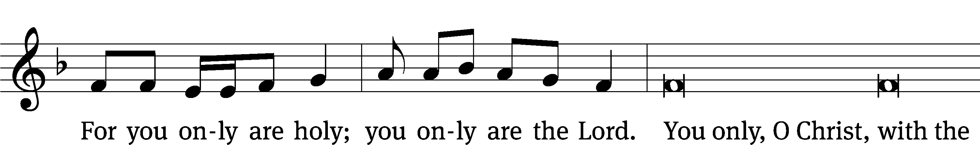
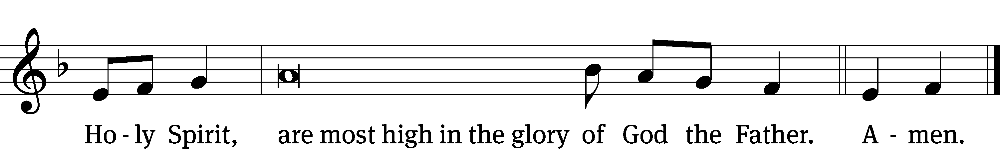

The Word

The Lord be with you.
And also with you.

Prayer of the Day
Let us pray.

Almighty God, you sent your one and only Son as the Word of life for our eyes to see and our ears to hear. Help us believe what the Scriptures proclaim about him and do the things that are pleasing in your sight; through your Son, Jesus Christ our Lord, who lives and reigns with you and the Holy Spirit, one God, now and forever.
Amen.

Be seated

First Reading Exodus 19:1–8a
¹On the first day of the third month after the Israelites left Egypt—on that very day—they came to the Desert of Sinai. ²After they set out from Rephidim, they entered the Desert of Sinai, and Israel camped there in the desert in front of the mountain.
³Then Moses went up to God, and the Lord called to him from the mountain and said, “This is what you are to say to the descendants of Jacob and what you are to tell the people of Israel: ⁴‘You yourselves have seen what I did to Egypt, and how I carried you on eagles’ wings and brought you to myself. ⁵Now if you obey me fully and keep my covenant, then out of all nations you will be my treasured possession. Although the whole earth is mine, ⁶you will be for me a kingdom of priests and a holy nation.’ These are the words you are to speak to the Israelites.”
⁷So Moses went back and summoned the elders of the people and set before them all the words the Lord had commanded him to speak. ⁸The people all responded together, “We will do everything the Lord has said.”

The Word of the Lord.
Thanks be to God.

18C The LORD My God Will Turn Psalm 18C
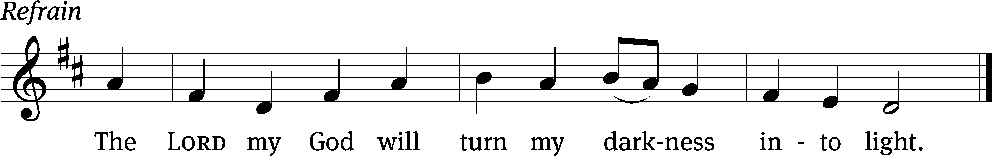


The Lord is my rock, my fortress and my de- / liverer;
my God is my rock, in whom I take / refuge.
In my distress I called / to the Lord;
I cried to my / God for help.
From his temple he / heard my voice;
my cry came before him, in- / to his ears. Refrain

He reached down from on high and took / hold of me;
he drew me out of deep / waters.
He rescued me from my powerful / enemy,
from my foes, who were too / strong for me.
They confronted me in the day of my dis- / aster,
but the Lord was / my support.
He brought me out into a / spacious place;
he rescued me because he delighted / in me. Refrain

You, Lord, keep my lamp / burning;
my God turns my darkness / into light.
With your help I can advance a- / gainst a troop;
with my God I can / scale a wall.
Glory be to the Father and / to the Son
and to the Holy / Spirit,
as it was in the be- / ginning,
is now, and will be forever. / Amen. Refrain
Tune: © Richard Peers. Used by permission: License no. 130030798
Setting: © 2021 Northwestern Publishing House. Used by permission: OneLicense no. 722228

Second Reading 1 Peter 2:9–12
⁹But you are a chosen people, a royal priesthood, a holy nation, God’s special possession, that you may declare the praises of him who called you out of darkness into his wonderful light. ¹⁰Once you were not a people, but now you are the people of God; once you had not received mercy, but now you have received mercy.
¹¹Dear friends, I urge you, as foreigners and exiles, to abstain from sinful desires, which wage war against your soul. ¹²Live such good lives among the pagans that, though they accuse you of doing wrong, they may see your good deeds and glorify God on the day he visits us.

The Word of the Lord.
Thanks be to God.

Stand

Gospel Acclamation Matthew 5:16
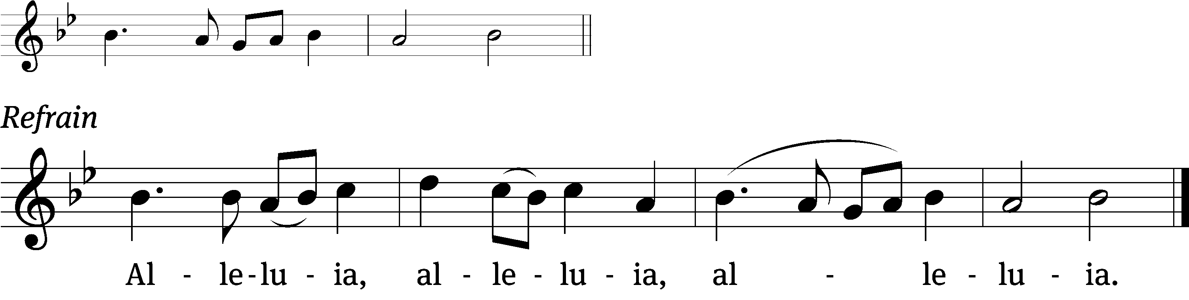
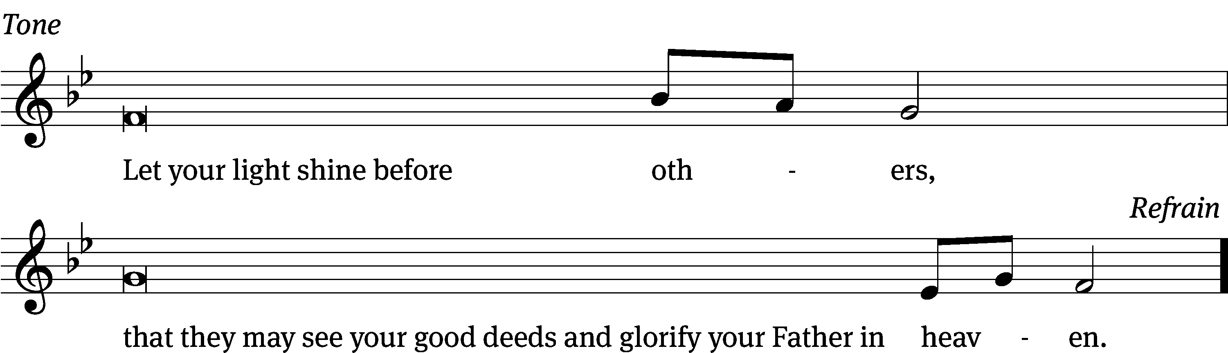
Tune: © 2021 Northwestern Publishing House. Used by permission: OneLicense no. 722228

Gospel Matthew 5:13–20
¹³“You are the salt of the earth. But if the salt loses its saltiness, how can it be made salty again? It is no longer good for anything, except to be thrown out and trampled underfoot.
¹⁴“You are the light of the world. A town built on a hill cannot be hidden. ¹⁵Neither do people light a lamp and put it under a bowl. Instead they put it on its stand, and it gives light to everyone in the house. ¹⁶In the same way, let your light shine before others, that they may see your good deeds and glorify your Father in heaven.
¹⁷“Do not think that I have come to abolish the Law or the Prophets; I have not come to abolish them but to fulfill them. ¹⁸For truly I tell you, until heaven and earth disappear, not the smallest letter, not the least stroke of a pen, will by any means disappear from the Law until everything is accomplished. ¹⁹Therefore anyone who sets aside one of the least of these commands and teaches others accordingly will be called least in the kingdom of heaven, but whoever practices and teaches these commands will be called great in the kingdom of heaven. ²⁰For I tell you that unless your righteousness surpasses that of the Pharisees and the teachers of the law, you will certainly not enter the kingdom of heaven.

The Gospel of the Lord.
Praise be to you, O Christ!

Be seated

854 Church of God, Elect and Glorious CW 854
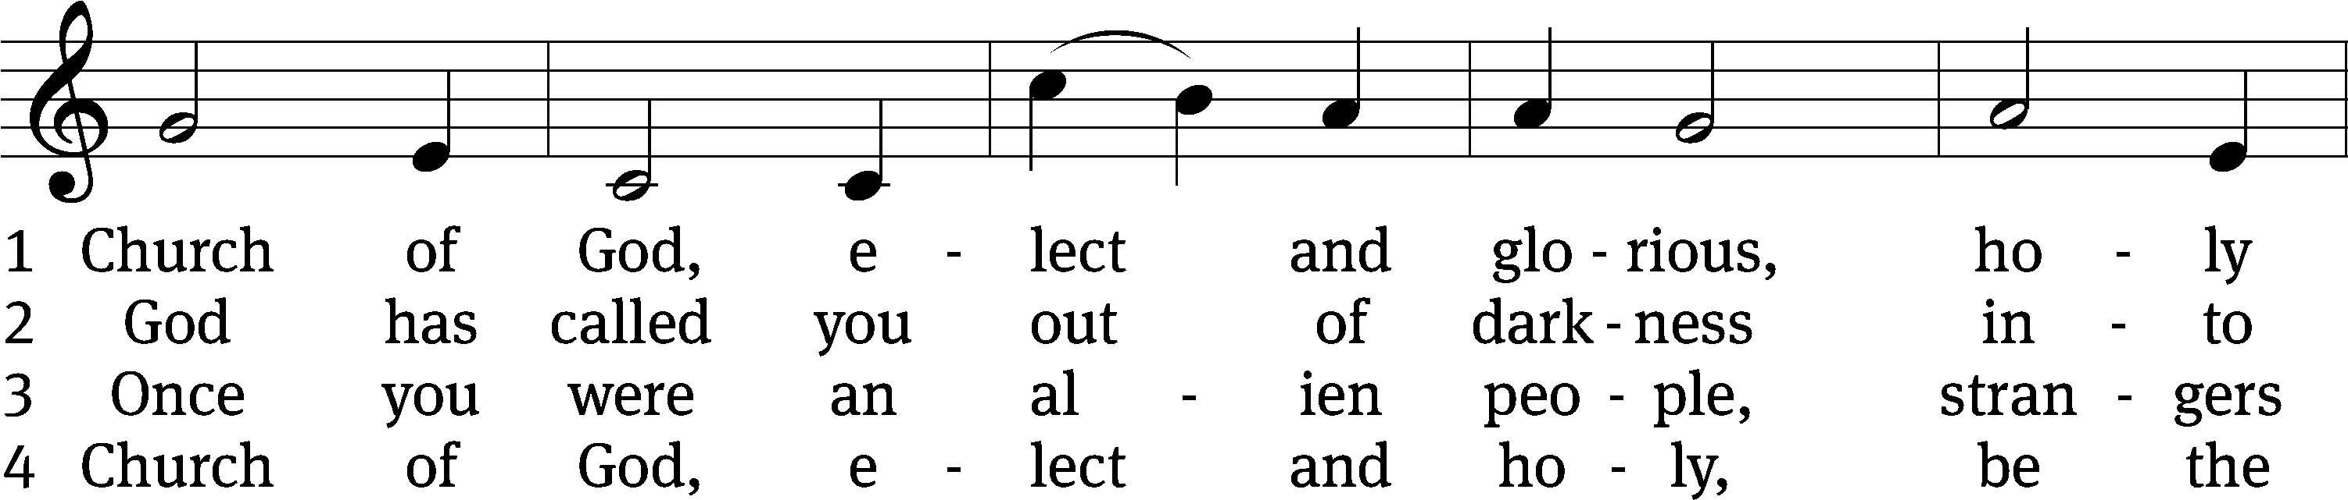
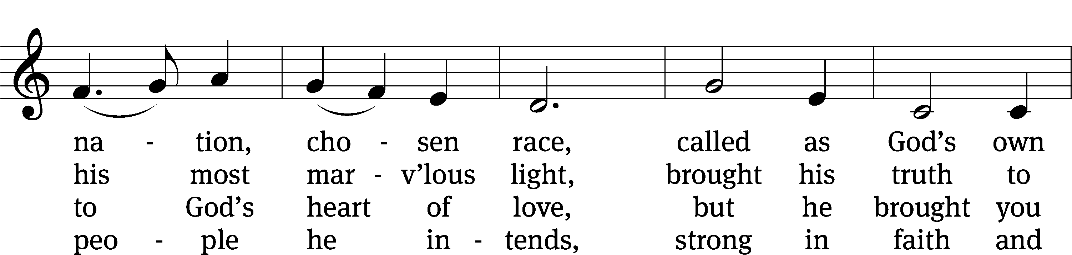
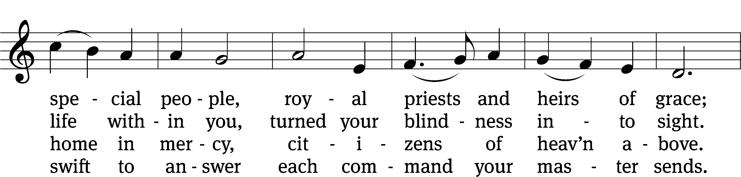
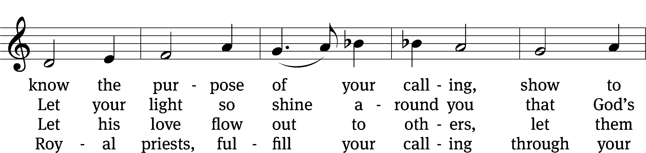
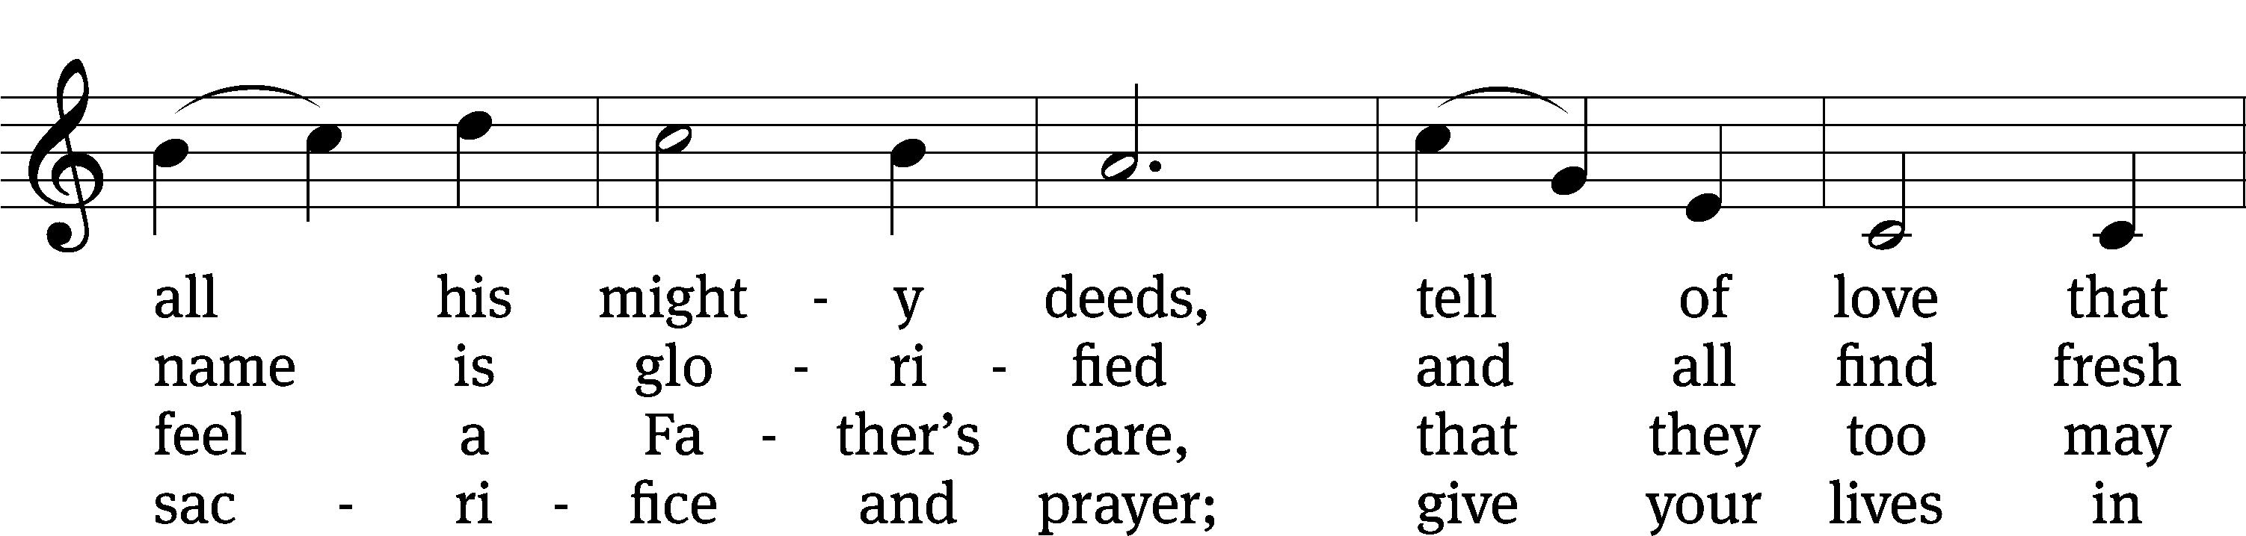
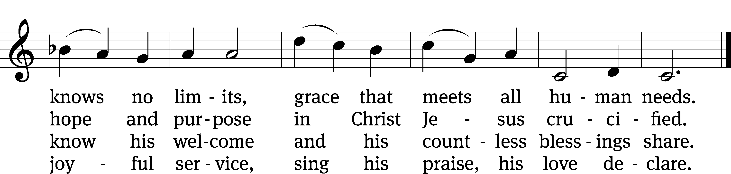
Text: James E. Seddon, 1915–1983
Tune: Cyril V. Taylor, 1907–1992
Text: © 1982 The Jubilate Group, admin. Hope Publishing Co. Used by permission: OneLicense no. 722228
Tune: © 1942, ren. 1970 Hope Publishing Co. Used by permission: OneLicense no. 722228

Sermon: Exodus 19:2-8a "God Communicates to Us"

Stand

Apostles’ Creed
I believe in God, the Father Almighty,
maker of heaven and earth.

I believe in Jesus Christ, his only Son, our Lord,
who was conceived by the Holy Spirit,
born of the Virgin Mary,
suffered under Pontius Pilate,
was crucified, died, and was buried.
He descended into hell.
The third day he rose again from the dead.
He ascended into heaven
and is seated at the right hand of God the Father Almighty.
From there he will come to judge the living and the dead.

I believe in the Holy Spirit,
the holy Christian Church,
the communion of saints,
the forgiveness of sins,
the resurrection of the body,
and the life everlasting. Amen.

Be seated

Prayer of the Church
Brief intercessory prayers may be added in a fitting place.

Almighty God and Father, we thank you for all your mercies, especially for the gift of your Son, through whom you have revealed your gracious will. We praise you for the Holy Spirit and his working through the means of grace.
Plant your Word in our hearts, and cause it to produce fruit in our lives.

Strengthen and defend your Church, that by your Word and sacraments faith may grow and love toward all may increase.
Support all who spread the light of your truth throughout the world.

Keep our children in the grace of their baptisms. Enable their parents to train them in lives of faith.
Raise up Christians to serve you in the ministry of the Word and in all godly walks of life.

Preserve our nation in justice and honor. Guide and bless all who make, administer, and judge our laws.
Give them wisdom that they may promote justice and hinder evil.

Let your blessing rest on planting and harvest, commerce and industry, medicine and science, the arts and culture. Protect all who travel, and care for those whose work is difficult or dangerous.
Be with all who devote themselves to any useful task.

Comfort all who are in sorrow or need, sickness or adversity, [especially . . . here name the person and the cause of the petition]. Remember those who suffer persecution for the faith. Have mercy on those for whom death draws near.
Grant them your love, and take them into your tender care.

Hear us, Lord, as we pray in silence.

Silent prayer

We remember with thanksgiving those who have loved and served you, who now rest from their labors, [especially . . . here name the person]. Console those who are mourning or living with sadness.
Keep us in the true faith, and bring us at last to the joys of heaven.

Grant us these things, Father, for the sake of Jesus, who died and rose again.
Amen.

Offering

Lord’s Prayer
Our Father in heaven,
hallowed be your name,
your kingdom come,
your will be done
on earth as in heaven.
Give us today our daily bread.
Forgive us our sins,
as we forgive those
who sin against us.
Lead us not into temptation,
but deliver us from evil.
For the kingdom, the power,
and the glory are yours
now and forever. Amen.

Blessing
The Lord bless you and keep you.
The Lord make his face shine on you and be gracious to you.
The Lord look on you with favor and T give you peace.
Amen.

736 Lord, You Call Us as Your People CW 736
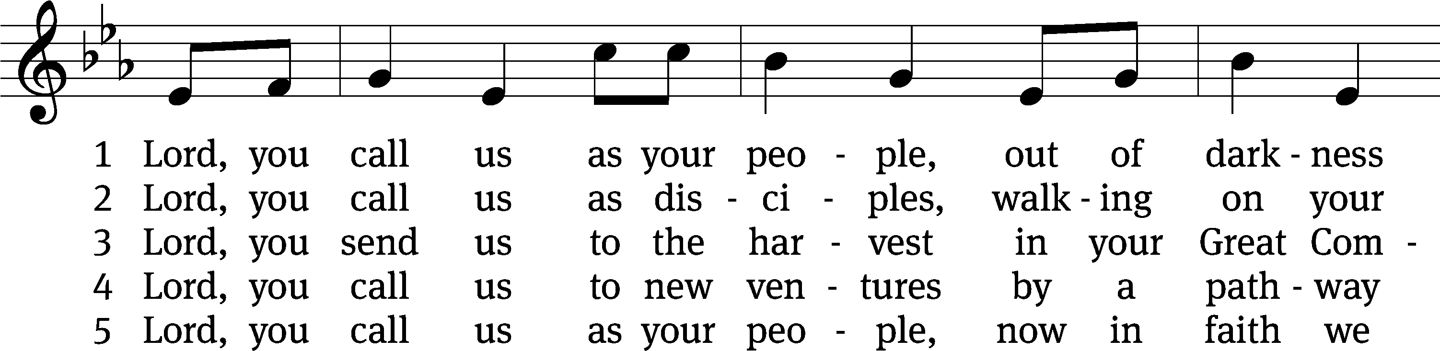
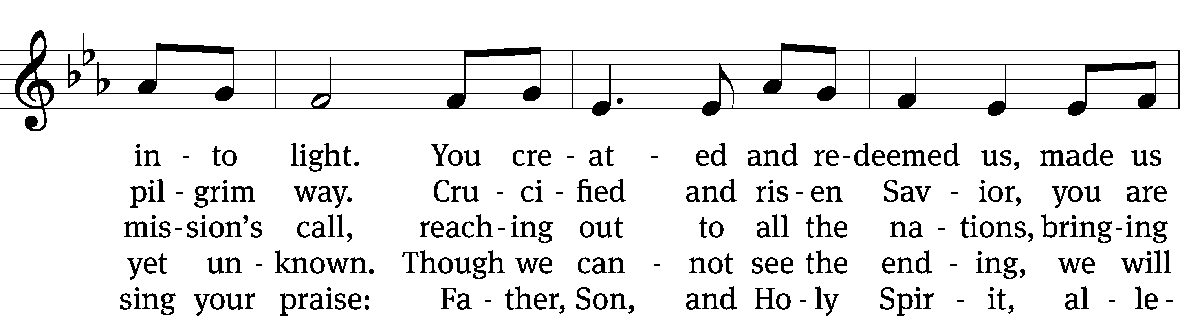
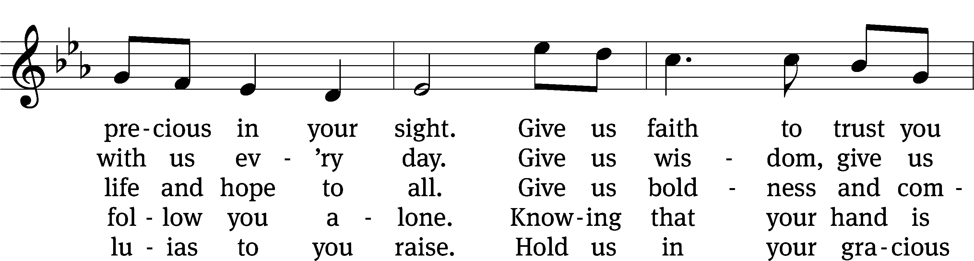
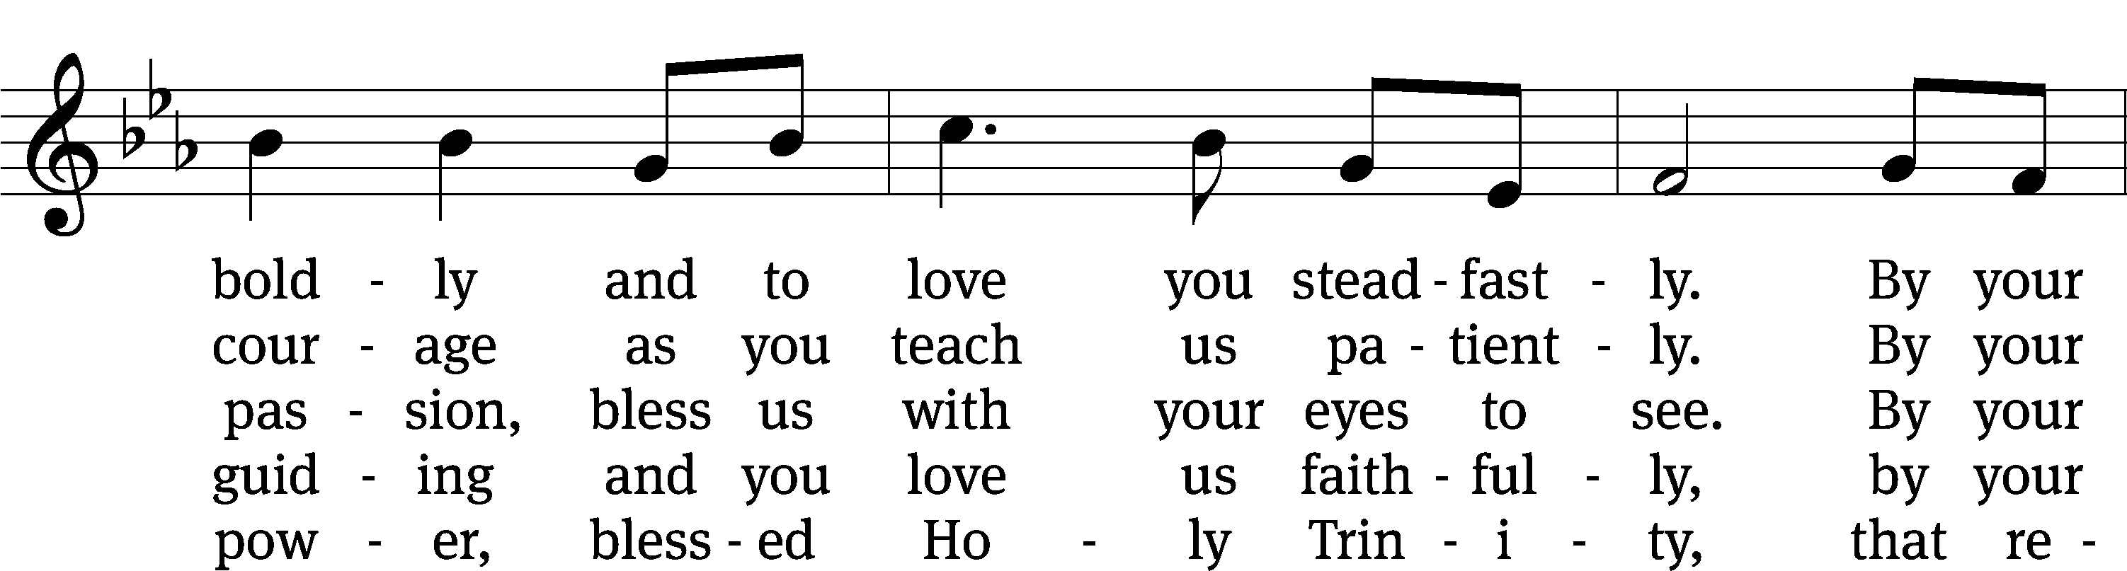
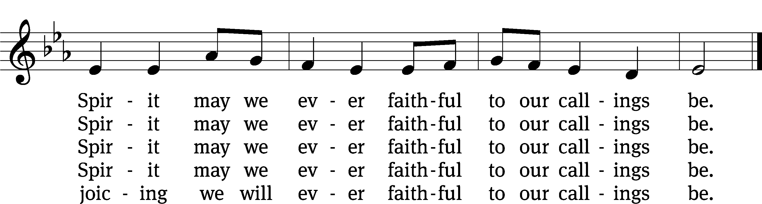
Tune: Marty Haugen, b. 1950
Text: © 2010 Stephen P. Mueller. Used by permission: OneLicense no. 722228
Tune: © 1987 GIA Publications, Inc. Used by permission: OneLicense no. 722228

Acknowledgments
Setting One from Christian Worship
Unless otherwise indicated, Scripture quotations are from The Holy Bible, New International Version®, NIV®. Copyright © 1973, 1978, 1984, 2011 by Biblica, Inc.TM Used by permission of Zondervan. All rights reserved worldwide.
Software distributed in partnership with Northwestern Publishing House.
Created by Christian Worship: Service Builder © 2023 Concordia Publishing House.

